pughphonos
  Post subject: Re: Inventory of Beethoven and Schubert Edisonic phonographs
  Posted: Thu Dec 15, 2016 12:33 pm
Joined: Tue Jul 17, 2012 11:35 am  Posts: 670  Location: Homewood, Illinois, USA
  Victor III
  
  "You must serve music"
  EARL HENNAGIR (MASON CITY, IOWA) HAS PURCHASED SCHUBERT SERIAL # 2590
  Model: Schubert Edisonic
  Serial number: 2590
  My friend Earl Hennagir contacted me in early October to let me know that he'd just purchased Schubert Edisonic serial no. 2590. I'll cut-and-paste the details he provided in a couple messages about its condition. Those of you (Fran in particular) who are interested in the brief run of earliest Schuberts that carried the "New Edisonic" sticker should consult his narrative (which also touches on a Schubert other than his no. 2590.
  ++++++++++++++++++++++++++++++++++++
  October 9, 2016
  Hello Ralph,
  Say, I just dragged home an Edison Schubert yesterday from up in Wisconsin and thought you might like the information on it. What all do you want to know besides the serial number? I'm got home late last night and need to get the truck unloaded and then I can get all that stuff sorted out. The lid prop is missing on it for some reason so I'm going to have to get that sorted out, but other than that it's in I would call below average condition in a lot of ways. I'll have to refinish it in the spring, but that's no big deal. The guy I got it from really knew nothing about it, it was given to him and with 9 children he didn't want to keep it! Anyway, you let me know what you'd like to know about it and I'll get all the details later. If you know of a lid prop or what other machines used that style, I'll get that sorted out. Take care now, Earl.
  Earl Hennagir
  Mason City, Iowa
  October 11, 2016
  The serial number is 2590 and I'll take some pictures of it in a day or so and get them sent to you. If you'd like me to post all of that stuff on the forum I can do that. It is kind of interesting to look through the photos of these things, even though in a lot of ways they are all alike! I refinished one of these things for Burdette Walters 10-15 years ago and his had "The New Edison" decal on it and his also had a long play motor in it. From that, I just thought they were all like that, but this one just says "The Edisonic" for a decal. I actually like the other decal better. This one really needs to be refinished, but that will have to wait until next year. The lid prop is all screwed up and missing parts, so I'll put an earlier style one in it. Way less trouble with those stupid springs as well. Eventually, the right one will turn up and it's not really a big deal either way. This one has a reproducer holder with it, but it was laying in the bottom of the cabinet behind the horn. They might have taken it out to try and figure out something with that lid prop. At least it stayed in the cabinet. One of the pads for the governor is broken off as well, so I'll have to get that figured out as well. It was kind of dumb that Edison put the speed control under the turntable like he did, but anything to save a dime I guess.....
  ++++++++++++++++++++
  Quick comment (from Ralph): Burdette Walters maintains a "Mr. Opera" website; see link below, which shows a Schubert Edisonic with no serial number provided. The photo shows the standard "Edisonic" decal, so Mr. Walters has (or had) another Schubert not displayed on his site.
  http://www.misteropera.com/html/schuber ... ic_de.html
  "You must serve music, because music is so enormous and can envelop you into such a state of perpetual anxiety and torture--but it is our first and main duty"
  -- Maria Callas, 1968 interview.
  Last edited by pughphonos on Thu Dec 15, 2016 1:21 pm, edited 1 time in total.
Top

pughphonos
  Post subject: Re: Inventory of Beethoven and Schubert Edisonic phonographs
  Posted: Thu Dec 15, 2016 12:51 pm
Joined: Tue Jul 17, 2012 11:35 am  Posts: 670  Location: Homewood, Illinois, USA
  Victor III
  "You must serve music"
  SCHUBERT # 2501 OFFERED ON E-BAY FOR $350 ("BUY IT NOW") BY "JESJUSLIZ" OF RIO LINDA, CALIFORNIA
  Model: Schubert Edisonic
  Serial number: 2501
  As mentioned above on November 25, E-bay has yet another Schubert on offer--and as of today it's still there. For the record I will cut-and-paste the description below, and then post most of the photos that are included with it.
  +++++++++++++++++++++++++++++++++++++++++++++
  This is a beautiful old Edison No. 18 Edisonic model console phonograph. CLT 2501 The cabinet is in good sturdy condition. The wood is darker then it appears in some of the pictures. The phonograph works and sounds great. We used it often when our kids were little and the power was out, but kids have moved on and now it is just sitting. Time for it to find a new family to enjoy it. One knob is missing from the front door. The cabinet is approximately 24 inches wide, stands 39 inches tall and is 21 inches deep.
  There is an extra item that I think is another head for it.
  I am also including all of my old thick 78's that I have.
  Attachments:
  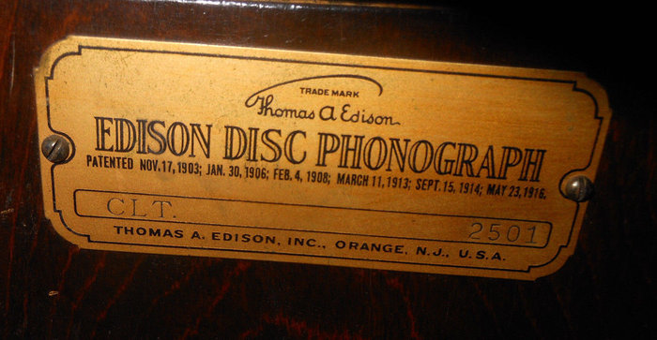
  2501 three.jpg [ 210.76 KiB | Viewed 863 times ]
  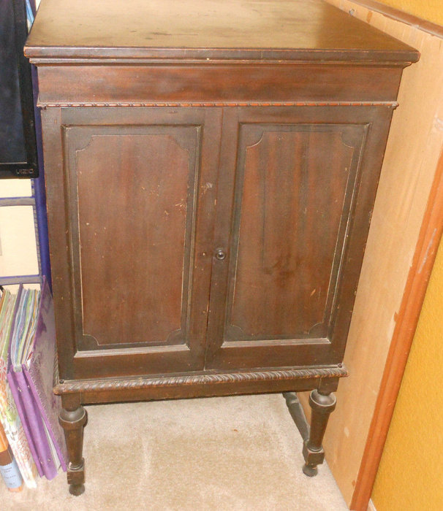
  2501 one.jpg [ 248.43 KiB | Viewed 865 times ]
  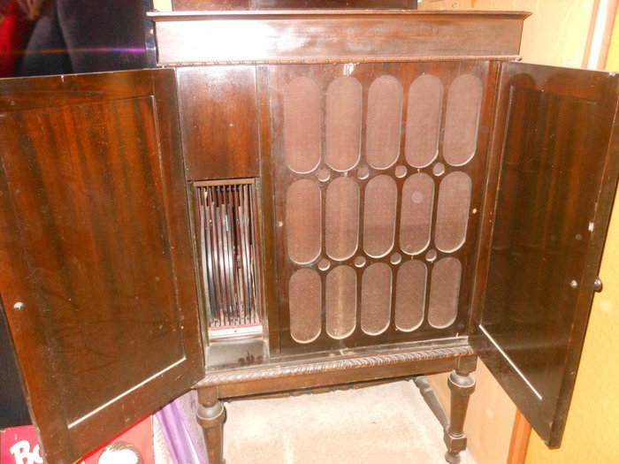
  2501 seven.jpg [ 399.71 KiB | Viewed 865 times ]
  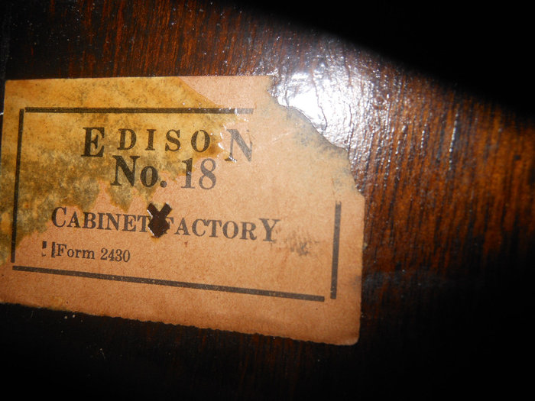
  2501 six.jpg [ 338.43 KiB | Viewed 865 times ]
  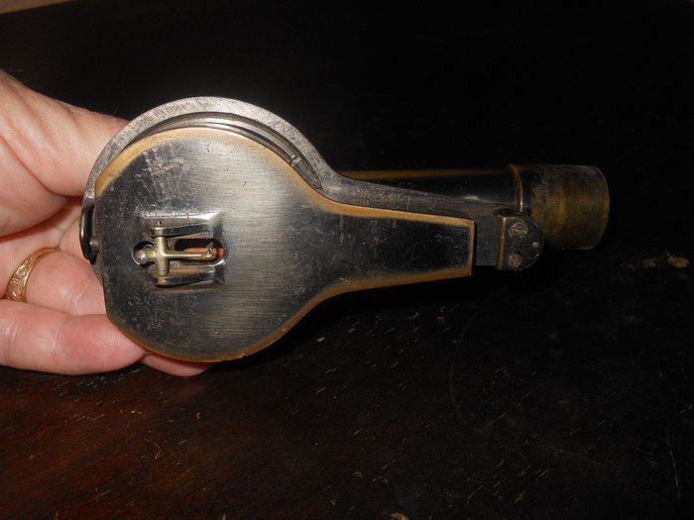
  2501 four.jpg [ 276.9 KiB | Viewed 865 times ]
  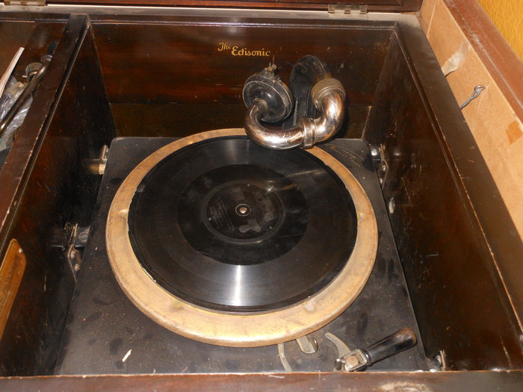
  2501 two.jpg [ 365.13 KiB | Viewed 865 times ]
  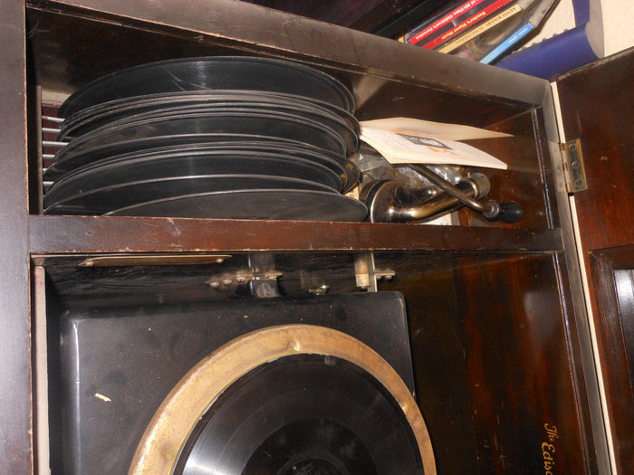
  2501 eight.jpg [ 381.69 KiB | Viewed 865 times ]
  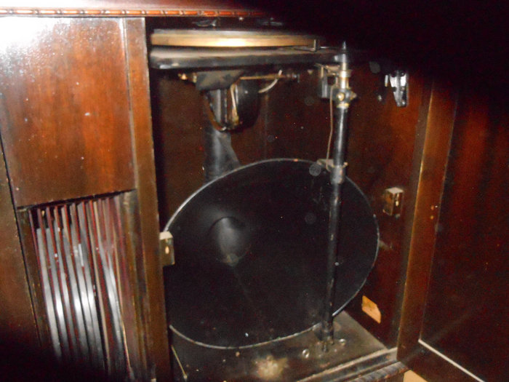
  2501 five.jpg [ 407.84 KiB | Viewed 865 times ]
  "You must serve music, because music is so enormous and can envelop you into such a state of perpetual anxiety and torture--but it is our first and main duty"
  -- Maria Callas, 1968 interview.
Top

pughphonos
  Post subject: Re: Inventory of Beethoven and Schubert Edisonic phonographs
  Posted: Thu Dec 15, 2016 1:11 pm
Joined: Tue Jul 17, 2012 11:35 am  Posts: 670  Location: Homewood, Illinois, USA
  Victor III
  "You must serve music"
  UPDATED INDEX (AS OF DECEMBER 15, 2016) TO POSTINGS:
  SERIAL NUMBERS of machines posted above (and some below), arranged in order (with dates of posting):
  BEETHOVEN EDISONICS:
  1049 (11/13/2015 & 11/15/2015); 1121 (4/30/2014); 1150 (4/25/2014);
  1200 (03/8/2015); 1220 (4/25/2014); 1238 (4/29/2014);
  1262 (4/25/2014); 1316 (4/25/2014 & 9/1/2015 & 11/15/2015);
  1545 (12/24/2015 & 4/8/2016); 1757 (4/25/2014 & 11/19/2015); 1853 (4/23/2014);
  1898 (4/21/2014); 1977 (6/20/2014 & 7/1/2014 & 4/6/2015 & 6/4/2015 & 8/6/2015);
  2036 (4/25/2014); 2157 (4/22/2014); 2292? (4/21/2014); 2488 (5/1/2014);
  2491 (7/12/2014 & 6/2/2015); 2641 (5/14/2014)
  SCHUBERT EDISONICS:
  1020 (6/2/2015); 1108 (8/7/2015); 1150 (4/25/2014); 1187 (4/24/2014);
  1216 (4/25/2014, 4/26/2014 & 5/4/2014); 1217 (4/28/2014 & 5/4/2014);
  1246 (4/21/2014); 1329 (5/1/2014 & 05/6/2014); 1394 (4/25/2014);
  1441 (4/25/2014); 1537 (6/5/2015); 1544 (6/13/2016);
  1556 (4/22/2014 & 5/2/2015 & ½/2016);
  1596 (7/22/2014); 1656 (4/25/2014); 1672 (7/30/2014);
  1765 (4/23/2015 & 4/25/2015); 1844 (3/11/2015 & 5/3/2015 & 9/17/2015);
  1897 (5/14/2014); 1902 (4/22/2014); 1913 (4/25/2014);
  1922 (12/24/2015); 1958 (4/27/2014 & 11/8/2015 & 11/15/2015);
  2002 (4/25/2014); 2010 (4/28/2014); 2058 (4/25/2014);
  2288 (4/22/2014 & 5/1/2014); 2501 (11/25/2016 & 12/15/2016);
  2590 (11/25/2016 & 12/15/2016);
  2673 (4/24/2014 & 5/29/2014); 2723 (4/23/2014);
  2773 (9/1/2015); 2982 (4/25/2014);
  3020 (4/22/2014 & 10/18/2015); 3023 (4/25/2014); 3398 (4/21/2014);
  3618 (4/21/2014); 3621 (5/18/2014 & 1/17/2016);
  3675 (4/21/2014); 3835 (6/4/2015 & 11/30/2015);
  3919 (7/7/2014); 4005 (4/22/2014);
  4129 (4/22/2014); 4139 (6/11/2016);
  4157 (8/4/2015 & 9/1/2015); 4246 (4/25/2014);
  4484 (4/25/2014); 4574 (6/12/2016); 4752 (4/21/2014);
  4869 (4/29/2014); 5056 (4/22/2014 & 5/23/2014 & 2/16/2016);
  5451 (10/15/2015 & 10/17/2015 & 2/17/2016));
  5653 (4/21/2014); 5670 (05/6/2014 & 5/19/2014);
  5678 (4/28/2014 & 8/8/2015); 6025 (4/30/2014 & 6/21/2014)
  +++++++++++++++++++++++++++++++++++++++++++++++++++++++++++++++++++++++++++++++++++++++++++++++
  NON-SERIAL NUMBER DESIGNATION SYSTEM
  As stated at the start of this thread, it is preferred first and foremost that we list information on machines using serial numbers.
  However, in the case of old/inactive on-line listings where serial numbers were not provided and there is no current contact information, I have devised the following designation system whereby we can record information from these listings. It is not a perfect system as the same machines might appear again in listings from other localities. But it will still add to our knowledge base by enabling us to capture unique images and information on particular machines as they work their way through listings. If, in future, we can gain serial numbers for any of these machines, I will link the serial number to the old listings.
  For example, in 2013 I contacted a Craigslist seller in Minnesota who had a Schubert; he would not sell it to me as I could not arrange a local pick-up. I do not know what has since happened with that machine. But I still have the description from 2013. My temporary designation for that machine (so that I can post it here) is USMN2013MAY19.
  How to create a non-serial number designation. For old US postings, use US and then the US state postal code (in this case, MN=Minnesota), followed immediately by the original date of posting. For old foreign postings, spell out the full country name and then the original date of posting: e.g. FRANCE2012JANUARY31.
  The following entries are arranged chronologically by original posting dates:
  BEETHOVEN EDISONICS:
  USMI2007NOVEMBER9 (4/27/2014); US2010DECEMBER19 (5/3/2014)
  SCHUBERT EDISONICS:
  USNJ1997NOVEMBER15 (5/7/2014); AUSTRALIA1997NOVEMBER20 (5/1/2014);
  USNY2005 (5/2/2014); GERMANY2006 (4/25/2014);
  USMD2006JULY7 (4/24/2014 & 5/29/2014--SEE Serial #2673);
  USPA2007 (5/1/2014); USMI2007NOVEMBER9 (4/27/2014); USIL2008JUNE16 (4/27/2014--SEE Serial #1958);
  USIL2010JUNE12(4/24/2014); NEW ZEALAND2012MAY3 (4/25/2014);
  USWA2013MARCH17 (5/1/2014); USMN2013MAY19 (4/23/2013);
  USGA2013AUGUST8 (4/25/2014); USNY2015SEP (10/15/2015 & 10/17/2015—SEE Serial #5451)
  +++++++++++++++++++++++++++++++++++++++++++++++++++++++++++++++++++++++++++++++++++++++++++++
  FINALLY, "YOU TUBE" VIDEOS OF UNIDENTIFIED EDISONICS AND THEIR UNIDENTIFIED OWNERS
  (see posting dated 4/30/2014 for details and links)
  Number of BEETHOVEN EDISONICS portrayed: 0
  Number of SCHUBERT EDISONICS portrayed: 2
  ("Classy8888" has since been identified as Ian Griggs, who owns #6025)
  ("Chagall56" has since been identified as our own "Marcapra"--and he reveals that the Schubert filmed is #1246)
  "You must serve music, because music is so enormous and can envelop you into such a state of perpetual anxiety and torture--but it is our first and main duty"
  -- Maria Callas, 1968 interview.
Top

jimmy47
  Post subject: Re: Inventory of Beethoven and Schubert Edisonic phonographs
  Posted: Thu Sep 06, 2018 9:07 am
Joined: Sun Jul 22, 2018 9:18 pm  Posts: 3
  Victor Jr
  [attachment=0]4A19B211-267A-49E8-B4EC-27E04052988D.jpeg
  Edisonic Schubert
  Purchased Sept 3, 2018, Tylertown, Mississippi from the son whose mother had owned it for 40 years.
  Serial Number CLT. 2276
  Case fair, motor strong, reproducer needs rebuilding.
  Attachments:
  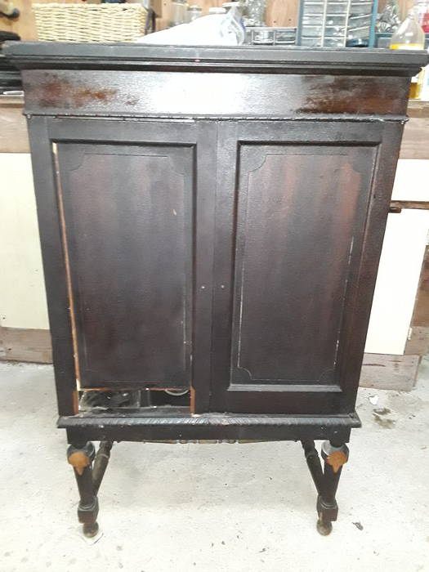
  4A19B211-267A-49E8-B4EC-27E04052988D.jpeg [ 2.91 MiB | Viewed 471 times ]
Top

marcapra
  Post subject: Re: Inventory of Beethoven and Schubert Edisonic phonographs
  Posted: Thu Sep 06, 2018 1:21 pm
Joined: Wed Jun 27, 2012 11:29 pm  Posts: 1915  Location: Temecula, CA
  Victor IV
  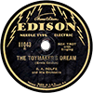
  Man who ride on tiger find it very difficult to dismount! Charlie Chan
  Funny, how so many non-phonograph sellers think that cabinet factory number is important or part of the name of the phonograph.
Top

Skogga
  Post subject: Re: Inventory of Beethoven and Schubert Edisonic phonographs
  Posted: Thu Nov 14, 2019 2:33 am
Joined: Sat Aug 24, 2019 6:15 pm  Posts: 2
  Victor Jr
  Attachment:
  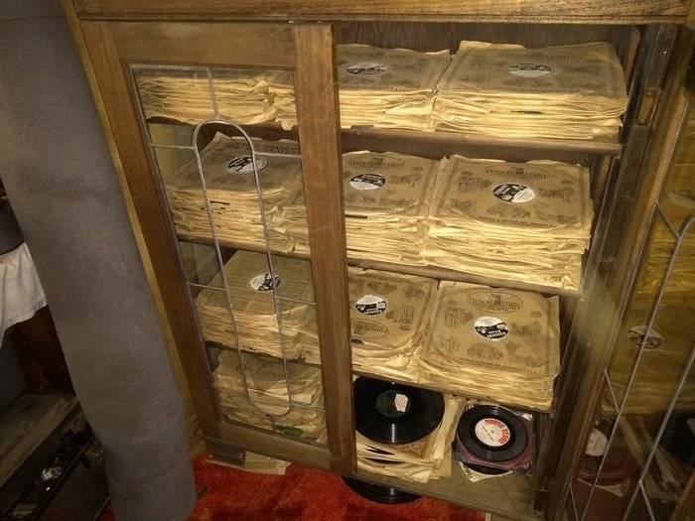
  IMG_20191114_180429051.jpg [ 4.47 MiB | Viewed 138 times ]
  Thought I better add my Schubert to the inventory! I am in Australia, and as far as I know this was an Australian delivered Edisonic purchased in Sydney, probably in 1928. It has been restored mechanically and has a great tone and volume. Serial CLT 4587. Cab factory 18. Growing the number of discs! The user manual, been in its envelope all its life looks a week old.
  Attachments:
  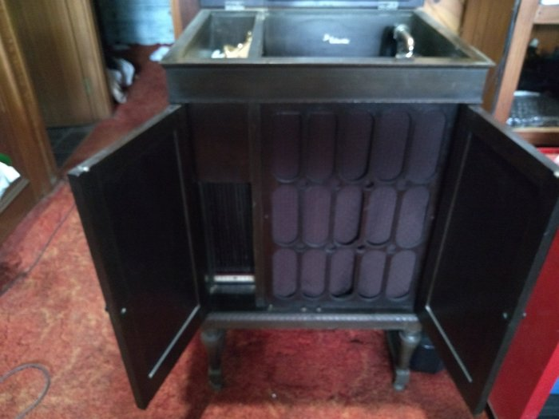
  IMG_20191114_180246539.jpg [ 3.08 MiB | Viewed 138 times ]
  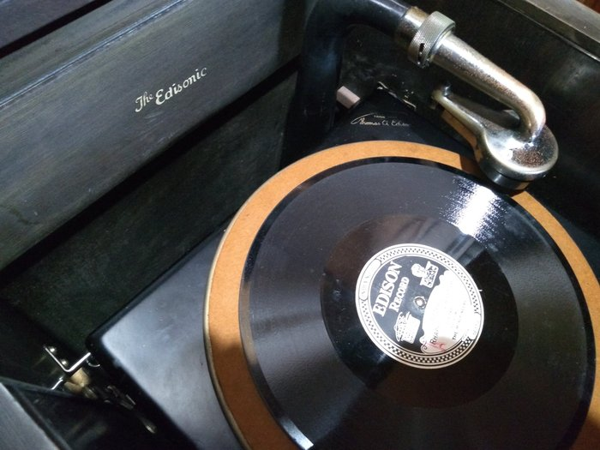
  IMG_20191114_180216295.jpg [ 3.45 MiB | Viewed 138 times ]
  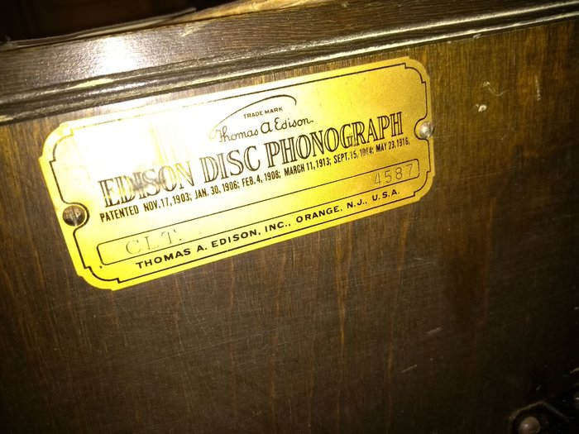
  IMG_20191114_180137177.jpg [ 3.87 MiB | Viewed 138 times ]
  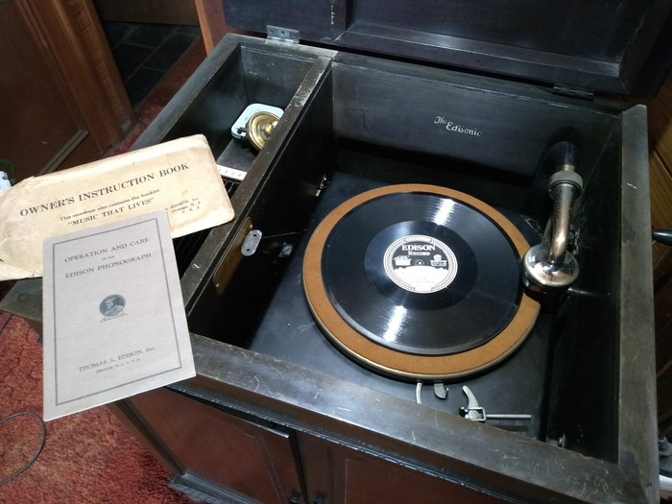
  IMG_20191114_180113842.jpg [ 3.55 MiB | Viewed 138 times ]
Top

vansteem78
  Post subject: Re: Inventory of Beethoven and Schubert Edisonic phonographs
  Posted: Tue Nov 19, 2019 5:07 pm
Joined: Wed Nov 12, 2014 5:50 pm  Posts: 220
  Victor II
  I have a Schubert serial number 3155. Plays nice. When I looked inside I saw it had been glued together! In the back was a lot of the glue. I made a minor adjustment after buying it as the reproducer was to low. It certainly is a dark machine but sounds wonderful The Edisonic had to be repaired by Medved in Florida. Actually diamond replaced. I might have bought it in 2017. I got it from Ron haring. What else is there to say I like it a lot.
  Attachments:
  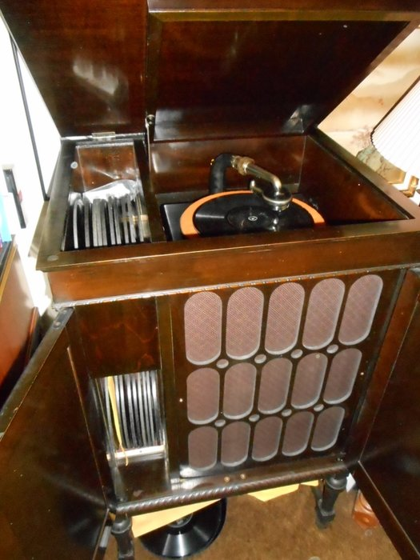
  schubert55.JPG [ 383.38 KiB | Viewed 75 times ]
Top

Previous topic | Next topic

Display posts from previous:  Sort by   

 | Page 25 of 25 | [ 247 posts ] | Go to page Previous 1 ... 21, 22, 23, 24, 25

