marcapra
  Post subject: Re: Inventory of Beethoven and Schubert Edisonic phonographs
  Posted: Mon Jul 07, 2014 12:32 pm
Joined: Wed Jun 27, 2012 11:29 pm  Posts: 1915  Location: Temecula, CA
  Victor IV
  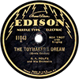
  Man who ride on tiger find it very difficult to dismount! Charlie Chan
  If you did not get Ron Dethlefson's Beethoven, there is another one for you. I don't know the serial number. Marc.
Top

pughphonos
  Post subject: Re: Inventory of Beethoven and Schubert Edisonic phonographs
  Posted: Thu Jul 10, 2014 10:33 am
Joined: Tue Jul 17, 2012 11:35 am  Posts: 670  Location: Homewood, Illinois, USA
  Victor III
  
  "You must serve music"
  UPDATED INDEX (AS OF JULY 10, 2014) TO POSTINGS:
  The information in this posting became outdated and has been replaced by a new "Updated Index" that can be found at or near the end of this thread.
  "You must serve music, because music is so enormous and can envelop you into such a state of perpetual anxiety and torture--but it is our first and main duty"
  -- Maria Callas, 1968 interview.
  Last edited by pughphonos on Wed Jul 30, 2014 10:17 am, edited 7 times in total.
Top

marcapra
  Post subject: Re: Inventory of Beethoven and Schubert Edisonic phonographs
  Posted: Thu Jul 10, 2014 11:47 pm
Joined: Wed Jun 27, 2012 11:29 pm  Posts: 1915  Location: Temecula, CA
  Victor IV
  Man who ride on tiger find it very difficult to dismount! Charlie Chan
  One thing that was not covered thoroughly in this inventory was if the phonograph console was complete. By this, I mean does it have the original knobs or door pulls, in the case of the Beethoven? Does it have the complete original legs and stretcher, turntable, crank, reproducer, etc.? It is known that many Schuberts have replaced door knobs because the original wooden knobs tended to break. Beethovens have elaborate door pulls involving an escutcheon, pin, and knocker, rather than simple knobs and on some consoles they are missing, incomplete, or have been replaced. One I know of has lion heads with a pull ring instead of the original door pulls. I want to take this time to alert Beethoven owners that I am having the Beethoven door pulls recast by a professional company, but am only casting as many as I need and if any others need them too, this is your chance to order, if you act fast. See my ad on the Yankee Trader if interested. http://forum.talkingmachine.info/viewtopic.php?f=9&t=17724
  Thanks, Marc.
Top

pughphonos
  Post subject: Re: Inventory of Beethoven and Schubert Edisonic phonographs
  Posted: Sat Jul 12, 2014 10:04 am
Joined: Tue Jul 17, 2012 11:35 am  Posts: 670  Location: Homewood, Illinois, USA
  Victor III
  "You must serve music"
  RON DETHLEFSON'S BEETHOVEN
  Model: Beethoven Edisonic
  Serial number: 2491
  I'm happy to report that this inventory now has the serial number for Ron Dethlefson's Beethoven, along with a couple images. Ron, as many of you know, has been a leading figure in the antique phonograph community for many years. Ron very graciously and quickly responded to my request for this documentation.
  Attachments:
  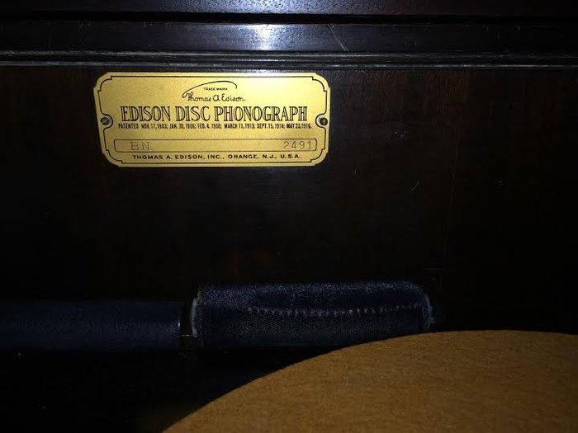
  Dethlefson2.jpg [ 28.38 KiB | Viewed 931 times ]
  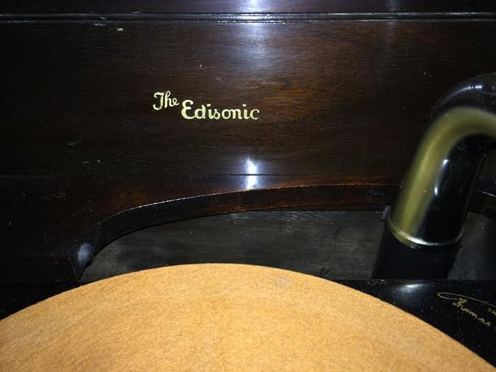
  Dethlefson1.jpg [ 31.99 KiB | Viewed 931 times ]
  "You must serve music, because music is so enormous and can envelop you into such a state of perpetual anxiety and torture--but it is our first and main duty"
  -- Maria Callas, 1968 interview.
Top

marcapra
  Post subject: Re: Inventory of Beethoven and Schubert Edisonic phonographs
  Posted: Sun Jul 13, 2014 5:34 am
Joined: Wed Jun 27, 2012 11:29 pm  Posts: 1915  Location: Temecula, CA
  Victor IV
  Man who ride on tiger find it very difficult to dismount! Charlie Chan
  From your estimated projection that there were approximately 4500 Schuberts originally made and about 1500 Beethovens, that makes a ratio of about three Schuberts for every one Beethoven. And that pretty closely fits the ratio of existing machines counting the ones with known serial numbers in the hands of collectors, and those found in the "wild" on Craigslist and Ebay. I want to thank the creator of this blog as you have done some valuable research on these models where little knowledge existed before. The bigger mystery is how many of these machines still exist in basements, barns, and attics, or are just owned by "civilians" who don't realize their value? I just recently purchased a Beethoven in the wild, which was sold by the granddaughter of the last owner who used it to play lateral church records with a crudely fitted Victrola tone arm stuffed into the Edison horn neck! Who knows when this Victrola tone arm and Exhibition sound box was put there? Who knows when the machine lost its Edisonic reproducer and Diamond Discs? Was it in the 30s, 40s, 50s, no way to know? That's the mystery of time and mutability.
  Last edited by marcapra on Mon Jul 14, 2014 12:24 am, edited 1 time in total.
Top

PeterF
  Post subject: Re: Inventory of Beethoven and Schubert Edisonic phonographs
  Posted: Sun Jul 13, 2014 10:11 pm
Joined: Sun Jul 08, 2012 12:06 pm  Posts: 1365
  Victor IV
  Edison, Columbia, Victor, Pathé...and oddball makes
  I visited a collector friend this weekend and noticed he had one of those Schuberts. I told him I'd like to get the s/n info from him for a registry, and he said, "oh, I already sent that in, years ago."
  I forgot to get his serial but will ask him to pass it along soon. But in the meantime, I think you need to find a copy of that prior registry!
Top

marcapra
  Post subject: Re: Inventory of Beethoven and Schubert Edisonic phonographs
  Posted: Mon Jul 14, 2014 12:32 am
Joined: Wed Jun 27, 2012 11:29 pm  Posts: 1915  Location: Temecula, CA
  Victor IV
  Man who ride on tiger find it very difficult to dismount! Charlie Chan
  Just an update on the Beethoven door pulls project. So far I have not had any owners who are interested in getting a door pull or two for their Beethoven models. Looks like most of you have a complete set of door pulls on your sets. I have given my one original door pull to Rinaudos Reproductions to be cast in brass, I believe using the green sand cast method. They will send it out for the actual casting as the shop does not have a foundry. Then the shop will polish and antique the pieces so that they replicate the originals in finish. I will post updates and take pics of the final results. It will cost about $60 per door pull.
Top

pughphonos
  Post subject: Re: Inventory of Beethoven and Schubert Edisonic phonographs
  Posted: Mon Jul 14, 2014 10:36 am
Joined: Tue Jul 17, 2012 11:35 am  Posts: 670  Location: Homewood, Illinois, USA
  Victor III
  "You must serve music"
  PeterF wrote:
  I visited a collector friend this weekend and noticed he had one of those Schuberts. I told him I'd like to get the s/n info from him for a registry, and he said, "oh, I already sent that in, years ago."
  I forgot to get his serial but will ask him to pass it along soon. But in the meantime, I think you need to find a copy of that prior registry!
  Hi Peter. Thanks for being willing to get that Schubert serial number for this inventory. As for the "prior registry" he's referring to, perhaps he means the 1987 inventory that was printed in the New Amberola Graphic. If so, I've already got it covered; I have a scanned copy of the relevant page from that periodical on this thread, posted on April 25 (above). Still, it would be great to get the number confirmed--and any photos he'd like to share. The 1987 inventory was purely a list of serial numbers.
  Ralph
  "You must serve music, because music is so enormous and can envelop you into such a state of perpetual anxiety and torture--but it is our first and main duty"
  -- Maria Callas, 1968 interview.
Top

pughphonos
  Post subject: Re: Inventory of Beethoven and Schubert Edisonic phonographs
  Posted: Tue Jul 22, 2014 10:24 am
Joined: Tue Jul 17, 2012 11:35 am  Posts: 670  Location: Homewood, Illinois, USA
  Victor III
  "You must serve music"
  SCHUBERT SOLD AT "SCHLICK TWO-DAY PHONOGRAPH AUCTION," JULY 19-20, 2014
  (DONLEY AUCTION SERVICES, INC., UNION, ILLINOIS)
  Model: Schubert Edisonic
  Serial number: 1596
  Some of you would have already seen this sale. Who knows: maybe it has ended up in the hands of one of our "Talking Machine Forum" folks. At any rate, from the main photo provided by Donley Auction Services, Inc. (see below) the machine looks in fine condition (apart from the sagging grille cloth) and would certainly be worth the unofficial sale price given ($1000).
  Attachments:
  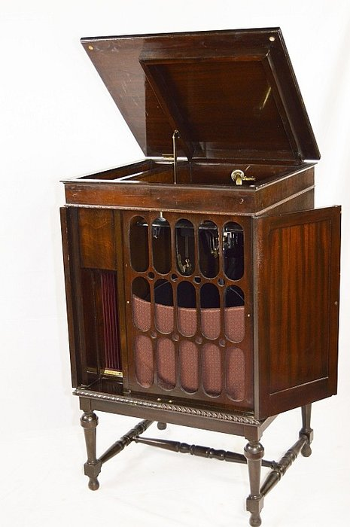
  Schlick1596.jpg [ 88.53 KiB | Viewed 859 times ]
  "You must serve music, because music is so enormous and can envelop you into such a state of perpetual anxiety and torture--but it is our first and main duty"
  -- Maria Callas, 1968 interview.
Top

Damfino59
  Post subject: Re: Inventory of Beethoven and Schubert Edisonic phonographs
  Posted: Tue Jul 22, 2014 8:34 pm
Joined: Thu Feb 14, 2013 8:37 pm  Posts: 233  Location: Stillman Valley, IL
  Victor II
  From what I saw of this Schubert at the sale it was very nice. Slight crazing to the lacquer. I may be wrong but I don't think it was refinished. It was on my list but you can't buy them all!
Top

Previous topic | Next topic

Display posts from previous:  Sort by   

 | Page 9 of 25 | [ 247 posts ] | Go to page Previous 1 ... 6, 7, 8, 9, 10, 11, 12 ... 25 Next

