fran604g
  Post subject: Re: Inventory of Beethoven and Schubert Edisonic phonographs
  Posted: Wed Feb 17, 2016 7:17 am
Joined: Mon Mar 04, 2013 2:22 pm  Posts: 3276  Location: Livonia, NY
  Victor VI
  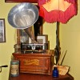
  I'm Feeling Cranky
  phonogfp wrote:
  The Schubert I have here (No.5451) has the same style data plate. It was bought from a descendant of the original owner here in New York State, so it's more likely just a later style plate rather than intended for export.
  George P.
  Thank you George for that observation.
  The question for me now becomes: "When did this (presumably) final version of Diamond Disc Phonograph dataplate occur?"
  An interesting recognition.
  Fran
  Francis; "i" for him, "e" for her
  "Even a blind squirrel finds a nut once in a while" - the unappreciative supervisor.
Top

phonogfp
  Post subject: Re: Inventory of Beethoven and Schubert Edisonic phonographs
  Posted: Wed Feb 17, 2016 12:17 pm
Joined: Wed Jan 07, 2009 5:08 pm  Posts: 6212  Location: New York's Finger Lakes
  Victor Monarch Special
  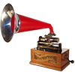
  Who is John Galt?
  fran604g wrote:
  The question for me now becomes: "When did this (presumably) final version of Diamond Disc Phonograph dataplate occur?"
  Fran
  Fran,
  Interestingly, this late data plate has a tiny FORM NUMBER in the upper right-hand corner (pictured below). This interested me because by the late 1920s, Edison form numbers doubled as date codes. I checked some of the Edison literature here, and this is what I found:
  Form No.4848-11-26 was issued in November 1926.
  Form No.41226 was issued in December 1926.
  Form No.4127 was issued in January 1927.
  Form No.4864 - 200M - 4-27 was issued in April 1927.
  Form No.4427 was issued in April 1927.
  Form No.41227 was issued in December 1927.
  Form No.4128 was issued in January 1928.
  As you can see, all of these forms begin with a "4" and I suspect that the form numbers were in the 4000's when a decision was made to stop issuing them in numerical order, and substitute a date code. The "4" seems to have survived merely as a prefix - at least in the monthly supplements.
  This brings us to the late data plates: No.45110.
  If the "4" remains a prefix, then we are left with "5110." If (and that's a big "IF") this is a date code, the only possible date I can deduce is May 11, 1930. That's over 6 months after entertainment Phonograph and record production ceased. However, keep in mind that there was a lot of remaining inventory, and the company was no doubt selling machines and records in 1930.
  Do I think this is a likely scenario? Emphatically - NO. But, based upon prior Edison Form Number practices, it is a possibility that should not be dismissed out of hand.
  I'm open to further suggestions!
  George P.
  P.S.: The patent information is of little use, as the last one was granted 9/21/26 for "Mounting For Diamonds And The Like." It was filed July 6, 1923.
  Attachments:
  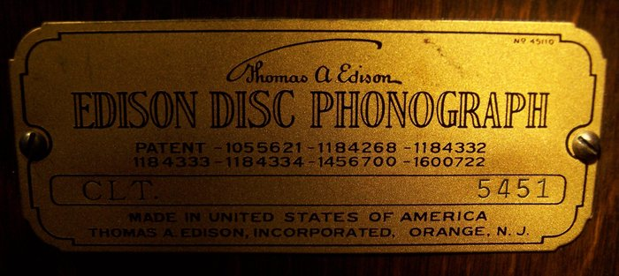
  Schubertdataplate.jpg [ 595.86 KiB | Viewed 1299 times ]
Top

fran604g
  Post subject: Re: Inventory of Beethoven and Schubert Edisonic phonographs
  Posted: Wed Feb 17, 2016 12:50 pm
Joined: Mon Mar 04, 2013 2:22 pm  Posts: 3276  Location: Livonia, NY
  Victor VI
  I'm Feeling Cranky
  George; a very interesting contribution to the discussion!
  I'll have to digest this info, and apply it to some of the documents I have here!
  Fran
  Francis; "i" for him, "e" for her
  "Even a blind squirrel finds a nut once in a while" - the unappreciative supervisor.
Top

pughphonos
  Post subject: Re: Inventory of Beethoven and Schubert Edisonic phonographs
  Posted: Fri Apr 08, 2016 1:30 pm
Joined: Tue Jul 17, 2012 11:35 am  Posts: 670  Location: Homewood, Illinois, USA
  Victor III
  
  "You must serve music"
  NEW OWNER FOR BEETHOVEN EDISONIC #1545
  As documented early last month in this forum's "Yankee Trader" section, Charles Gregory's Beethoven Edisonic (serial no. 1545) was sold by Über-dealer Ron Haring of Plano, Illinois for (I assume) Ron's $1800 asking price--after Ron picked it up for around $1000. Ron, in updating his notice from "FOR SALE" to "SOLD," did not indicate who the new owner is--which is fine of course. If the new owner does not chose to identify himself, at least Ron's transaction resulted in three additional photographs being made public of this particular phonograph, which I am attaching below "for the record" on this thread.
  Ron, I suppose, can answer as to why one knob is missing from the machine (as can be seen in the three photographs he provided)--whereas in late December the machine still had BOTH knobs when illustrated (via four photographs) on-line at "liveauctions.com"--plus two extra reproducers (see this thread, 12/24/2015).
  Attachments:
  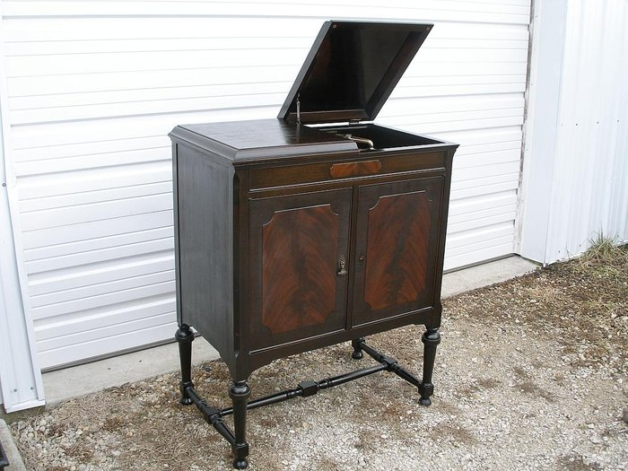
  B20.JPG [ 175.85 KiB | Viewed 1266 times ]
  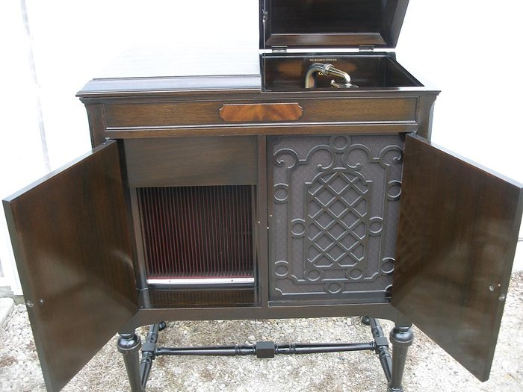
  B13.JPG [ 119.91 KiB | Viewed 1266 times ]
  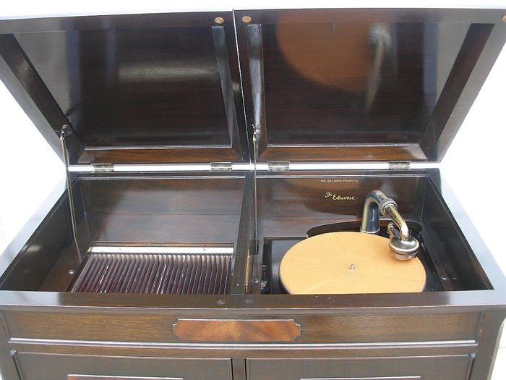
  B8.JPG [ 115 KiB | Viewed 1266 times ]
  "You must serve music, because music is so enormous and can envelop you into such a state of perpetual anxiety and torture--but it is our first and main duty"
  -- Maria Callas, 1968 interview.
Top

pughphonos
  Post subject: Re: Inventory of Beethoven and Schubert Edisonic phonographs
  Posted: Sat Jun 11, 2016 8:57 pm
Joined: Tue Jul 17, 2012 11:35 am  Posts: 670  Location: Homewood, Illinois, USA
  Victor III
  "You must serve music"
  SCHUBERT EDISONIC # 4139 IN RON HARING'S BOOTH AT 2016 UNION SHOW
  I was at the Union show today and see that Ron has a Schubert Edisonic (No. 4139) for sale for $1200.00 that I've never seen mention of before; so another one has come in from the wild. I didn't have a camera device with me; perhaps someone who's going tomorrow (Sunday) will snap some photos.
  It has the Edisonic reproducer on it, plus the long play gearing. Its finish is pretty dull, but it didn't seem to have any scarring, veneer lifting, or any such cosmetic issues.
  "You must serve music, because music is so enormous and can envelop you into such a state of perpetual anxiety and torture--but it is our first and main duty"
  -- Maria Callas, 1968 interview.
Top

pughphonos
  Post subject: Re: Inventory of Beethoven and Schubert Edisonic phonographs
  Posted: Sun Jun 12, 2016 12:43 pm
Joined: Tue Jul 17, 2012 11:35 am  Posts: 670  Location: Homewood, Illinois, USA
  Victor III
  "You must serve music"
  JOHN'S ("RIZBONE'S) SCHUBERT EDISONIC PURCHASED FROM A DEALER IN BOWIE, MARYLAND
  Model: Schubert Edisonic
  Serial number: 4574
  As posted elsewhere on this forum. Currently has an Edisonic reproducer and a lateral adapter. No speed control knob; gun-metal finish; no long play gearing.
  Attachments:
  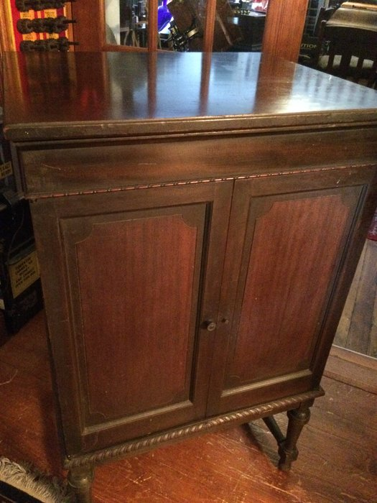
  IMG_0367.JPG [ 1.47 MiB | Viewed 1194 times ]
  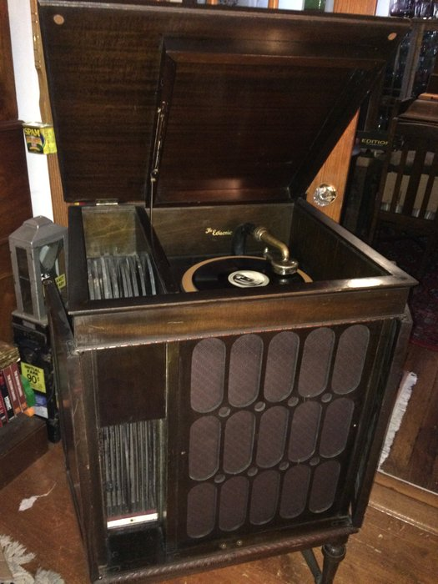
  IMG_0366.JPG [ 1.36 MiB | Viewed 1194 times ]
  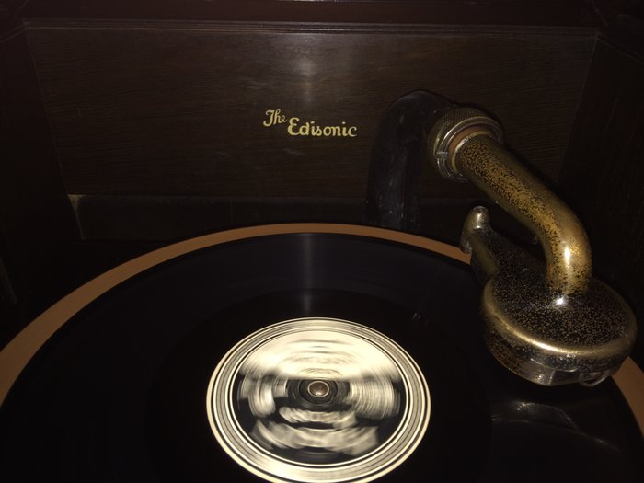
  IMG_0364.JPG [ 1.24 MiB | Viewed 1194 times ]
  "You must serve music, because music is so enormous and can envelop you into such a state of perpetual anxiety and torture--but it is our first and main duty"
  -- Maria Callas, 1968 interview.
Top

fran604g
  Post subject: Re: Inventory of Beethoven and Schubert Edisonic phonographs
  Posted: Sun Jun 12, 2016 1:11 pm
Joined: Mon Mar 04, 2013 2:22 pm  Posts: 3276  Location: Livonia, NY
  Victor VI
  I'm Feeling Cranky
  Looks to be in pretty nice shape!
  Fran
  Francis; "i" for him, "e" for her
  "Even a blind squirrel finds a nut once in a while" - the unappreciative supervisor.
Top

pughphonos
  Post subject: Re: Inventory of Beethoven and Schubert Edisonic phonographs
  Posted: Sun Jun 12, 2016 1:35 pm
Joined: Tue Jul 17, 2012 11:35 am  Posts: 670  Location: Homewood, Illinois, USA
  Victor III
  "You must serve music"
  fran604g wrote:
  Looks to be in pretty nice shape!
  Fran
  Sure does, Fran. You and I sure do love these Plain Jane phonographs.
  As expected, a few more Schuberts are coming out of the wild; we now know of slightly over 50, I believe.
  I've got to bug Ron Haring for photos of his no. 4139 before he sells it. The Union shows ends in around 90 minutes, I believe.
  "You must serve music, because music is so enormous and can envelop you into such a state of perpetual anxiety and torture--but it is our first and main duty"
  -- Maria Callas, 1968 interview.
Top

pughphonos
  Post subject: Re: Inventory of Beethoven and Schubert Edisonic phonographs
  Posted: Mon Jun 13, 2016 10:26 am
Joined: Tue Jul 17, 2012 11:35 am  Posts: 670  Location: Homewood, Illinois, USA
  Victor III
  "You must serve music"
  SCHUBERT EDISONIC FOR SALE ON RENO, NEVADA CRAIGSLIST (CARSON CITY LOCATION) FOR $1200
  Model: Schubert Edisonic
  Serial Number: 1544
  This one has seen better days; missing door knobs; significant work required. Posting contains no information besides two photographs of the cabinet (reproduced here)
  The seller seems to be a nice guy; name is Mike. He responded to my request for the serial number and sent an additional photo of the ID plate (also below).
  http://reno.craigslist.org/atq/5566248534.html
  Attachments:
  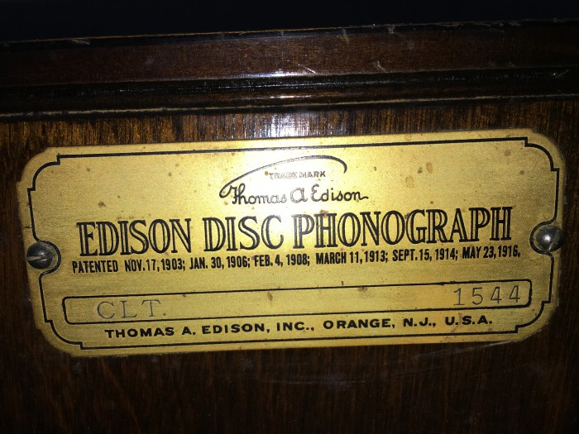
  IMG_0470.JPG [ 3.61 MiB | Viewed 1144 times ]
  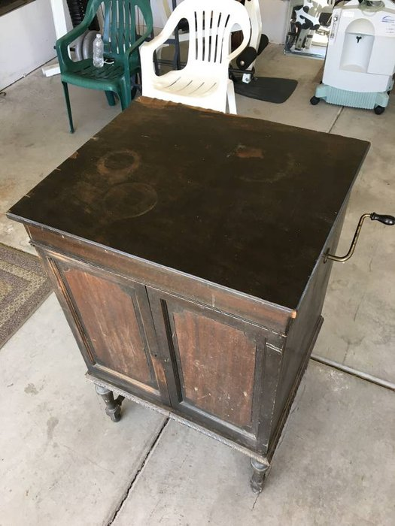
  00C0C_iF0OEOQ8YyC_1200x900.jpg [ 70.19 KiB | Viewed 1159 times ]
  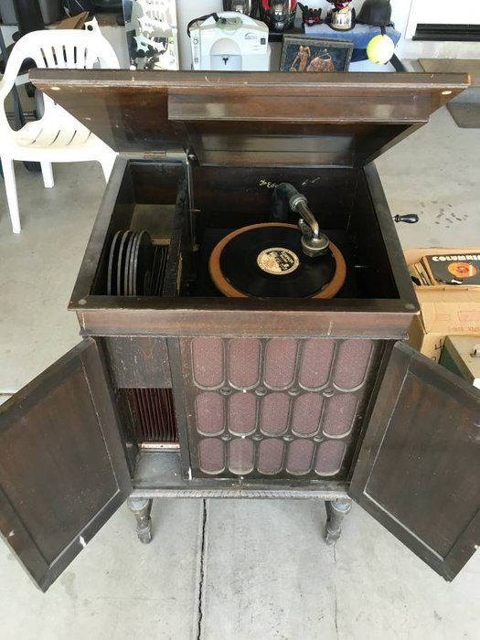
  00s0s_abdmAmON2sU_1200x900.jpg [ 73.76 KiB | Viewed 1159 times ]
  "You must serve music, because music is so enormous and can envelop you into such a state of perpetual anxiety and torture--but it is our first and main duty"
  -- Maria Callas, 1968 interview.
Top

drh
  Post subject: Re: Inventory of Beethoven and Schubert Edisonic phonographs
  Posted: Fri Nov 25, 2016 10:43 pm
Joined: Tue May 27, 2014 11:24 am  Posts: 381
  Victor II
  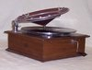
  Heads up, folks, in case it hasn't been otherwise spotted yet: Schubert no. 2501 is up for bids on eBay. http://www.ebay.com/itm/Rare-1920S-Edis ... SwHMJYNLP~
Top

Previous topic | Next topic

Display posts from previous:  Sort by   

 | Page 24 of 25 | [ 247 posts ] | Go to page Previous 1 ... 21, 22, 23, 24, 25 Next

