pughphonos
  Post subject: Re: Inventory of Beethoven and Schubert Edisonic phonographs
  Posted: Mon Jan 25, 2016 7:24 am
Joined: Tue Jul 17, 2012 11:35 am  Posts: 670  Location: Homewood, Illinois, USA
  Victor III
  
  "You must serve music"
  I've finally recorded my Schubert playing a Diamond Disc using one of Larry Hollenberg's diaphragms--installed in its Edisonic reproducer. The visual isn't great, but the audio is what counts and hopefully my little camera shows off his diaphragm to advantage.
  https://www.youtube.com/watch?v=VcZvCDo ... e=youtu.be
  "You must serve music, because music is so enormous and can envelop you into such a state of perpetual anxiety and torture--but it is our first and main duty"
  -- Maria Callas, 1968 interview.
Top

marcapra
  Post subject: Re: Inventory of Beethoven and Schubert Edisonic phonographs
  Posted: Wed Jan 27, 2016 1:27 am
Joined: Wed Jun 27, 2012 11:29 pm  Posts: 1915  Location: Temecula, CA
  Victor IV
  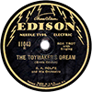
  Man who ride on tiger find it very difficult to dismount! Charlie Chan
  Someone on this forum was looking for some Edisonic type grille cloth. I think I've found some cloth that might serve although it is much more golden in color than the original. It has a very similar diamond pattern.
  http://www.ebay.com/itm/Antique-Radio-Grille-ClothDiamond-Pattern18-X-24-Free-Shipping-/172074600295
Top

Lucius1958
  Post subject: Re: Inventory of Beethoven and Schubert Edisonic phonographs
  Posted: Sun Jan 31, 2016 1:36 am
Joined: Tue Dec 14, 2010 12:17 am  Posts: 3226  Location: Where there's "hamburger ALL OVER the highway"...
  Victor VI
  
  marcapra wrote:
  Someone on this forum was looking for some Edisonic type grille cloth. I think I've found some cloth that might serve although it is much more golden in color than the original. It has a very similar diamond pattern.
  http://www.ebay.com/itm/Antique-Radio-Grille-ClothDiamond-Pattern18-X-24-Free-Shipping-/172074600295
  Looks pretty decent: I've just ordered a piece for my BC-34.
  Bill
Top

Uncle Vanya
  Post subject: Re: Inventory of Beethoven and Schubert Edisonic phonographs
  Posted: Sun Jan 31, 2016 11:06 am
Joined: Sun Oct 25, 2009 11:53 am  Posts: 1257  Location: Michiana
  Victor IV
  I used that cloth back when the pattern was available from John Olkoniwicz. This works well in an Edisonic, but one needs to overdye it with RIT Burgandy and RIT Black (the black in a weak solution). Experiment on scrap pieces of this cloth and remember that Rayon likes a bit of extra vinegar in the solution to set the dye. The cloth will shrink slightly, then it needs to be pressed and sized (Niagra spray starch is good enough, Magic Sizing is another appropriate product).
Top

fran604g
  Post subject: Re: Inventory of Beethoven and Schubert Edisonic phonographs
  Posted: Sun Jan 31, 2016 12:24 pm
Joined: Mon Mar 04, 2013 2:22 pm  Posts: 3276  Location: Livonia, NY
  Victor VI
  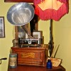
  I'm Feeling Cranky
  Uncle Vanya wrote:
  I used that cloth back when the pattern was available from John Olkoniwicz. This works well in an Edisonic, but one needs to overdye it with RIT Burgandy and RIT Black (the black in a weak solution). Experiment on scrap pieces of this cloth and remember that Rayon likes a bit of extra vinegar in the solution to set the dye. The cloth will shrink slightly, then it needs to be pressed and sized (Niagra spray starch is good enough, Magic Sizing is another appropriate product).
  Great pointers! I was going to do a search to find the answer to that very question, thanks!
  Fran
  Francis; "i" for him, "e" for her
  "Even a blind squirrel finds a nut once in a while" - the unappreciative supervisor.
Top

larryh
  Post subject: Re: Inventory of Beethoven and Schubert Edisonic phonographs
  Posted: Sun Jan 31, 2016 1:15 pm
Joined: Wed Jan 07, 2009 7:44 pm  Posts: 1552
  Victor IV
  Were probably quite a way off topic here but after years of having issues with the cloth becoming saggy looking after I glued them to the grills I came up with a solution that works. I take a piece of plywood larger than the grill it self several inches at least, then I staple the material tightly to it working from the center of the top to the bottom and then pulling it towards the sides which I do last. Then I lay the grill with some glue on the back over it and weight it down. When its dry I take a matt knife and cut the material free from the board and then turning the grill over I remove the excess cloth from that along the edges. So far the ones did that way look nice and taunt a couple of years now.
  Larry
Top

Uncle Vanya
  Post subject: Re: Inventory of Beethoven and Schubert Edisonic phonographs
  Posted: Sun Jan 31, 2016 10:13 pm
Joined: Sun Oct 25, 2009 11:53 am  Posts: 1257  Location: Michiana
  Victor IV
  larryh wrote:
  Were probably quite a way off topic here but after years of having issues with the cloth becoming saggy looking after I glued them to the grills I came up with a solution that works. I take a piece of plywood larger than the grill it self several inches at least, then I staple the material tightly to it working from the center of the top to the bottom and then pulling it towards the sides which I do last. Then I lay the grill with some glue on the back over it and weight it down. When its dry I take a matt knife and cut the material free from the board and then turning the grill over I remove the excess cloth from that along the edges. So far the ones did that way look nice and taunt a couple of years now.
  Larry
  That is really the only way to properly install grille cloth, in either a radio or a phonograph.
  Tape works to strech the cloth, too.
Top

marcapra
  Post subject: Re: Inventory of Beethoven and Schubert Edisonic phonographs
  Posted: Mon Feb 01, 2016 12:23 am
Joined: Wed Jun 27, 2012 11:29 pm  Posts: 1915  Location: Temecula, CA
  Victor IV
  Man who ride on tiger find it very difficult to dismount! Charlie Chan
  Quote:
  I used that cloth back when the pattern was available from John Olkoniwicz. This works well in an Edisonic, but one needs to overdye it with RIT Burgandy and RIT Black (the black in a weak solution). Experiment on scrap pieces of this cloth and remember that Rayon likes a bit of extra vinegar in the solution to set the dye. The cloth will shrink slightly, then it needs to be pressed and sized (Niagra spray starch is good enough, Magic Sizing is another appropriate product).
  I have tried to dye synthetic grille cloth with Rit dye before. I even cooked it on the stove as in the directions, but the cloth never took any of the dye and came out looking just the same. I don't think I added any vinegar though as I don't think that was in the directions. Is that the key? I also applied the old advice to dip your modern grille cloth in coffee, but that never did anything either, so I figured that advice was only if you had genuine silk.
Top

fran604g
  Post subject: Re: Inventory of Beethoven and Schubert Edisonic phonographs
  Posted: Tue Feb 16, 2016 8:20 pm
Joined: Mon Mar 04, 2013 2:22 pm  Posts: 3276  Location: Livonia, NY
  Victor VI
  I'm Feeling Cranky
  [quote="pughphonos"]E-BAY OFFERING AS OF APRIL 22, 2014
  "Designers Consignment" offered a Schubert Edisonic for $599.99, providing photos and the vague description "record turn but needle does not hit." This sale is dragging as the same E-bay posting is still up as of May 14, 2014.
  [b]Model:[/b] Schubert Edisonic
  [b]Serial number:[/b] 5056
  http://www.ebay.com/itm/1-Rare-Amazing- ... 000wt_1200
  NOTE: The posting above is confusing. It is selling as #3695, but that must be some sort of store lot number as one of the photos is of the ID tag and it clearly shows serial number 5056.
  NOTE: A previous owner was Michael Malloy, who posted about this machine on the Online Edison Phonograph Discussion Board on July 17, 2012: "Hello, I just joined the forum. I have what I am 95% sure is a Edisonic Schubert with a serial # of CLT 5056. It was repaired at some point very poorly. I was wondering if any one could send me a photo of what the lid support arm apparatus should look like. I'm trying to repair it currently.
  Thank You, Michael Malloy."[/quote]
  Hi folks,
  I was reaquaining myself with Ralph's post, and noticed this very unusual dataplate.
  I assume it was on an export machine, can anyone otherwise explain it?
  Best,
  Fran
  Attachments:
  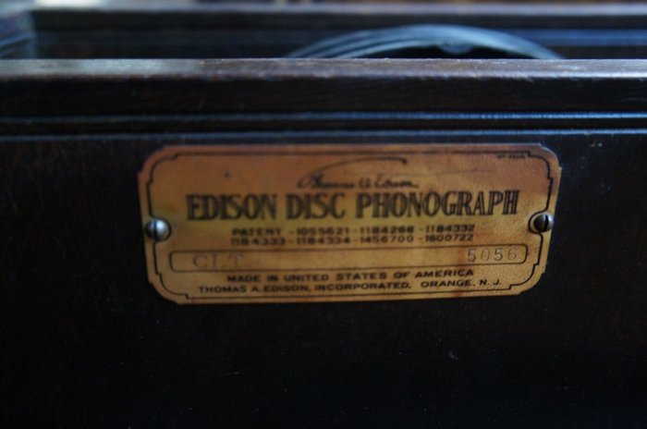
  %24T2eC16dHJGoFFvNw2n%28%2CBSLeH9nw%2Cw--60_57.jpg [ 37.94 KiB | Viewed 1029 times ]
  Francis; "i" for him, "e" for her
  "Even a blind squirrel finds a nut once in a while" - the unappreciative supervisor.
Top

phonogfp
  Post subject: Re: Inventory of Beethoven and Schubert Edisonic phonographs
  Posted: Tue Feb 16, 2016 10:06 pm
Joined: Wed Jan 07, 2009 5:08 pm  Posts: 6212  Location: New York's Finger Lakes
  Victor Monarch Special
  
  Who is John Galt?
  The Schubert I have here (No.5451) has the same style data plate. It was bought from a descendant of the original owner here in New York State, so it's more likely just a later style plate rather than intended for export.
  George P.
Top

Previous topic | Next topic

Display posts from previous:  Sort by   

 | Page 23 of 25 | [ 247 posts ] | Go to page Previous 1 ... 20, 21, 22, 23, 24, 25 Next

