fran604g
  Post subject: Re: Inventory of Beethoven and Schubert Edisonic phonographs
  Posted: Thu Dec 24, 2015 12:27 pm
Joined: Mon Mar 04, 2013 2:22 pm  Posts: 3276  Location: Livonia, NY
  Victor VI
  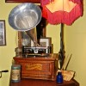
  I'm Feeling Cranky
  Ralph, how I would love the "Elizabethan" Art model listed with these two Edisonics! RIP Mr. Gregory, I wish I could have met him (and the ever-growing list of fine folks leaving us too soon).
  Merry Christmas my friend,
  Fran
  Francis; "i" for him, "e" for her
  "Even a blind squirrel finds a nut once in a while" - the unappreciative supervisor.
Top

pughphonos
  Post subject: Re: Inventory of Beethoven and Schubert Edisonic phonographs
  Posted: Thu Dec 24, 2015 12:56 pm
Joined: Tue Jul 17, 2012 11:35 am  Posts: 670  Location: Homewood, Illinois, USA
  Victor III
  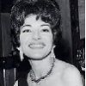
  "You must serve music"
  fran604g wrote:
  Ralph, how I would love the "Elizabethan" Art model listed with these two Edisonics! RIP Mr. Gregory, I wish I could have met him (and the ever-growing list of fine folks leaving us too soon).
  Merry Christmas my friend,
  Fran
  Yes--a truly stunning machine.
  This time of year puts us in mind of loved ones lost. But as someone told me recently, "the only way to avoid being a survivor is to go first." I'll take a pass on that--and so, 2016, bring it on!
  Merry Christmas to you as well, Fran.
  "You must serve music, because music is so enormous and can envelop you into such a state of perpetual anxiety and torture--but it is our first and main duty"
  -- Maria Callas, 1968 interview.
Top

pughphonos
  Post subject: Re: Inventory of Beethoven and Schubert Edisonic phonographs
  Posted: Sat Jan 02, 2016 7:04 pm
Joined: Tue Jul 17, 2012 11:35 am  Posts: 670  Location: Homewood, Illinois, USA
  Victor III
  "You must serve music"
  NEW OWNER FOR SCHUBERT EDISONIC SERIAL NO. 1556
  I (Ralph) have decided to let Schubert no. 1556 go; it's the one I obtained from Gene Emering last year. I mainly wanted it for its original grille cloth and Edisonic reproducer--which are now on my main Schubert (serial no. 3621). No. 1556 still has potential though; runs wonderfully on a single spring and one can tell the cabinet will restore nicely in skilled hands. It now belongs to Mike Wohl of Peoria, Illinois--who picked it up today. Mike has the heart of a rescuer/restorationist and I'm sure no. 1556 will re-emerge into public view in due course in great form.
  "You must serve music, because music is so enormous and can envelop you into such a state of perpetual anxiety and torture--but it is our first and main duty"
  -- Maria Callas, 1968 interview.
Top

colmike1
  Post subject: Re: Inventory of Beethoven and Schubert Edisonic phonographs
  Posted: Sat Jan 02, 2016 8:59 pm
Joined: Thu Feb 26, 2015 8:27 pm  Posts: 404  Location: Peoria, IL
  Victor II
  Thank you, Ralph, for entrusting me with this wonderful old phonograph. I will do my best to bring it back to its former glory.
Top

marcapra
  Post subject: Re: Inventory of Beethoven and Schubert Edisonic phonographs
  Posted: Sat Jan 02, 2016 9:11 pm
Joined: Wed Jun 27, 2012 11:29 pm  Posts: 1915  Location: Temecula, CA
  Victor IV
  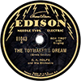
  Man who ride on tiger find it very difficult to dismount! Charlie Chan
  That is a fine Beethoven that the late Mr. Gregory had! I heard it sold for just $900. That's a bargain to me! Do we know who the new owner is? Marc.
Top

DGPros
  Post subject: Re: Inventory of Beethoven and Schubert Edisonic phonographs
  Posted: Sat Jan 02, 2016 11:07 pm
Joined: Sun Apr 01, 2012 10:22 am  Posts: 497  Location: Whitehouse St. NJ
  Victor II
  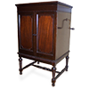
  Gary
  marcapra wrote:
  That is a fine Beethoven that the late Mr. Gregory had! I heard it sold for just $900. That's a bargain to me! Do we know who the new owner is? Marc.
  Does anyone know what all 3 of his sold for and is that # with the 18%? I would love to know what the Elizabethan went for if nothing else.
  In short, is not liberty the freedom of every person to make full use of his faculties, so long as he does not harm other persons while doing so?
  Frederic Bastiat
Top

marcapra
  Post subject: Re: Inventory of Beethoven and Schubert Edisonic phonographs
  Posted: Sun Jan 03, 2016 12:32 am
Joined: Wed Jun 27, 2012 11:29 pm  Posts: 1915  Location: Temecula, CA
  Victor IV
  Man who ride on tiger find it very difficult to dismount! Charlie Chan
  I was told that the Beethoven sold for $900 and the Schubert for $400. Plus you would have to add the 18% premium, which would make the Beethoven actually $1062 and the Schubert $472, plus shipping of course. The Edison Elizabethan, with a starting bid of $4000, did not sell.
Top

pughphonos
  Post subject: Re: Inventory of Beethoven and Schubert Edisonic phonographs
  Posted: Sun Jan 17, 2016 7:46 pm
Joined: Tue Jul 17, 2012 11:35 am  Posts: 670  Location: Homewood, Illinois, USA
  Victor III
  "You must serve music"
  STATUS REPORT FOR SCHUBERT SERIAL NO. 3621
  Hi all,
  After owning Schubert serial no. 3621 for a couple years, I've finally come to an end-point in terms of upgrades and restoration--and am now posting photos below. In my humble estimation, my Schubert is the nicest-looking and nicest-sounding of all the known survivors. Nicest-sounding, due to Larry Hollenberg's diaphragms. Nicest-looking, due to several folks who did great restoration work.
  I paid a sizable sum to a museum-quality textile restoration shop to have my grill cloth (which originally was on Schubert serial no. 1556) cleaned, mended, and backed by a dark piece of silk to give it strength for the years to come.
  As for the wood tone contrasts on the doors, I asked for a pretty definite contrast--with the reddish interior panels being definitely reddish! We of course will never know for sure what the contrast was when these machines were new in 1927-29, but this is what I opted for.
  Once I get busy again on You Tube I will post some examples of this phonograph's sound.
  Ralph
  Attachments:
  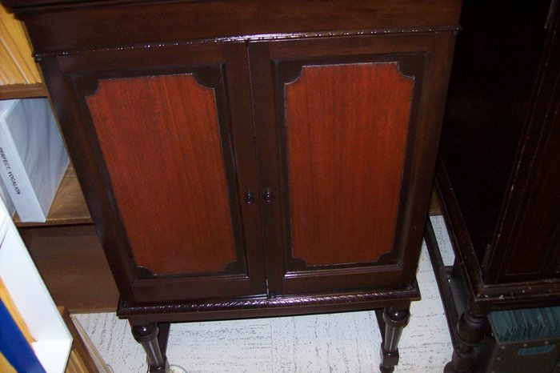
  schubert2 002.JPG [ 875.34 KiB | Viewed 847 times ]
  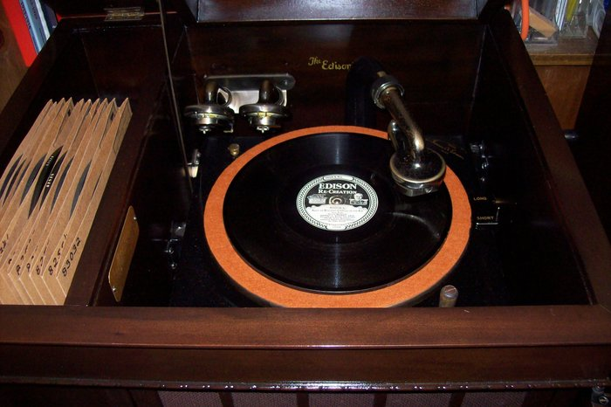
  Schubert 003.JPG [ 871.59 KiB | Viewed 858 times ]
  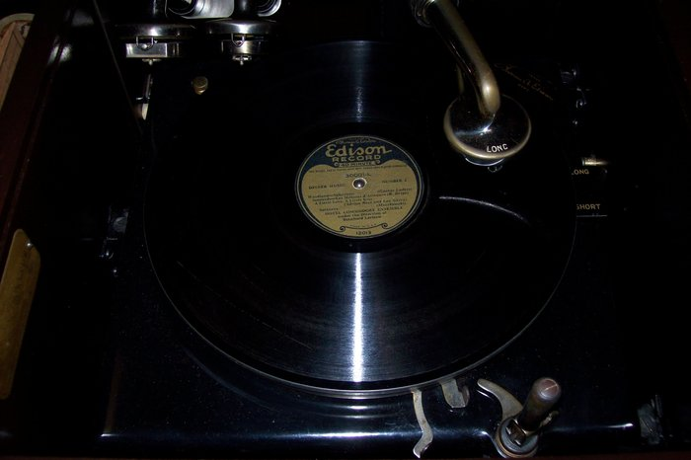
  Schubert 006.JPG [ 1011.25 KiB | Viewed 858 times ]
  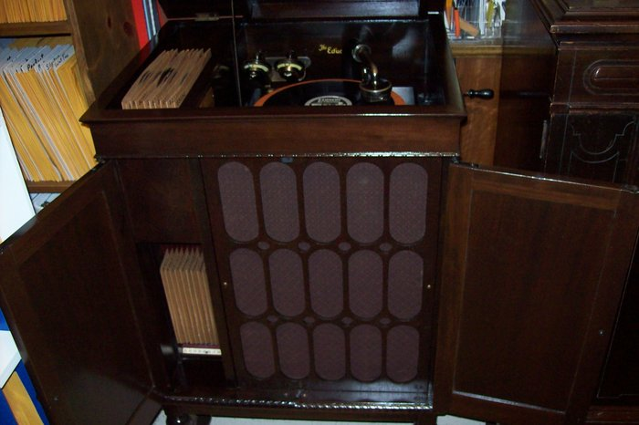
  Schubert 002.JPG [ 880.36 KiB | Viewed 858 times ]
  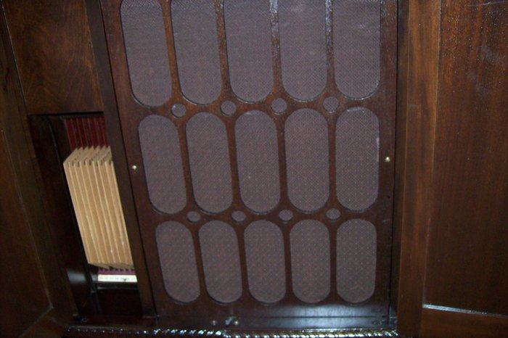
  Schubert 001.JPG [ 776.04 KiB | Viewed 858 times ]
  "You must serve music, because music is so enormous and can envelop you into such a state of perpetual anxiety and torture--but it is our first and main duty"
  -- Maria Callas, 1968 interview.
  Last edited by pughphonos on Sun Jan 17, 2016 9:42 pm, edited 1 time in total.
Top

fran604g
  Post subject: Re: Inventory of Beethoven and Schubert Edisonic phonographs
  Posted: Sun Jan 17, 2016 8:25 pm
Joined: Mon Mar 04, 2013 2:22 pm  Posts: 3276  Location: Livonia, NY
  Victor VI
  I'm Feeling Cranky
  Congrats, Ralph! She looks beautiful.
  Fran
  Francis; "i" for him, "e" for her
  "Even a blind squirrel finds a nut once in a while" - the unappreciative supervisor.
Top

pughphonos
  Post subject: Re: Inventory of Beethoven and Schubert Edisonic phonographs
  Posted: Sun Jan 17, 2016 9:51 pm
Joined: Tue Jul 17, 2012 11:35 am  Posts: 670  Location: Homewood, Illinois, USA
  Victor III
  "You must serve music"
  fran604g wrote:
  Congrats, Ralph! She looks beautiful.
  Fran
  Thanks, Fran. This machine has given me so much joy; I have to remind myself to listen to the Victrola once in awhile.
  It's also good I'm done fussing with this machine as a good friend of mine (who's an antique phonograph collector and restorer) is working on resurrecting my Pathé Sheraton model 27. The thread I've started on that project should jump back to life in the next few weeks.
  "You must serve music, because music is so enormous and can envelop you into such a state of perpetual anxiety and torture--but it is our first and main duty"
  -- Maria Callas, 1968 interview.
Top

Previous topic | Next topic

Display posts from previous:  Sort by   

 | Page 22 of 25 | [ 247 posts ] | Go to page Previous 1 ... 19, 20, 21, 22, 23, 24, 25 Next

