fran604g
  Post subject: Re: Inventory of Beethoven and Schubert Edisonic phonographs
  Posted: Fri Dec 11, 2015 4:58 pm
Joined: Mon Mar 04, 2013 2:22 pm  Posts: 3276  Location: Livonia, NY
  Victor VI
  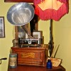
  I'm Feeling Cranky
  pughphonos wrote:
  fran604g wrote:
  Hi folks,
  In anticipation of new respondents to this inventory, I would ask that people please go to our more comprehensive survey.
  It can be found here: http://forum.talkingmachine.info/viewtopic.php?f=2&t=24028.
  Fran
  I'd just add one edit, Fran: "...that people ALSO go to our more comprehensive survey." For this (my) thread is very much alive and offers a place for photos and anecdotes whereby the Edisonics and their ownership histories can be tracked.
  As to which thread is "more comprehensive," that's in the eye of the beholder.
  Vive la difference....
  Happy Holidays to all as well --
  Ralph
  You're right of course Ralph. My apologies, I meant no disrespect, and in retrospect, I had meant to pass this by you first, and neglected to do that.
  I truly am sorry for my short-sightedness.
  I just finished sending personal messages to those respondents here; next, I will go through the units you've posted yourself (there are many!) and add them to the spreadsheet. If you wish, I will send you a copy of it, then you can follow along, with the survey if you please.
  Best,
  Fran
  Francis; "i" for him, "e" for her
  "Even a blind squirrel finds a nut once in a while" - the unappreciative supervisor.
Top

pughphonos
  Post subject: Re: Inventory of Beethoven and Schubert Edisonic phonographs
  Posted: Fri Dec 11, 2015 5:05 pm
Joined: Tue Jul 17, 2012 11:35 am  Posts: 670  Location: Homewood, Illinois, USA
  Victor III
  
  "You must serve music"
  fran604g wrote:
  pughphonos wrote:
  fran604g wrote:
  Hi folks,
  In anticipation of new respondents to this inventory, I would ask that people please go to our more comprehensive survey.
  It can be found here: http://forum.talkingmachine.info/viewtopic.php?f=2&t=24028.
  Fran
  I'd just add one edit, Fran: "...that people ALSO go to our more comprehensive survey." For this (my) thread is very much alive and offers a place for photos and anecdotes whereby the Edisonics and their ownership histories can be tracked.
  As to which thread is "more comprehensive," that's in the eye of the beholder.
  Vive la difference....
  Happy Holidays to all as well --
  Ralph
  You're right of course Ralph. My apologies, I meant no disrespect, and in retrospect, I had meant to pass this by you first, and neglected to do that.
  I truly am sorry for my short-sightedness.
  I just finished sending personal messages to those respondents here; next, I will go through the units you've posted yourself (there are many!) and add them to the spreadsheet. If you wish, I will send you a copy of it, then you can follow along, with the survey if you please.
  Best,
  Fran
  Sounds like a good plan. The more the merrier, as I said earlier; the thrusts of your survey and my inventory are somewhat different and both can (and will) co-exist.
  As I also said earlier, people on this forum are just going to have to get used to seeing TWO Edisonic-themed threads going on.
  Ralph
  "You must serve music, because music is so enormous and can envelop you into such a state of perpetual anxiety and torture--but it is our first and main duty"
  -- Maria Callas, 1968 interview.
Top

fran604g
  Post subject: Re: Inventory of Beethoven and Schubert Edisonic phonographs
  Posted: Sun Dec 13, 2015 11:16 am
Joined: Mon Mar 04, 2013 2:22 pm  Posts: 3276  Location: Livonia, NY
  Victor VI
  I'm Feeling Cranky
  Yes! Two sides of the same coin.
  Fran
  Francis; "i" for him, "e" for her
  "Even a blind squirrel finds a nut once in a while" - the unappreciative supervisor.
Top

DGPros
  Post subject: Re: Inventory of Beethoven and Schubert Edisonic phonographs
  Posted: Tue Dec 22, 2015 7:30 pm
Joined: Sun Apr 01, 2012 10:22 am  Posts: 497  Location: Whitehouse St. NJ
  Victor II
  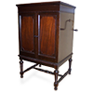
  Gary
  http://www.liveauctioneers.com/item/429 ... phonograph
  http://www.liveauctioneers.com/item/429 ... phonograph
  I just came across these. They are from Charles Gregory estate. There's also this Elizabethan for those interested
  http://www.liveauctioneers.com/item/429 ... phonograph
  In short, is not liberty the freedom of every person to make full use of his faculties, so long as he does not harm other persons while doing so?
  Frederic Bastiat
Top

pughphonos
  Post subject: Re: Inventory of Beethoven and Schubert Edisonic phonographs
  Posted: Tue Dec 22, 2015 11:22 pm
Joined: Tue Jul 17, 2012 11:35 am  Posts: 670  Location: Homewood, Illinois, USA
  Victor III
  "You must serve music"
  DGPros wrote:
  http://www.liveauctioneers.com/item/42956761_edison-beethoven-phonograph
  http://www.liveauctioneers.com/item/429 ... phonograph
  I just came across these. They are from Charles Gregory estate. There's also this Elizabethan for those interested
  http://www.liveauctioneers.com/item/429 ... phonograph
  Great discovery, Gary! Two Edisonics that were off most people's radars for a long while; both machines not even reported in the 1987 Amberola Graphic.
  I'll transfer the info and pictures to this thread in a day or two.
  "You must serve music, because music is so enormous and can envelop you into such a state of perpetual anxiety and torture--but it is our first and main duty"
  -- Maria Callas, 1968 interview.
Top

pughphonos
  Post subject: Re: Inventory of Beethoven and Schubert Edisonic phonographs
  Posted: Thu Dec 24, 2015 11:08 am
Joined: Tue Jul 17, 2012 11:35 am  Posts: 670  Location: Homewood, Illinois, USA
  Victor III
  "You must serve music"
  BEETHOVEN NO. 1545 ON LIVEAUCTIONS.COM IN DECEMBER 2015
  Model: Beethoven Edisonic
  Serial number: 1545
  Below for the record is the description on this machine as posted on liveauctions.com; also am posting some of the photographs provided.
  "An Edison "Beethoven" model "The Edisonic" Diamond Disc phonograph in a Mahogany case. Serial number "BN 1545". Original finish with only minor wear. Includes two extra Reproducers, one in the box, and a Diamond Disc record. 37 x 21 x 44 ½" high. ESTIMATE $1,000-2,000 ex collection Charles E. Gregory, Melvindale, Michigan."
  Attachments:
  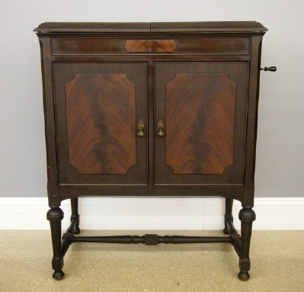
  42956761_1_l.jpg [ 24.62 KiB | Viewed 669 times ]
  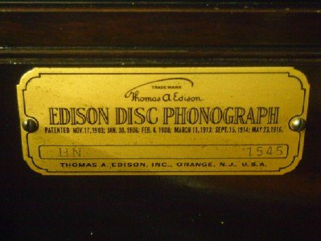
  42956761_5_l.jpg [ 24.43 KiB | Viewed 669 times ]
  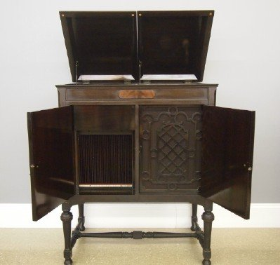
  42956761_2_l.jpg [ 23.06 KiB | Viewed 669 times ]
  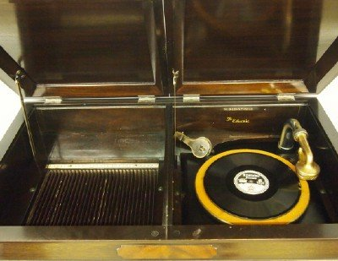
  42956761_3_l.jpg [ 29.31 KiB | Viewed 669 times ]
  "You must serve music, because music is so enormous and can envelop you into such a state of perpetual anxiety and torture--but it is our first and main duty"
  -- Maria Callas, 1968 interview.
Top

pughphonos
  Post subject: Re: Inventory of Beethoven and Schubert Edisonic phonographs
  Posted: Thu Dec 24, 2015 11:16 am
Joined: Tue Jul 17, 2012 11:35 am  Posts: 670  Location: Homewood, Illinois, USA
  Victor III
  "You must serve music"
  SCHUBERT NO. 1922 ON LIVEAUCTIONS.COM IN DECEMBER 2015
  Model: Schubert Edisonic
  Serial number: 1922
  Below for the record is the description on this machine as posted on liveauctions.com; also am posting some of the photographs provided.
  "An Edison "Schubert" model "The Edisonic" Diamond Disc phonograph in a Mahogany case. Originally sold by "F. J. Bagley, Dertoit, Mich.". Serial number "CLT 1922". Original finish with some surface wear, lacks interior wood bezel from around the turntable. Includes an extra Reproducer, and a Diamond Disc record. 24 x 21 x 39 ¾" high. ESTIMATE $600-800 ex collection Charles E. Gregory, Melvindale, Michigan."
  Attachments:
  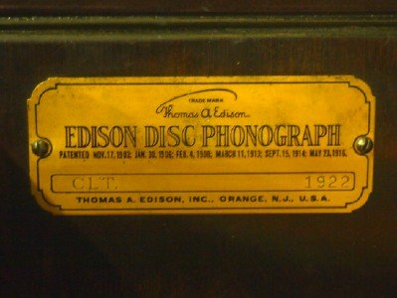
  42956765_4_l.jpg [ 23.36 KiB | Viewed 667 times ]
  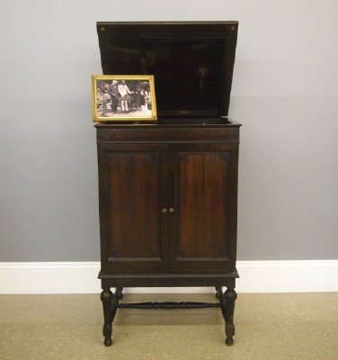
  42956765_1_l.jpg [ 19.27 KiB | Viewed 667 times ]
  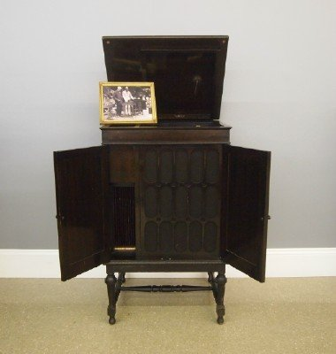
  42956765_2_l.jpg [ 19.86 KiB | Viewed 667 times ]
  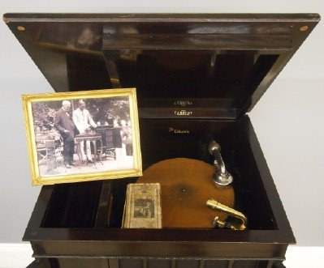
  42956765_3_l.jpg [ 26.22 KiB | Viewed 667 times ]
  "You must serve music, because music is so enormous and can envelop you into such a state of perpetual anxiety and torture--but it is our first and main duty"
  -- Maria Callas, 1968 interview.
Top

barnettrp21122
  Post subject: Re: Inventory of Beethoven and Schubert Edisonic phonographs
  Posted: Thu Dec 24, 2015 11:26 am
Joined: Thu Jan 08, 2009 4:19 pm  Posts: 1433
  Victor IV
  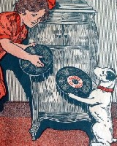
  "Did you ever stop to think that pleasure is a duty?" (Victor sales pamphlet)
  Regarding the Schubert above, in case anyone's following this auction-
  Quote from auction description:
  "lacks interior wood bezel from around the turntable"
  The Schubert model never had the wood bezel, so nothing's apparently missing. I'd still recommend contacting the seller for any further details if bidding online, just to be safe.
  Bob
  "Comparison is the thief of joy" Theodore Roosevelt
Top

pughphonos
  Post subject: Re: Inventory of Beethoven and Schubert Edisonic phonographs
  Posted: Thu Dec 24, 2015 11:29 am
Joined: Tue Jul 17, 2012 11:35 am  Posts: 670  Location: Homewood, Illinois, USA
  Victor III
  "You must serve music"
  UPDATED INDEX (AS OF DECEMBER 24, 2015) TO POSTINGS:
  SERIAL NUMBERS of machines posted above (and some below), arranged in order (with dates of posting):
  BEETHOVEN EDISONICS:
  1049 (11/13/2015 & 11/15/2015); 1121 (4/30/2014); 1150 (4/25/2014);
  1200 (03/8/2015); 1220 (4/25/2014); 1238 (4/29/2014);
  1262 (4/25/2014); 1316 (4/25/2014 & 9/1/2015 & 11/15/2015);
  1545 (12/24/2015); 1757 (4/25/2014 & 11/19/2015); 1853 (4/23/2014);
  1898 (4/21/2014); 1977 (6/20/2014 & 7/1/2014 & 4/6/2015 & 6/4/2015 & 8/6/2015);
  2036 (4/25/2014); 2157 (4/22/2014); 2292? (4/21/2014); 2488 (5/1/2014);
  2491 (7/12/2014 & 6/2/2015); 2641 (5/14/2014)
  SCHUBERT EDISONICS:
  1020 (6/2/2015); 1108 (8/7/2015); 1150 (4/25/2014); 1187 (4/24/2014);
  1216 (4/25/2014, 4/26/2014 & 5/4/2014); 1217 (4/28/2014 & 5/4/2014);
  1246 (4/21/2014); 1329 (5/1/2014 & 05/6/2014); 1394 (4/25/2014);
  1441 (4/25/2014); 1537 (6/5/2015); 1556 (4/22/2014 & 5/2/2015 & ½/2016);
  1596 (7/22/2014); 1656 (4/25/2014); 1672 (7/30/2014);
  1765 (4/23/2015 & 4/25/2015); 1844 (3/11/2015 & 5/3/2015 & 9/17/2015);
  1897 (5/14/2014); 1902 (4/22/2014); 1913 (4/25/2014);
  1922 (12/24/2015); 1958 (4/27/2014 & 11/8/2015 & 11/15/2015);
  2002 (4/25/2014); 2010 (4/28/2014); 2058 (4/25/2014);
  2288 (4/22/2014 & 5/1/2014); 2673 (4/24/2014 & 5/29/2014);
  2723 (4/23/2014); 2773 (9/1/2015); 2982 (4/25/2014);
  3020 (4/22/2014 & 10/18/2015); 3023 (4/25/2014); 3398 (4/21/2014);
  3618 (4/21/2014); 3621 (5/18/2014); 3675 (4/21/2014);
  3835 (6/4/2015 & 11/30/2015); 3919 (7/7/2014); 4005 (4/22/2014);
  4129 (4/22/2014); 4157 (8/4/2015 & 9/1/2015); 4246 (4/25/2014);
  4484 (4/25/2014); 4752 (4/21/2014); 4869 (4/29/2014);
  5056 (4/22/2014 & 5/23/2014); 5451 (10/15/2015 & 10/17/2015);
  5653 (4/21/2014); 5670 (05/6/2014 & 5/19/2014);
  5678 (4/28/2014 & 8/8/2015); 6025 (4/30/2014 & 6/21/2014)
  +++++++++++++++++++++++++++++++++++++++++++++++++++++++++++++++++++++++++++++++++++++++++++++++
  NON-SERIAL NUMBER DESIGNATION SYSTEM
  As stated at the start of this thread, it is preferred first and foremost that we list information on machines using serial numbers.
  However, in the case of old/inactive on-line listings where serial numbers were not provided and there is no current contact information, I have devised the following designation system whereby we can record information from these listings. It is not a perfect system as the same machines might appear again in listings from other localities. But it will still add to our knowledge base by enabling us to capture unique images and information on particular machines as they work their way through listings. If, in future, we can gain serial numbers for any of these machines, I will link the serial number to the old listings.
  For example, in 2013 I contacted a Craigslist seller in Minnesota who had a Schubert; he would not sell it to me as I could not arrange a local pick-up. I do not know what has since happened with that machine. But I still have the description from 2013. My temporary designation for that machine (so that I can post it here) is USMN2013MAY19.
  How to create a non-serial number designation. For old US postings, use US and then the US state postal code (in this case, MN=Minnesota), followed immediately by the original date of posting. For old foreign postings, spell out the full country name and then the original date of posting: e.g. FRANCE2012JANUARY31.
  The following entries are arranged chronologically by original posting dates:
  BEETHOVEN EDISONICS:
  USMI2007NOVEMBER9 (4/27/2014); US2010DECEMBER19 (5/3/2014)
  SCHUBERT EDISONICS:
  USNJ1997NOVEMBER15 (5/7/2014); AUSTRALIA1997NOVEMBER20 (5/1/2014);
  USNY2005 (5/2/2014); GERMANY2006 (4/25/2014);
  USMD2006JULY7 (4/24/2014 & 5/29/2014--SEE Serial #2673);
  USPA2007 (5/1/2014); USMI2007NOVEMBER9 (4/27/2014); USIL2008JUNE16 (4/27/2014--SEE Serial #1958);
  USIL2010JUNE12(4/24/2014); NEW ZEALAND2012MAY3 (4/25/2014);
  USWA2013MARCH17 (5/1/2014); USMN2013MAY19 (4/23/2013);
  USGA2013AUGUST8 (4/25/2014); USNY2015SEP (10/15/2015 & 10/17/2015—SEE Serial #5451)
  +++++++++++++++++++++++++++++++++++++++++++++++++++++++++++++++++++++++++++++++++++++++++++++
  FINALLY, "YOU TUBE" VIDEOS OF UNIDENTIFIED EDISONICS AND THEIR UNIDENTIFIED OWNERS
  (see posting dated 4/30/2014 for details and links)
  Number of BEETHOVEN EDISONICS portrayed: 0
  Number of SCHUBERT EDISONICS portrayed: 2
  ("Classy8888" has since been identified as Ian Griggs, who owns #6025)
  ("Chagall56" has since been identified as our own "Marcapra"--and he reveals that the Schubert filmed is #1246)
  "You must serve music, because music is so enormous and can envelop you into such a state of perpetual anxiety and torture--but it is our first and main duty"
  -- Maria Callas, 1968 interview.
  Last edited by pughphonos on Sat Jan 02, 2016 7:05 pm, edited 1 time in total.
Top

pughphonos
  Post subject: Re: Inventory of Beethoven and Schubert Edisonic phonographs
  Posted: Thu Dec 24, 2015 11:33 am
Joined: Tue Jul 17, 2012 11:35 am  Posts: 670  Location: Homewood, Illinois, USA
  Victor III
  "You must serve music"
  barnettrp21122 wrote:
  Regarding the Schubert above, in case anyone's following this auction-
  Quote from auction description:
  "lacks interior wood bezel from around the turntable"
  The Schubert model never had the wood bezel, so nothing's apparently missing. I'd still recommend contacting the seller for any further details if bidding online, just to be safe.
  Bob
  Bob is spot on: Schuberts didn't have the wood bezel--and people should check for further details.
  Didn't want Bob's message to get buried as I just did a re-post of the index. Happy holidays to all!
  "You must serve music, because music is so enormous and can envelop you into such a state of perpetual anxiety and torture--but it is our first and main duty"
  -- Maria Callas, 1968 interview.
Top

Previous topic | Next topic

Display posts from previous:  Sort by   

 | Page 21 of 25 | [ 247 posts ] | Go to page Previous 1 ... 18, 19, 20, 21, 22, 23, 24, 25 Next

Board index » Talking Machines & Music » Machines
All times are UTC - 5 hours

Who is online
Users browsing this forum: 52089, Adam_G, Bing [Bot], Google [Bot], LtFrenchFries, pughphonos and 7 guests

