phonogfp
  Post subject: Re: Inventory of Beethoven and Schubert Edisonic phonographs
  Posted: Fri Nov 13, 2015 1:21 pm
Joined: Wed Jan 07, 2009 5:08 pm  Posts: 6212  Location: New York's Finger Lakes
  Victor Monarch Special
  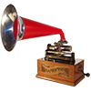
  Who is John Galt?
  Hi Ralph,
  I note that Schubert No.5451 does not appear in your serial number listing, although the number was shared on Oct. 17, 2015. It is referenced under the posting date chronology.
  George P.
Top

pughphonos
  Post subject: Re: Inventory of Beethoven and Schubert Edisonic phonographs
  Posted: Fri Nov 13, 2015 3:45 pm
Joined: Tue Jul 17, 2012 11:35 am  Posts: 670  Location: Homewood, Illinois, USA
  Victor III
  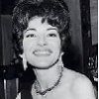
  "You must serve music"
  phonogfp wrote:
  Hi Ralph,
  I note that Schubert No.5451 does not appear in your serial number listing, although the number was shared on Oct. 17, 2015. It is referenced under the posting date chronology.
  George P.
  Thanks for catching that, George! It's now corrected.
  This would be a nice opportunity to tell my fellow Edisonic owners that I'm about move one of my two Schubert Edisonics (in this case, serial #1556) into a public space. I'm the University Archivist at the Illinois Institute of Technology, where we have a reading room area and some floor space for displaying 3-d items. I'm developing something of a music archives, and have decided to loan that machine to the department so that I can introduce new generations to hand-crank disc machines.
  Ralph
  "You must serve music, because music is so enormous and can envelop you into such a state of perpetual anxiety and torture--but it is our first and main duty"
  -- Maria Callas, 1968 interview.
Top

Kirkwood
  Post subject: Re: Inventory of Beethoven and Schubert Edisonic phonographs
  Posted: Sat Nov 14, 2015 11:09 pm
Joined: Sat Jan 17, 2009 4:17 pm  Posts: 345
  Victor II
  I'm thinking the Edisonic I just bought November 5th is the same machine that had been owned by the late Sharon Maurer, a.k.a. "3victrolas" of Berryville VA. The distinctive angled grain pattern of the right hand door, the nominal fading of the grill cloth only at the bottom, and the proximity of the auction to Berryville all lead me to the irresistible conclusion that this is the same machine. So Edisonic "USIL2008June16" may have been located after all?
  This same auction had a number of other machines being sold, likely those were Sharon's as well. The Orthophonic Victrola Revere model I got at this same auction is almost certainly from her collection. The Wurlitzer dealer's tag is placed off-center above the Victrola data plate inside the playing compartment. I was trying to show a co-worker what a Revere looked like and---via Google image searches---came across her old posts on another board showing this very machine. The dealer that attended the sale and bid on my behalf isn't a collector, so the details of what other machines were sold (there were several nice ones) and for how much were sketchy at best, except he noted that the phonograph prices were---in his opinion---generally low.
Top

pughphonos
  Post subject: Re: Inventory of Beethoven and Schubert Edisonic phonographs
  Posted: Sun Nov 15, 2015 3:19 am
Joined: Tue Jul 17, 2012 11:35 am  Posts: 670  Location: Homewood, Illinois, USA
  Victor III
  "You must serve music"
  Kirkwood wrote:
  I'm thinking the Edisonic I just bought November 5th is the same machine that had been owned by the late Sharon Maurer, a.k.a. "3victrolas" of Berryville VA. The distinctive angled grain pattern of the right hand door, the nominal fading of the grill cloth only at the bottom, and the proximity of the auction to Berryville all lead me to the irresistible conclusion that this is the same machine. So Edisonic "USIL2008June16" may have been located after all?
  This same auction had a number of other machines being sold, likely those were Sharon's as well. The Orthophonic Victrola Revere model I got at this same auction is almost certainly from her collection. The Wurlitzer dealer's tag is placed off-center above the Victrola data plate inside the playing compartment. I was trying to show a co-worker what a Revere looked like and---via Google image searches---came across her old posts on another board showing this very machine. The dealer that attended the sale and bid on my behalf isn't a collector, so the details of what other machines were sold (there were several nice ones) and for how much were sketchy at best, except he noted that the phonograph prices were---in his opinion---generally low.
  Hi Kirkwood,
  I agree with you entirely and have updated the indexing so that my 2014 posting about Sharon's machine is now linked to your information for Schubert Edisonic #1958.
  This is one of the chief goals I had with this thread: amassing enough detail on particular machines (via photos and descriptions) so that we can develop an ownership history for them. The thread has only been up for 18 months and it's already attaining that goal.
  Given Sharon's evident love of her machines, I am glad that several have found their way into the hands of an equally caring, careful, and sharing owner.
  Ralph
  "You must serve music, because music is so enormous and can envelop you into such a state of perpetual anxiety and torture--but it is our first and main duty"
  -- Maria Callas, 1968 interview.
Top

pughphonos
  Post subject: Re: Inventory of Beethoven and Schubert Edisonic phonographs
  Posted: Sun Nov 15, 2015 3:32 am
Joined: Tue Jul 17, 2012 11:35 am  Posts: 670  Location: Homewood, Illinois, USA
  Victor III
  "You must serve music"
  NEW OWNER FOR BEETHOVEN EDISONIC #1316
  Bob Barnett has just informed me that he is the new owner of Beethoven serial #1316. Congrats to him and to that fine machine for finding each other!
  "You must serve music, because music is so enormous and can envelop you into such a state of perpetual anxiety and torture--but it is our first and main duty"
  -- Maria Callas, 1968 interview.
Top

pughphonos
  Post subject: Re: Inventory of Beethoven and Schubert Edisonic phonographs
  Posted: Sun Nov 15, 2015 3:52 am
Joined: Tue Jul 17, 2012 11:35 am  Posts: 670  Location: Homewood, Illinois, USA
  Victor III
  "You must serve music"
  FRAN'S DISCOVERY OF BEETHOVEN #1049
  fran604g wrote:
  Thank you for the update Ralph!
  I was just checking in to see if Beethoven #1049 was on your list (as it turns out, it wasn't).
  There is a guy on Facebook ("The Antique Phonograph Enthusiasts" page) whom has Beethoven #1049, with an installed LP assembly (he retrieved the works from a No. 1 LP console).
  I must say, the machine is drop-dead gorgeous, as are all of his several other instruments he posted pictures of, including a particularly beautiful B 450 Louis XVI.
  Best,
  Fran
  Hi Fran,
  Thanks for alerting us. I've added Beethoven #1049 to the index with a date reference to your post. I've not yet been able to find that particular machine among the mass of photos that are part of that Facebook page--and it's 3 a.m. and I'd better get to bed. If you could provide a link to a more specific page I'd appreciate it; I'll then copy the photos to this thread. Thanks again!
  Ralph
  "You must serve music, because music is so enormous and can envelop you into such a state of perpetual anxiety and torture--but it is our first and main duty"
  -- Maria Callas, 1968 interview.
Top

fran604g
  Post subject: Re: Inventory of Beethoven and Schubert Edisonic phonographs
  Posted: Sun Nov 15, 2015 7:47 am
Joined: Mon Mar 04, 2013 2:22 pm  Posts: 3276  Location: Livonia, NY
  Victor VI
  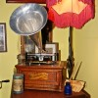
  I'm Feeling Cranky
  pughphonos wrote:
  FRAN'S DISCOVERY OF BEETHOVEN #1049
  fran604g wrote:
  Thank you for the update Ralph!
  I was just checking in to see if Beethoven #1049 was on your list (as it turns out, it wasn't).
  There is a guy on Facebook ("The Antique Phonograph Enthusiasts" page) whom has Beethoven #1049, with an installed LP assembly (he retrieved the works from a No. 1 LP console).
  I must say, the machine is drop-dead gorgeous, as are all of his several other instruments he posted pictures of, including a particularly beautiful B 450 Louis XVI.
  Best,
  Fran
  Hi Fran,
  Thanks for alerting us. I've added Beethoven #1049 to the index with a date reference to your post. I've not yet been able to find that particular machine among the mass of photos that are part of that Facebook page--and it's 3 a.m. and I'd better get to bed. If you could provide a link to a more specific page I'd appreciate it; I'll then copy the photos to this thread. Thanks again!
  Ralph
  I should have thought of that, sorry, but I'll do you one better as I have the images saved on my PC.
  Fran
  Attachment:
  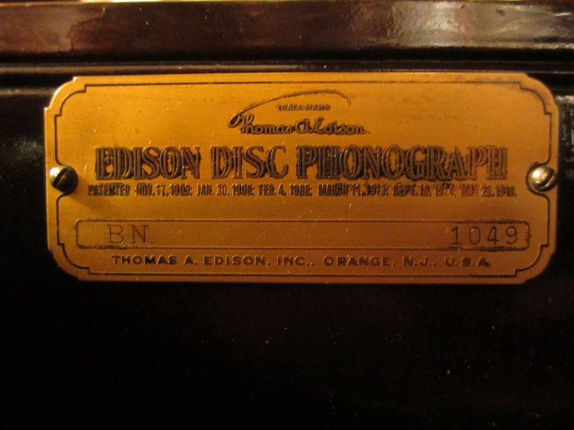
  11850678_10207629369638132_2467310229540363053_o.jpg [ 266.16 KiB | Viewed 462 times ]
  Attachment:
  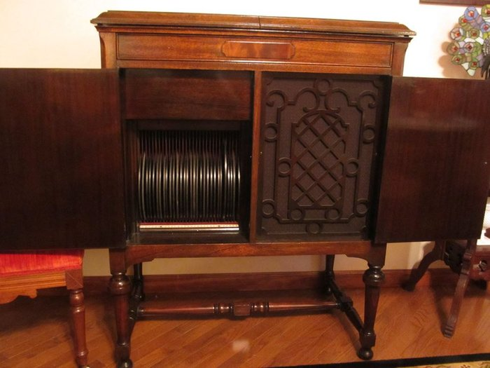
  11873542_10207629367958090_5296563101699921235_n.jpg [ 82.47 KiB | Viewed 462 times ]
  Attachment:
  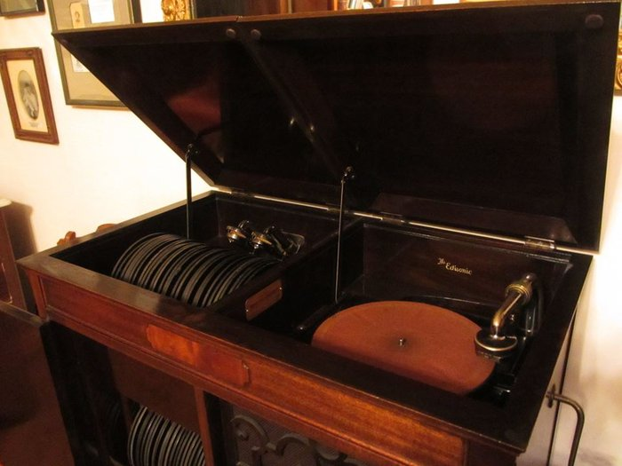
  11890986_10207629370318149_8237263385481794980_n.jpg [ 74.52 KiB | Viewed 462 times ]
  Attachment:
  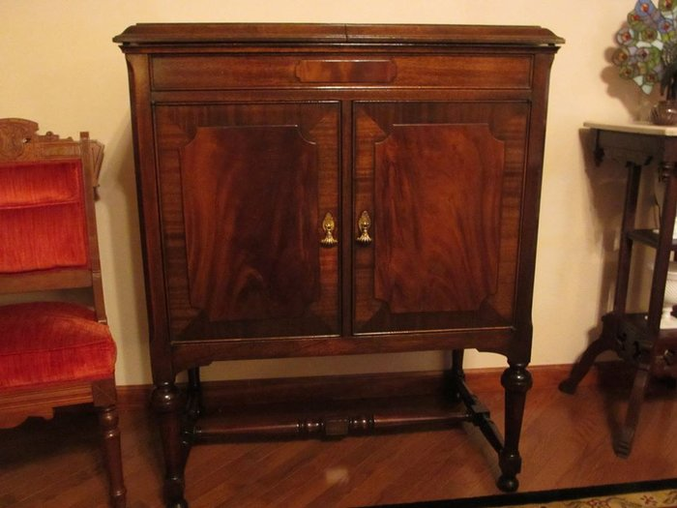
  11892234_10207629365878038_8744724197005328990_n.jpg [ 79.71 KiB | Viewed 462 times ]
  Attachment:
  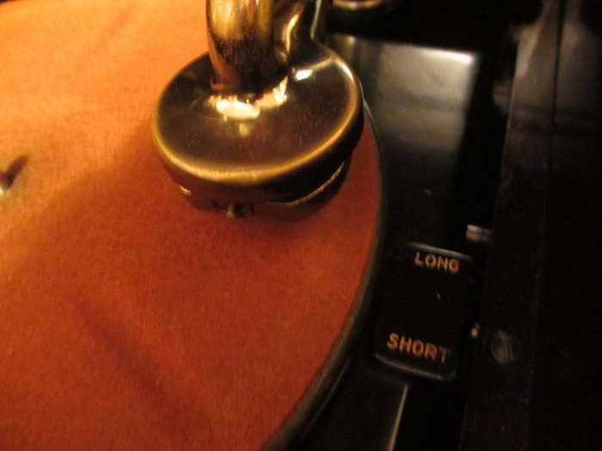
  11896114_10207629370278148_8514111357858618683_n.jpg [ 63.85 KiB | Viewed 462 times ]
  Attachment:
  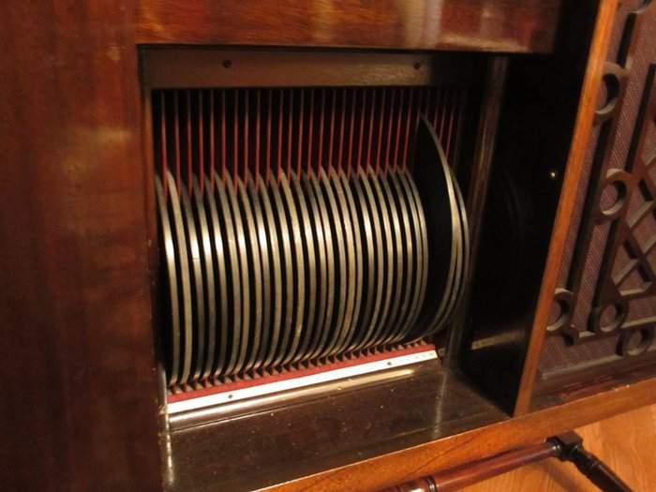
  11947619_10207629369798136_7028282087601598132_n.jpg [ 86.89 KiB | Viewed 462 times ]
  Attachment:
  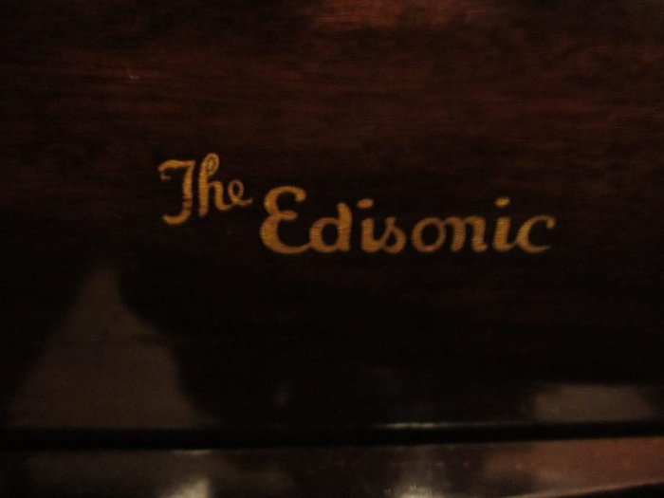
  11949409_10207629370118144_942676268350292774_n.jpg [ 49.24 KiB | Viewed 462 times ]
  Francis; "i" for him, "e" for her
  "Even a blind squirrel finds a nut once in a while" - the unappreciative supervisor.
Top

pughphonos
  Post subject: Re: Inventory of Beethoven and Schubert Edisonic phonographs
  Posted: Sun Nov 15, 2015 3:08 pm
Joined: Tue Jul 17, 2012 11:35 am  Posts: 670  Location: Homewood, Illinois, USA
  Victor III
  "You must serve music"
  fran604g wrote:
  I should have thought of that, sorry, but I'll do you one better as I have the images saved on my PC.
  Fran
  Thanks, Fran! Nice to have all these photos for Beethoven #1049.
  I think this thread is all caught up for the moment. Interesting that a couple of the most recent discoveries are of machines that we knew something about before; kind of pushes one back in the direction of thinking that perhaps there aren't as many completely "lost" Edisonics out there after all.
  BTW, I decided to load one of my Victor 8-4s into the car for transfer tomorrow to IIT instead of Schubert Edisonic #1556. I'm giving a public talk on December 2 in the IIT Archives about sound recording up to the advent of wire recording (which IIT played a large role in perfecting) and will have a couple hand-crank phonos to demonstrate (the other will be my Triumph model D).
  Had to disassemble the 8-4 to get it in the back seat; but I think it will come back together fairly easily--even though the cabinet will be a bit more worse for wear. It's important to "spread the gospel" of antique phonographs--and the 8-4 is hardly a rare machine. I'm trying to make my university more aware that part of the present-day campus was once Chicago's chief jazz district in the 1920s--and having a 1920s disc machine in the IIT Archives is something I've wanted for some time.
  Ralph
  "You must serve music, because music is so enormous and can envelop you into such a state of perpetual anxiety and torture--but it is our first and main duty"
  -- Maria Callas, 1968 interview.
Top

pughphonos
  Post subject: Re: Inventory of Beethoven and Schubert Edisonic Phonographs
  Posted: Thu Nov 19, 2015 10:56 pm
Joined: Tue Jul 17, 2012 11:35 am  Posts: 670  Location: Homewood, Illinois, USA
  Victor III
  "You must serve music"
  GARY OF NEW JERSEY ("DGPros") BOUGHT BEETHOVEN #1757 IN 2015
  It also has the LP attachment.
  See photo attached.
  Attachments:
  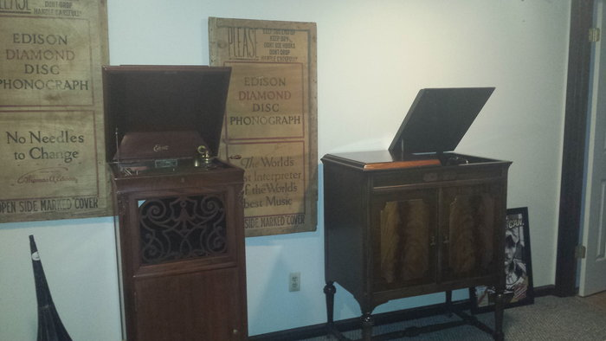
  2015-09-30 16.38.05.jpg [ 2.81 MiB | Viewed 426 times ]
  "You must serve music, because music is so enormous and can envelop you into such a state of perpetual anxiety and torture--but it is our first and main duty"
  -- Maria Callas, 1968 interview.
Top

pughphonos
  Post subject: Re: Inventory of Beethoven and Schubert Edisonic phonographs
  Posted: Mon Nov 30, 2015 10:43 am
Joined: Tue Jul 17, 2012 11:35 am  Posts: 670  Location: Homewood, Illinois, USA
  Victor III
  "You must serve music"
  THE CASE OF THE CURIOUS NEEDLE CUPS
  Model: Schubert Edisonic
  Serial number: 3835
  I'm posting to this thread (for the record) the following recent submission to a different thread on this forum--by our very own Marc ("Marcapra"):
  "My friend in MI, Paul Laurens, has an Edisonic Schubert CLT 3835 phonograph with three metal needle cups. I told him that I've never seen any Edisonic machine, Schubert or Beethoven, with needle cups. Could needle cups have been installed or supplied by the Edison Co. when they started making needle-cut 78s?"
  The consensus among Marc's respondents was that the needle cups were almost certainly installed by the machine's owner at the time and not by the Edison Company; it apparently represents a curious instance of someone frequently using their Edisonic as a lateral-playing machine through use of an adapter tone arm.
  The thread can be found at:
  viewtopic.php?f=2&t=23913
  I'm re-posting below the photo provided by Marc in that thread.
  Attachments:
  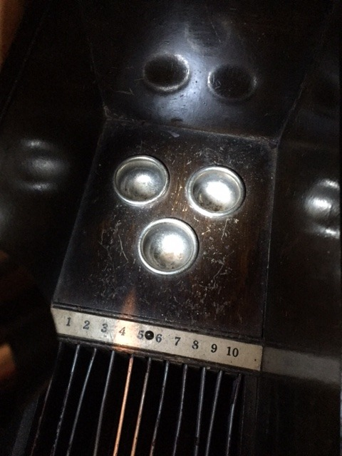
  IMG_0509_zpsrf6fiasd.jpg [ 78.56 KiB | Viewed 404 times ]
  "You must serve music, because music is so enormous and can envelop you into such a state of perpetual anxiety and torture--but it is our first and main duty"
  -- Maria Callas, 1968 interview.
Top

Previous topic | Next topic

Display posts from previous:  Sort by   

 | Page 19 of 25 | [ 247 posts ] | Go to page Previous 1 ... 16, 17, 18, 19, 20, 21, 22 ... 25 Nex

