pughphonos
  Post subject: Re: Inventory of Beethoven and Schubert Edisonic phonographs
  Posted: Fri Aug 07, 2015 7:08 pm
Joined: Tue Jul 17, 2012 11:35 am  Posts: 670  Location: Homewood, Illinois, USA
  Victor III
  
  "You must serve music"
  fran604g wrote:
  Ralph,
  CLR #1108.
  It is currently listed on eBAY, and was posted by a member in the eBAY and Craigslist section. viewtopic.php?f=14&t=22634
  Best,
  Fran
  As Jim Maxwell ("uncle-jimmy") observed yesterday elsewhere on this forum:
  "Another Edison Schubert appeared on Ebay today. Not great shape, but when zoomed into turntable photo, note the "The New Edison" decal like Mike Sherman's. Both have super low serial numbers."
  Absolutely. It's great that our members are catching these details. BTW, Mike Sherman's Schubert is serial no. 1020 and is at present the lowest we have for a Schubert.
  "You must serve music, because music is so enormous and can envelop you into such a state of perpetual anxiety and torture--but it is our first and main duty"
  -- Maria Callas, 1968 interview.
Top

CarlosV
  Post subject: Re: Inventory of Beethoven and Schubert Edisonic phonographs
  Posted: Sat Aug 08, 2015 5:58 pm
Joined: Sun Mar 15, 2009 5:18 am  Posts: 994
  Victor III
  My Schubert is S/N 5678.
  I purchased it in England, at the Roger Thorne collection auction. It has a LP attachment and the LP reproducer in addition to the standard one.
Top

pughphonos
  Post subject: Re: Inventory of Beethoven and Schubert Edisonic phonographs
  Posted: Sat Aug 08, 2015 6:39 pm
Joined: Tue Jul 17, 2012 11:35 am  Posts: 670  Location: Homewood, Illinois, USA
  Victor III
  "You must serve music"
  CarlosV wrote:
  My Schubert is S/N 5678.
  I purchased it in England, at the Roger Thorne collection auction. It has a LP attachment and the LP reproducer in addition to the standard one.
  Great to know you're the owner--and that it's LP equipped! Fuller information on that auction (Newbury, Berkshire, 2011) was posted on this thread on 4/28/2014.
  Yours is the newest-but-one Schubert recorded here thus far.
  "You must serve music, because music is so enormous and can envelop you into such a state of perpetual anxiety and torture--but it is our first and main duty"
  -- Maria Callas, 1968 interview.
Top

marcapra
  Post subject: Re: Inventory of Beethoven and Schubert Edisonic phonographs
  Posted: Mon Aug 10, 2015 2:23 am
Joined: Wed Jun 27, 2012 11:29 pm  Posts: 1915  Location: Temecula, CA
  Victor IV
  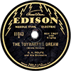
  Man who ride on tiger find it very difficult to dismount! Charlie Chan
  My Beethoven also has a dealer installed Long Play mechanism and a NOS Long Play reproducer. I think it was dealer installed because it was "left over" stock still in the dealer's grand daughter's possession, and it came with NOS Long Play records. It would be interesting to know how many Edisonic machines have Long Play mechanisms that were dealer installed. I guess it would be very hard to tell if it was dealer installed though. Maybe we could have an inventory of just how many owners have a Long Play mechanism on their Edisonics and if they know if it was put on recently or is unknown how it got there.
Top

pughphonos
  Post subject: Re: Inventory of Beethoven and Schubert Edisonic phonographs
  Posted: Mon Aug 10, 2015 3:29 pm
Joined: Tue Jul 17, 2012 11:35 am  Posts: 670  Location: Homewood, Illinois, USA
  Victor III
  "You must serve music"
  marcapra wrote:
  My Beethoven also has a dealer installed Long Play mechanism and a NOS Long Play reproducer. I think it was dealer installed because it was "left over" stock still in the dealer's grand daughter's possession, and it came with NOS Long Play records. It would be interesting to know how many Edisonic machines have Long Play mechanisms that were dealer installed. I guess it would be very hard to tell if it was dealer installed though. Maybe we could have an inventory of just how many owners have a Long Play mechanism on their Edisonics and if they know if it was put on recently or is unknown how it got there.
  I'll be the first to make this confession...though I might already have done so when I posted my own machine on this thread (Schubert serial no. 3621--too lazy to scroll back at the moment)... I contacted George Vollema in Michigan and he removed a Long Play mechanism for me from a Long Play console he had (still has?) in storage.
  Others are invited to respond to this interesting question--though my recollection is that very few of the Edisonics posted on this thread mention having the LP mechanism.
  "You must serve music, because music is so enormous and can envelop you into such a state of perpetual anxiety and torture--but it is our first and main duty"
  -- Maria Callas, 1968 interview.
Top

marcapra
  Post subject: Re: Inventory of Beethoven and Schubert Edisonic phonographs
  Posted: Wed Aug 12, 2015 12:58 am
Joined: Wed Jun 27, 2012 11:29 pm  Posts: 1915  Location: Temecula, CA
  Victor IV
  Man who ride on tiger find it very difficult to dismount! Charlie Chan
  yes, you're right. I think the only reason mine has a dealer installed LP mechanism is that it is an early 1927 Edisonic and the dealer, located in Phoenix, AZ, wanted to sell some Long Play record stock that he had, and he didn't have one of the Long Play machines. But little did he know that just 88 years would fly by before his Beethoven and NOS LP stock would sell!!! Marc.
Top

pughphonos
  Post subject: Re: Inventory of Beethoven and Schubert Edisonic phonographs
  Posted: Tue Sep 01, 2015 2:59 pm
Joined: Tue Jul 17, 2012 11:35 am  Posts: 670  Location: Homewood, Illinois, USA
  Victor III
  "You must serve music"
  BEETHOVEN EDISONIC FOR SALE VIA E-BAY FROM NEWARK, NEW JERSEY
  Model: Beethoven Edisonic
  Serial number: 1316
  In late August 2015 this Beethoven Edisonic was offered via E-bay by a seller in Newark, New Jersey with the following description:
  "Here is a great perfectly operating Edisonic Beethoven ...It has an original Edisonic reproducer that really sounds great. This is a large machine. Therefore it is only for pickup. It has a lovely case. It does not come with the records shown."
  For the record, several of the photographs from the E-bay posting are preserved below.
  NOTE: This machine was one of those listed in the July 1987 edition of the New Amberola Graphic (see posting above from 4/25/2014)
  Attachments:
  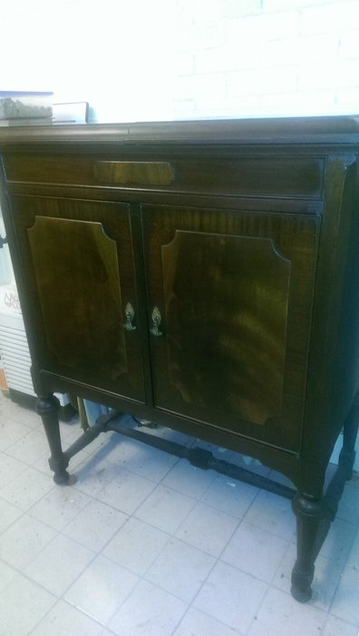
  Beethoven1316a.JPG [ 120.1 KiB | Viewed 585 times ]
  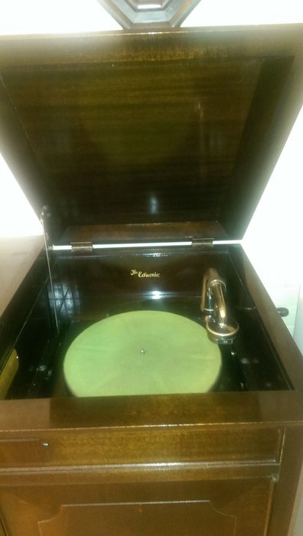
  Beethoven1316b.jpg [ 123.77 KiB | Viewed 585 times ]
  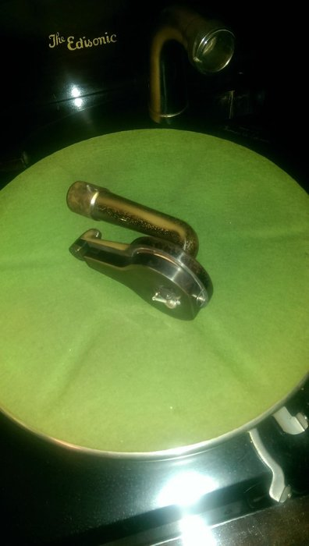
  Beethoven1316c.jpg [ 108.25 KiB | Viewed 585 times ]
  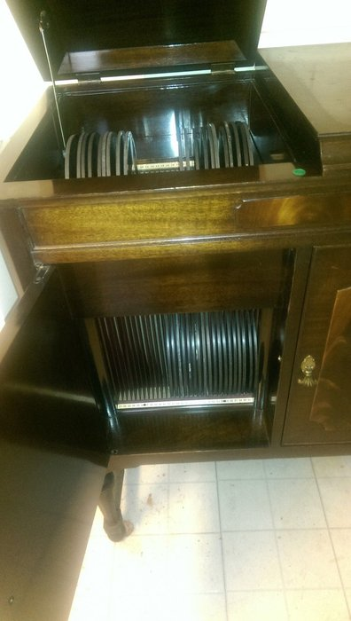
  Beethoven1316d.jpg [ 170.94 KiB | Viewed 585 times ]
  "You must serve music, because music is so enormous and can envelop you into such a state of perpetual anxiety and torture--but it is our first and main duty"
  -- Maria Callas, 1968 interview.
  Last edited by pughphonos on Tue Sep 01, 2015 3:45 pm, edited 2 times in total.
Top

pughphonos
  Post subject: Re: Inventory of Beethoven and Schubert Edisonic phonographs
  Posted: Tue Sep 01, 2015 3:24 pm
Joined: Tue Jul 17, 2012 11:35 am  Posts: 670  Location: Homewood, Illinois, USA
  Victor III
  "You must serve music"
  SCHUBERT EDISONIC FOR SALE VIA E-BAY FROM BARNEGAT, NEW JERSEY
  Model: Schubert Edisonic
  Serial number: 4157
  In late August 2015 this Schubert Edisonic was offered via E-bay by a seller in Barnegat, New Jersey with the following description:
  "Threelilangels Store:
  Offered for auction today is this wonderful old Edison Edisonic Schubert model console phonograph. The cabinet is in good sturdy condition. It does have some chips of veneer off of the top and some other areas of veneer that is lifting or loose. The phonograph works and sounds great. Apparently it does not have the original knobs on it and my research tells me that this is not unusual. The cabinet is approximately 24 inches wide, stands 43 inches tall and 21 inches deep."
  For the record, several of the photographs from the E-bay posting are preserved below.
  Attachments:
  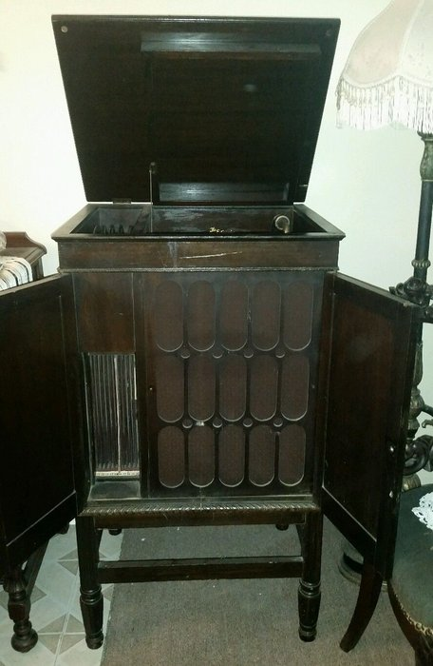
  Schubert1.JPG [ 53.94 KiB | Viewed 577 times ]
  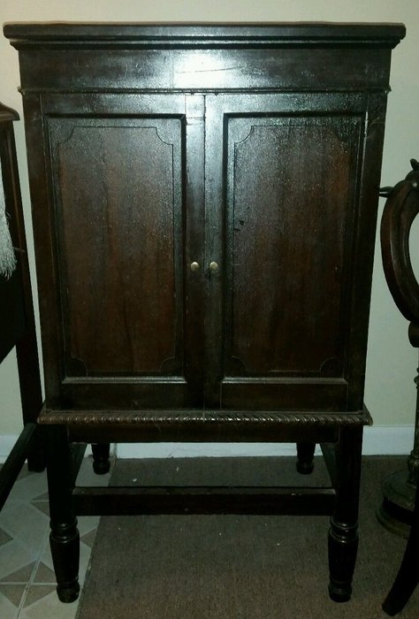
  Schubert2.JPG [ 150.29 KiB | Viewed 577 times ]
  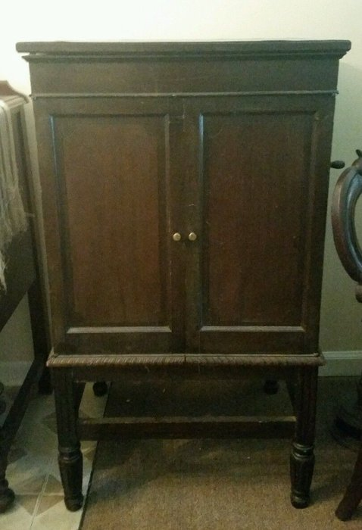
  Schubert3.JPG [ 131.71 KiB | Viewed 577 times ]
  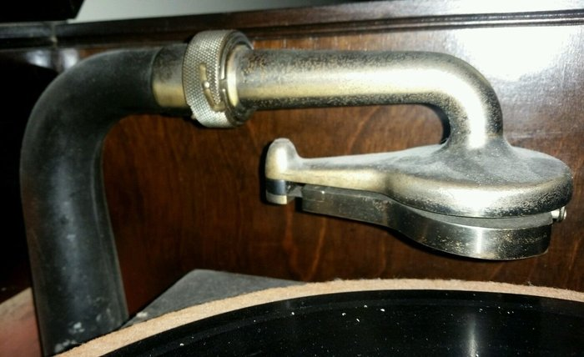
  Schubert8.JPG [ 164.4 KiB | Viewed 582 times ]
  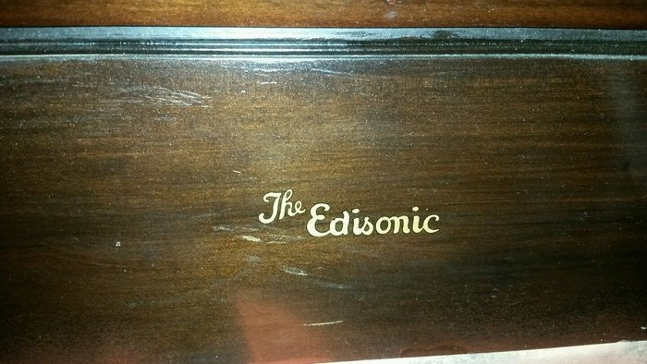
  Schubert7.JPG [ 244.09 KiB | Viewed 582 times ]
  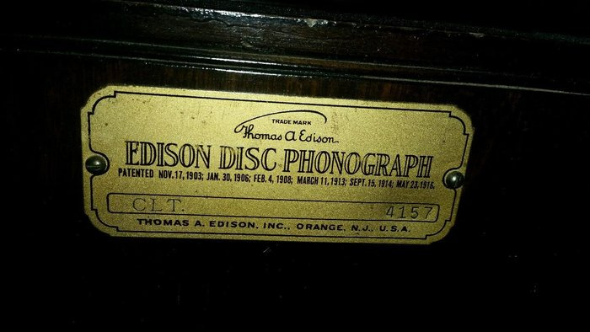
  Schubert6.JPG [ 199.65 KiB | Viewed 582 times ]
  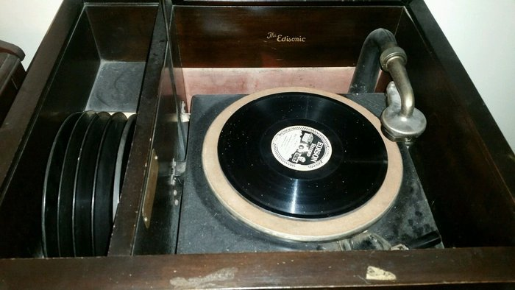
  Schubert5.JPG [ 184.6 KiB | Viewed 582 times ]
  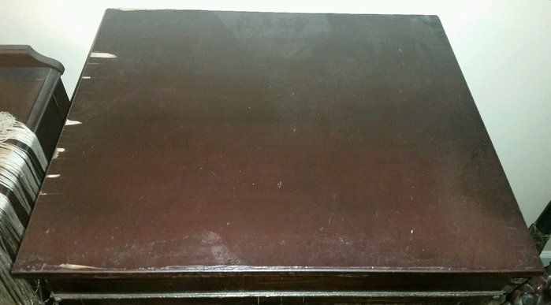
  Schubert4.JPG [ 118.61 KiB | Viewed 582 times ]
  "You must serve music, because music is so enormous and can envelop you into such a state of perpetual anxiety and torture--but it is our first and main duty"
  -- Maria Callas, 1968 interview.
  Last edited by pughphonos on Tue Sep 01, 2015 3:50 pm, edited 2 times in total.
Top

pughphonos
  Post subject: Re: Inventory of Beethoven and Schubert Edisonic phonographs
  Posted: Tue Sep 01, 2015 3:41 pm
Joined: Tue Jul 17, 2012 11:35 am  Posts: 670  Location: Homewood, Illinois, USA
  Victor III
  "You must serve music"
  SCHUBERT EDISONIC FOR SALE VIA E-BAY FROM MARION, NORTH CAROLINA
  Model: Schubert Edisonic
  Serial number: 2773
  In late August 2015 this Schubert Edisonic was offered via E-bay by a seller in Marion, North Carolina with the following description:
  "1920s edisonic diamond disc player that sounds and plays great, the top of the cabinet could use refinishing but the rest of it seems to be in good condition as seen in photos."
  For the record, several of the photographs from the E-bay posting are preserved below.
  Attachments:
  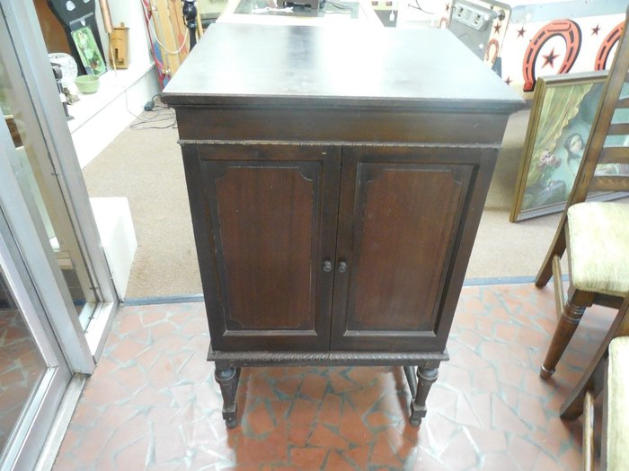
  Schubert1.JPG [ 254.71 KiB | Viewed 580 times ]
  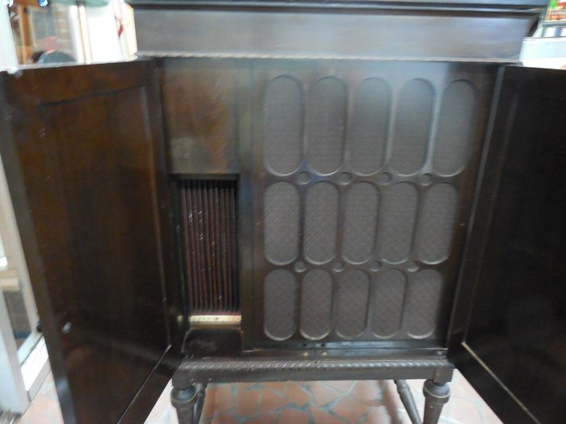
  Schubert2.JPG [ 225.34 KiB | Viewed 580 times ]
  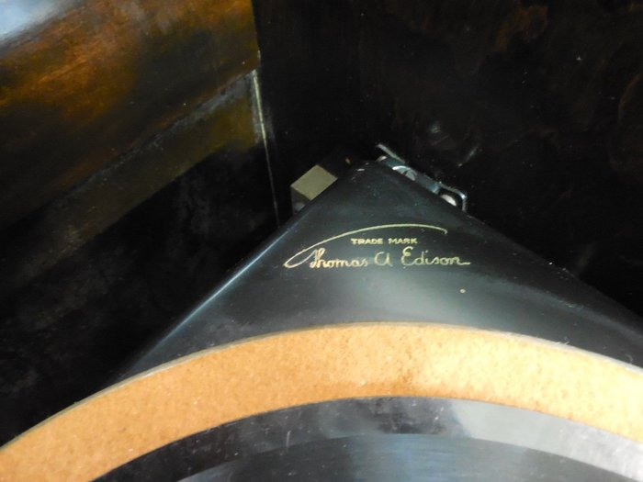
  Schubert3.JPG [ 185.03 KiB | Viewed 580 times ]
  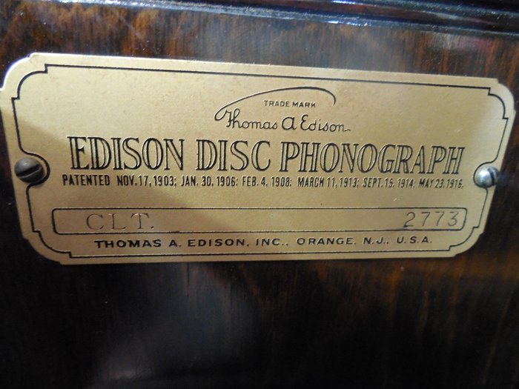
  Schubert4.JPG [ 281.43 KiB | Viewed 580 times ]
  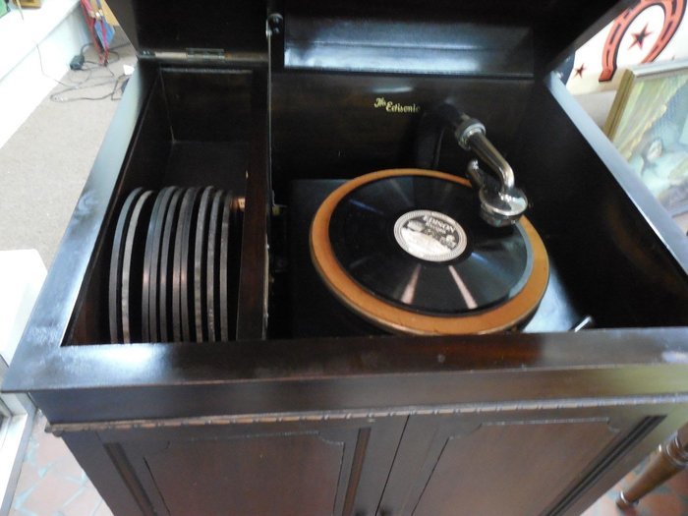
  Schubert5.JPG [ 237.82 KiB | Viewed 580 times ]
  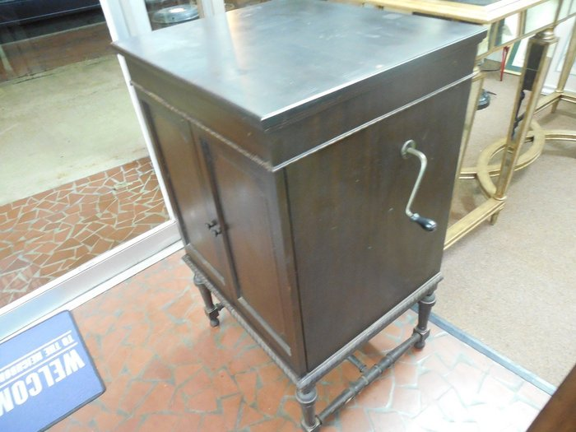
  Schubert6.JPG [ 245.03 KiB | Viewed 580 times ]
  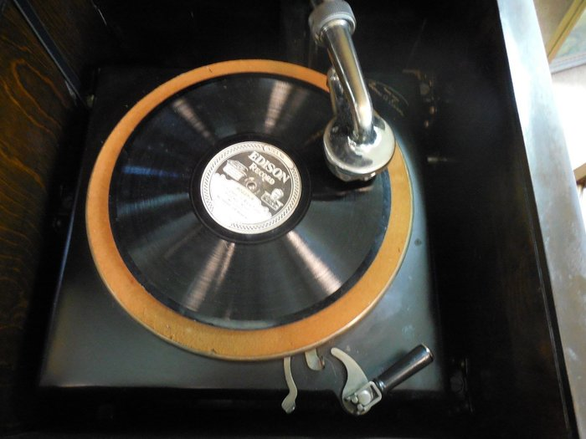
  Schubert7.JPG [ 217.06 KiB | Viewed 580 times ]
  "You must serve music, because music is so enormous and can envelop you into such a state of perpetual anxiety and torture--but it is our first and main duty"
  -- Maria Callas, 1968 interview.
Top

pughphonos
  Post subject: Re: Inventory of Beethoven and Schubert Edisonic phonographs
  Posted: Thu Sep 17, 2015 3:20 pm
Joined: Tue Jul 17, 2012 11:35 am  Posts: 670  Location: Homewood, Illinois, USA
  Victor III
  "You must serve music"
  Fran is now the owner of SCHUBERT EDISONIC #1844
  See string elsewhere on this forum:
  viewtopic.php?f=9&t=23118
  "You must serve music, because music is so enormous and can envelop you into such a state of perpetual anxiety and torture--but it is our first and main duty"
  -- Maria Callas, 1968 interview.
Top

Previous topic | Next topic

Display posts from previous:  Sort by   

 | Page 16 of 25 | [ 247 posts ] | Go to page Previous 1 ... 13, 14, 15, 16, 17, 18, 19 ... 25 Next

