melvind
  Post subject: Re: Inventory of Beethoven and Schubert Edisonic phonographs
  Posted: Tue Jun 02, 2015 9:25 am
Joined: Sun Mar 08, 2009 12:23 am  Posts: 993  Location: North Oregon Coast
  Victor III
  
  music is time travel and strings moments in time together like nothing else I know -- Kathleen Lane
  Will you be at Union? How much?
  -- Dan
  Visit My YouTube Channel
  Visit the OTAPS Home Page http://otaps.org
Top

msherman
  Post subject: Re: Inventory of Beethoven and Schubert Edisonic phonographs
  Posted: Wed Jun 03, 2015 8:24 am
Joined: Thu Apr 30, 2015 10:11 am  Posts: 13
  Victor Jr
  I plan on being at Union. We can discuss further there.
Top

marcapra
  Post subject: Re: Inventory of Beethoven and Schubert Edisonic phonographs
  Posted: Thu Jun 04, 2015 2:22 am
Joined: Wed Jun 27, 2012 11:29 pm  Posts: 1915  Location: Temecula, CA
  Victor IV
  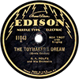
  Man who ride on tiger find it very difficult to dismount! Charlie Chan
  I'll see you, Mike, also at Union. I've never seen "The New Edison" on a Schubert! I wonder if early Beethovens also had "The New Edison" on them? BTW, I have sold my first Beethoven that was put up for sale on Craigslist and this forum some time ago. It is serial number 1977 and was sold to Paul Laurens of Dearborn, MI. He also owns a Schubert that has needle cups in the top record storage area. It is serial no. 3835 and is new to this inventory of Edisonics. Marc.
Top

pughphonos
  Post subject: Re: Inventory of Beethoven and Schubert Edisonic phonographs
  Posted: Fri Jun 05, 2015 10:02 am
Joined: Tue Jul 17, 2012 11:35 am  Posts: 670  Location: Homewood, Illinois, USA
  Victor III
  
  "You must serve music"
  UPDATED INDEX (AS OF June 5, 2015) TO POSTINGS:
  SERIAL NUMBERS of machines posted above (and some below), arranged in order (with dates of posting):
  BEETHOVEN EDISONICS:
  1121 (4/30/2014); 1150 (4/25/2014); 1200 (03/8/2015);
  1220 (4/25/2014); 1238 (4/29/2014); 1262 (4/25/2014);
  1316 (4/25/2014); 1757 (4/25/2014); 1853 (4/23/2014);
  1898 (4/21/2014); 1977 (6/20/2014 & 7/1/2014 & 4/6/2015 & 6/4/2015);
  2036 (4/25/2014); 2157 (4/22/2014); 2292? (4/21/2014);
  2488 (5/1/2014); 2491 (7/12/2014 & 6/2/2015); 2641 (5/14/2014)
  SCHUBERT EDISONICS:
  1020 (6/2/2015); 1150 (4/25/2014); 1187 (4/24/2014);
  1216 (4/25/2014, 4/26/2014 & 5/4/2014); 1217 (4/28/2014 & 5/4/2014);
  1246 (4/21/2014); 1329 (5/1/2014 & 05/6/2014);
  1394 (4/25/2014); 1441 (4/25/2014); 1556 (4/22/2014 & 5/2/2015);
  1596 (7/22/2014); 1656 (4/25/2014); 1672 (7/30/2014);
  1765 (4/23/2015 & 4/25/2015); 1844 (3/11/2015 & 5/3/2015);
  1897 (5/14/2014); 1902 (4/22/2014); 1913 (4/25/2014);
  2002 (4/25/2014); 2010 (4/28/2014); 2058 (4/25/2014);
  2288 (4/22/2014 & 5/1/2014); 2673 (4/24/2014 & 5/29/2014);
  2723 (4/23/2014); 2982 (4/25/2014); 3020(4/22/2014);
  3023 (4/25/2014); 3398 (4/21/2014); 3618 (4/21/2014);
  3621 (5/18/2014); 3675 (4/21/2014); 3835 (6/4/2015);
  3919 (7/7/2014); 4005 (4/22/2014); 4129 (4/22/2014);
  4246 (4/25/2014); 4484 (4/25/2014); 4752 (4/21/2014);
  4869 (4/29/2014); 5056 (4/22/2014 & 5/23/2014);
  5653 (4/21/2014); 5670 (05/6/2014 & 5/19/2014);
  5678 (4/28/2014); 6025 (4/30/2014 & 6/21/2014)
  +++++++++++++++++++++++++++++++++++++++++++++++++++++++++++++++++++++++++++++++++++++++++++++++
  NON-SERIAL NUMBER DESIGNATION SYSTEM
  As stated at the start of this thread, it is preferred first and foremost that we list information on machines using serial numbers.
  However, in the case of old/inactive on-line listings where serial numbers were not provided and there is no current contact information, I have devised the following designation system whereby we can record information from these listings. It is not a perfect system as the same machines might appear again in listings from other localities. But it will still add to our knowledge base by enabling us to capture unique images and information on particular machines as they work their way through listings. If, in future, we can gain serial numbers for any of these machines, I will link the serial number to the old listings.
  For example, in 2013 I contacted a Craigslist seller in Minnesota who had a Schubert; he would not sell it to me as I could not arrange a local pick-up. I do not know what has since happened with that machine. But I still have the description from 2013. My temporary designation for that machine (so that I can post it here) is USMN2013MAY19.
  How to create a non-serial number designation. For old US postings, use US and then the US state postal code (in this case, MN=Minnesota), followed immediately by the original date of posting. For old foreign postings, spell out the full country name and then the original date of posting: e.g. FRANCE2012JANUARY31.
  The following entries are arranged chronologically by original posting dates:
  BEETHOVEN EDISONICS:
  USMI2007NOVEMBER9 (4/27/2014); US2010DECEMBER19 (5/3/2014)
  SCHUBERT EDISONICS:
  USNJ1997NOVEMBER15 (5/7/2014); AUSTRALIA1997NOVEMBER20 (5/1/2014);
  USNY2005 (5/2/2014); GERMANY2006 (4/25/2014);
  USMD2006JULY7 (4/24/2014 & 5/29/2014--SEE Serial #2673);
  USPA2007 (5/1/2014); USMI2007NOVEMBER9 (4/27/2014); USIL2008JUNE16 (4/27/2014);
  USIL2010JUNE12(4/24/2014); NEW ZEALAND2012MAY3 (4/25/2014);
  USWA2013MARCH17 (5/1/2014); USMN2013MAY19 (4/23/2013);
  USGA2013AUGUST8 (4/25/2014)
  +++++++++++++++++++++++++++++++++++++++++++++++++++++++++++++++++++++++++++++++++++++++++++++
  FINALLY, "YOU TUBE" VIDEOS OF UNIDENTIFIED EDISONICS AND THEIR UNIDENTIFIED OWNERS
  (see posting dated 4/30/2014 for details and links)
  Number of BEETHOVEN EDISONICS portrayed: 0
  Number of SCHUBERT EDISONICS portrayed: 2
  ("Classy8888" has since been identified as Ian Griggs, who owns #6025)
  ("Chagall56" has since been identified as our own "Marcapra"--and he reveals that the Schubert filmed is #1246)
  "You must serve music, because music is so enormous and can envelop you into such a state of perpetual anxiety and torture--but it is our first and main duty"
  -- Maria Callas, 1968 interview.
Top

pughphonos
  Post subject: Re: Inventory of Beethoven and Schubert Edisonic phonographs
  Posted: Fri Jun 05, 2015 3:57 pm
Joined: Tue Jul 17, 2012 11:35 am  Posts: 670  Location: Homewood, Illinois, USA
  Victor III
  "You must serve music"
  "PHONOCOOKIE" ADDS HIS SCHUBERT TO THE MIX
  Model:Schubert Edisonic
  Serial number: 1537
  This past week has seen a nice uptick in Edisonic phonos being reported to me--or posted directly to this thread.
  Ah, 1537--the year Queen Jane Seymour died.
  Attachments:
  
  jane_seymour.jpg [ 10.68 KiB | Viewed 959 times ]
  "You must serve music, because music is so enormous and can envelop you into such a state of perpetual anxiety and torture--but it is our first and main duty"
  -- Maria Callas, 1968 interview.
Top

fran604g
  Post subject: Re: Inventory of Beethoven and Schubert Edisonic phonographs
  Posted: Tue Aug 04, 2015 11:40 am
Joined: Mon Mar 04, 2013 2:22 pm  Posts: 3276  Location: Livonia, NY
  Victor VI
  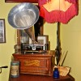
  I'm Feeling Cranky
  I have one for you, I checked your list and didn't see it on there yet:
  SCHUBERT CLT - 4157 (CL listing Jersey Shore - Barnegat http://jerseyshore.craigslist.org/atq/5154647377.html)
  Fran
  Pictures for posterity:
  Attachment:
  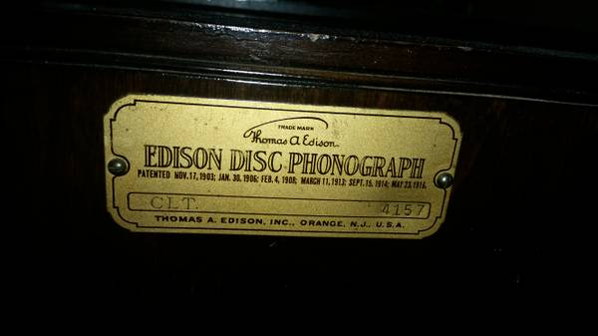
  00E0E_1Y4SK0KH5qo_600x450.jpg [ 19.47 KiB | Viewed 926 times ]
  Attachment:
  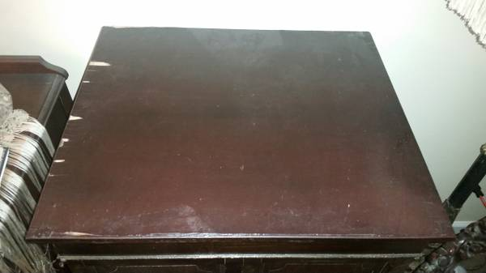
  00h0h_j4CUAMJlcbS_600x450.jpg [ 16.85 KiB | Viewed 926 times ]
  Attachment:
  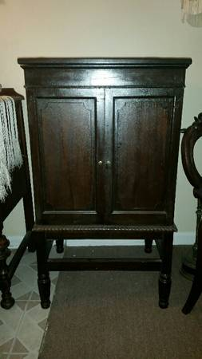
  00K0K_1lZGw2IpTwi_600x450.jpg [ 14.73 KiB | Viewed 926 times ]
  Attachment:
  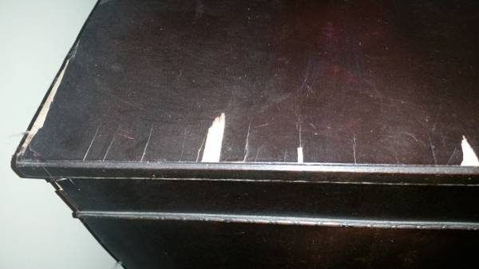
  00O0O_KkIrVYonhL_600x450.jpg [ 19.61 KiB | Viewed 926 times ]
  Attachment:
  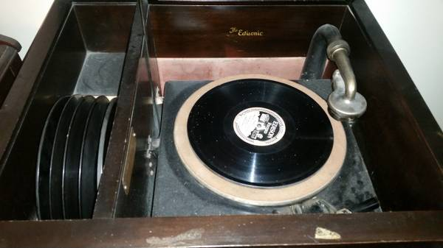
  00p0p_XL34vujlTj_600x450.jpg [ 25.35 KiB | Viewed 926 times ]
  Attachment:
  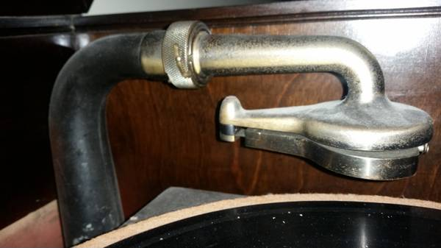
  00u0u_2Y05tKX21m3_600x450.jpg [ 24.12 KiB | Viewed 926 times ]
  Attachment:
  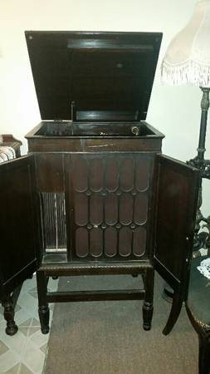
  00Z0Z_aPOe5raJBLl_600x450.jpg [ 14.53 KiB | Viewed 926 times ]
  Francis; "i" for him, "e" for her
  "Even a blind squirrel finds a nut once in a while" - the unappreciative supervisor.
Top

pughphonos
  Post subject: Re: Inventory of Beethoven and Schubert Edisonic phonographs
  Posted: Tue Aug 04, 2015 12:18 pm
Joined: Tue Jul 17, 2012 11:35 am  Posts: 670  Location: Homewood, Illinois, USA
  Victor III
  "You must serve music"
  fran604g wrote:
  I have one for you, I checked your list and didn't see it on there yet:
  SCHUBERT CLT - 4157 (CL listing Jersey Shore - Barnegat http://jerseyshore.craigslist.org/atq/5154647377.html)
  Fran
  Thanks, Fran, for catching this and making sure the photos are saved for posterity. I'll put out an updated index in the next few weeks.
  The Schuberts are emerging in a slow, steady trickle. We're now at 43 extant ones reported. My hunch is that there could still be a few hundred more out there in deep storage or otherwise off anyone's radar beside the owners'.
  Ralph
  "You must serve music, because music is so enormous and can envelop you into such a state of perpetual anxiety and torture--but it is our first and main duty"
  -- Maria Callas, 1968 interview.
Top

pughphonos
  Post subject: Re: Inventory of Beethoven and Schubert Edisonic phonographs
  Posted: Thu Aug 06, 2015 1:24 pm
Joined: Tue Jul 17, 2012 11:35 am  Posts: 670  Location: Homewood, Illinois, USA
  Victor III
  "You must serve music"
  NEW OWNER FOR BEETHOVEN EDISONIC SERIAL NO. 1977
  For the record (as incorporated in this thread), our very own Marc C. ("Marcapra") has posted elsewhere on this forum that he has sold his Beethoven Edisonic. Marc wrote:
  I am the one who put up the Beethoven Edisonic machine for sale on Craigslist as well as on the Yankee Trader here. There was some initial interest, but no serious offers for the machine. The price was $1575. I finally sold it through word of mouth to a collector in Michigan. Marc C.
  "You must serve music, because music is so enormous and can envelop you into such a state of perpetual anxiety and torture--but it is our first and main duty"
  -- Maria Callas, 1968 interview.
Top

marcapra
  Post subject: Re: Inventory of Beethoven and Schubert Edisonic phonographs
  Posted: Thu Aug 06, 2015 5:45 pm
Joined: Wed Jun 27, 2012 11:29 pm  Posts: 1915  Location: Temecula, CA
  Victor IV
  Man who ride on tiger find it very difficult to dismount! Charlie Chan
  It should be noted that the Schubert Edisonic 4157 shown above is not complete. The cabinet has been amputated and different legs and stretchers put on.
Top

fran604g
  Post subject: Re: Inventory of Beethoven and Schubert Edisonic phonographs
  Posted: Fri Aug 07, 2015 5:07 am
Joined: Mon Mar 04, 2013 2:22 pm  Posts: 3276  Location: Livonia, NY
  Victor VI
  I'm Feeling Cranky
  Ralph,
  CLR #1108.
  It is currently listed on eBAY, and was posted by a member in the eBAY and Craigslist section. viewtopic.php?f=14&t=22634
  Pictures for posterity:
  Attachment:
  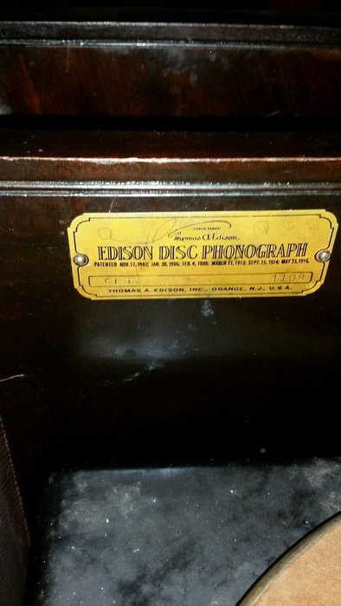
  $_57.jpg [ 140.21 KiB | Viewed 885 times ]
  Attachment:
  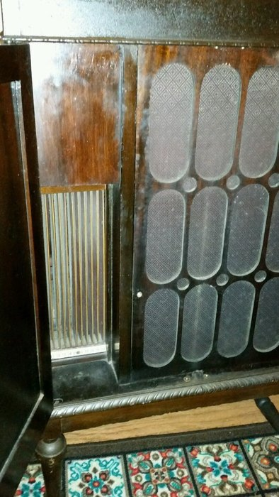
  $_57 (1).JPG [ 227.44 KiB | Viewed 885 times ]
  Attachment:
  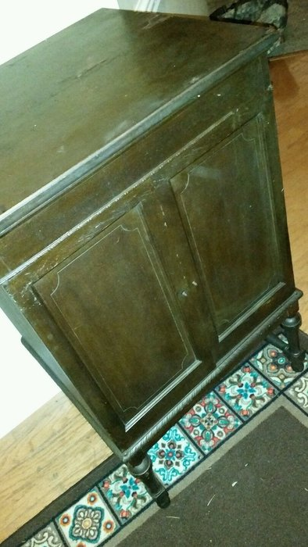
  $_57 (2).jpg [ 206.4 KiB | Viewed 885 times ]
  Attachment:
  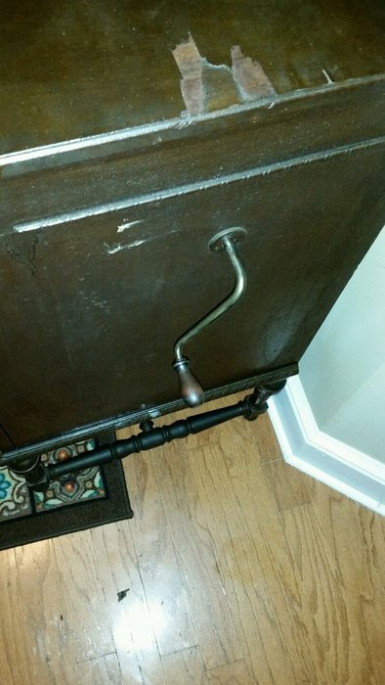
  $_57 (3).jpg [ 212.15 KiB | Viewed 885 times ]
  Attachment:
  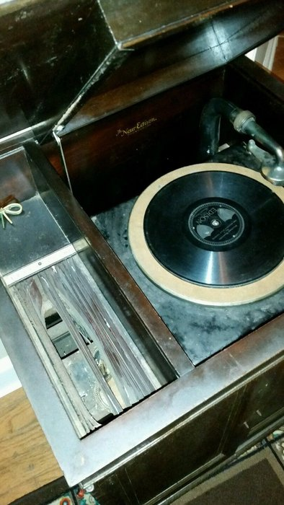
  $_57 (4).jpg [ 193.02 KiB | Viewed 885 times ]
  Attachment:
  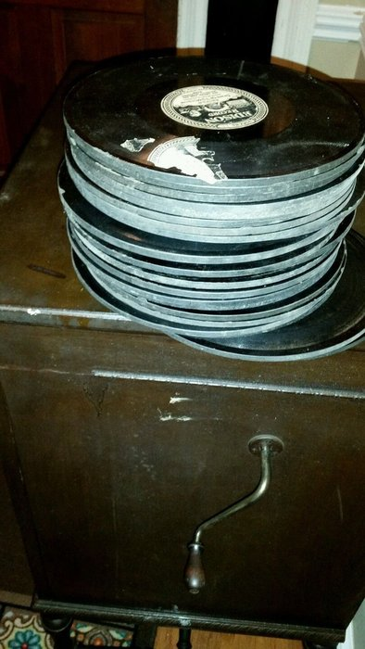
  $_57 (5).jpg [ 200.52 KiB | Viewed 885 times ]
  Best,
  Fran
  Francis; "i" for him, "e" for her
  "Even a blind squirrel finds a nut once in a while" - the unappreciative supervisor.
Top

Previous topic | Next topic

Display posts from previous:  Sort by   

 | Page 15 of 25 | [ 247 posts ] | Go to page Previous 1 ... 12, 13, 14, 15, 16, 17, 18 ... 25 Next

