marcapra
  Post subject: Re: Inventory of Beethoven and Schubert Edisonic phonographs
  Posted: Tue Apr 07, 2015 1:53 pm
Joined: Wed Jun 27, 2012 11:29 pm  Posts: 1915  Location: Temecula, CA
  Victor IV
  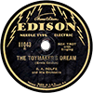
  Man who ride on tiger find it very difficult to dismount! Charlie Chan
  Well, it can't be 3675 since that one is amputated. It would have to be 1246.
Top

tubaphone
  Post subject: Re: Inventory of Beethoven and Schubert Edisonic phonographs
  Posted: Thu Apr 23, 2015 10:54 pm
Joined: Sat Mar 30, 2013 11:45 pm  Posts: 43
  Victor Jr
  Just found another Edisonic Schubert model listed on Craigslist. Here is a picture of the serial number. Here is a link to the ad. http://atlanta.craigslist.org/nat/atq/4963648360.html
  This is not my ad so I don't know anymore about it, just passing along the information.
  Attachments:
  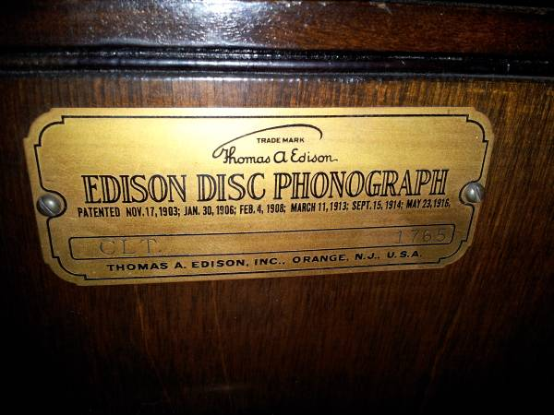
  00s0s_12aY9x6l2K2_600x450.jpg [ 41.9 KiB | Viewed 935 times ]
Top

marcapra
  Post subject: Re: Inventory of Beethoven and Schubert Edisonic phonographs
  Posted: Fri Apr 24, 2015 12:31 am
Joined: Wed Jun 27, 2012 11:29 pm  Posts: 1915  Location: Temecula, CA
  Victor IV
  Man who ride on tiger find it very difficult to dismount! Charlie Chan
  Looks like a good deal! Schubert is a great little console! or if you would prefer a Beethoven, just send me a PM. Marc.
Top

pughphonos
  Post subject: Re: Inventory of Beethoven and Schubert Edisonic phonographs
  Posted: Sat Apr 25, 2015 5:42 pm
Joined: Tue Jul 17, 2012 11:35 am  Posts: 670  Location: Homewood, Illinois, USA
  Victor III
  
  "You must serve music"
  SCHUBERT EDISONIC FOR SALE ON ATLANTA CRAIGSLIST FOR $350
  Model: Schubert Edisonic
  Serial number: 1765
  As "Tubaphone" announced above on April 23, Schubert Edisonic serial no. 1765 appeared on the Atlanta (Georgia) Craigslist earlier this month. The ad read: "Beautiful, unrestored Edisonic Disc Phonograph with 10 10" discs. Plays great!"
  For the record, here are several photos that were posted with the ad.
  Attachments:
  better.jpg [ 41.9 KiB | Viewed 906 times ]
  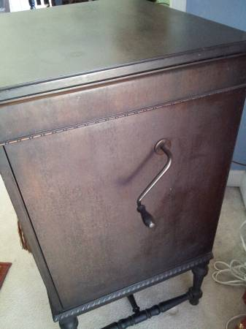
  side view.jpg [ 17.33 KiB | Viewed 906 times ]
  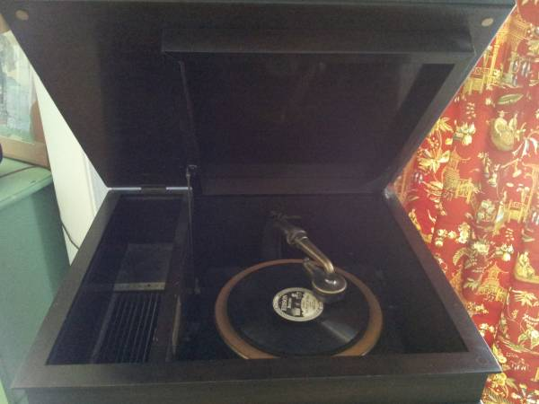
  open top.jpg [ 27.61 KiB | Viewed 906 times ]
  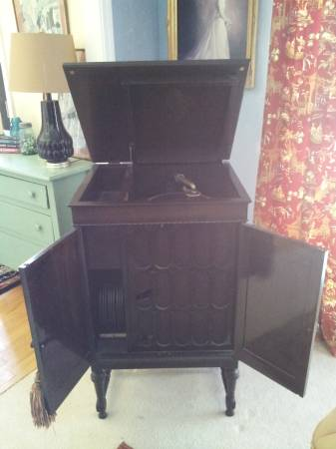
  00D0D_139gbMsDN8I_600x450.jpg [ 17.26 KiB | Viewed 907 times ]
  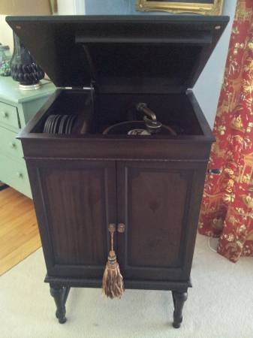
  00w0w_jSF12qSQBRK_600x450.jpg [ 17.74 KiB | Viewed 907 times ]
  "You must serve music, because music is so enormous and can envelop you into such a state of perpetual anxiety and torture--but it is our first and main duty"
  -- Maria Callas, 1968 interview.
Top

Edisone
  Post subject: Re: Inventory of Beethoven and Schubert Edisonic phonographs
  Posted: Sat Apr 25, 2015 8:11 pm
Joined: Sat Aug 01, 2009 4:17 pm  Posts: 1140  Location: Can see Canada from Attic Window
  Victor IV
  pughphonos wrote:
  SCHUBERT EDISONIC FOR SALE ON ATLANTA CRAIGSLIST FOR $350
  Model: Schubert Edisonic
  Serial number: 1765
  The ad read: "Beautiful, unrestored Edisonic Disc Phonograph with 10 10" discs. Plays great!"
  That's still what it reads, 30 seconds ago. It still hasn't sold, being more than a 2-hour drive from ME. hah.
Top

pughphonos
  Post subject: Re: Inventory of Beethoven and Schubert Edisonic phonographs
  Posted: Sat Apr 25, 2015 9:25 pm
Joined: Tue Jul 17, 2012 11:35 am  Posts: 670  Location: Homewood, Illinois, USA
  Victor III
  "You must serve music"
  Edisone wrote:
  That's still what it reads, 30 seconds ago. It still hasn't sold, being more than a 2-hour drive from ME. hah.
  Aincha even a lil bit tempted? That round lid on your car's backside is for gas; put in enough and go march on Atlanta like Sherman.
  "You must serve music, because music is so enormous and can envelop you into such a state of perpetual anxiety and torture--but it is our first and main duty"
  -- Maria Callas, 1968 interview.
Top

pughphonos
  Post subject: Re: Inventory of Beethoven and Schubert Edisonic phonographs
  Posted: Sat May 02, 2015 8:10 pm
Joined: Tue Jul 17, 2012 11:35 am  Posts: 670  Location: Homewood, Illinois, USA
  Victor III
  "You must serve music"
  NEW OWNER FOR SCHUBERT EDISONIC #1556.
  The hand-off occurred today in Athens, Ohio, halfway between my residence (Ralph's, in metro Chicago) and Gene Emering's (in New Jersey). Gene's #1556 is now mine, and I therefore now own two Schuberts (along with #3621).
  I don't attend as many shows as some of the rest of you, and therefore this realization has come upon me slowly--but, my goodness, I have now met some incredibly big-hearted individuals in this hobby (it takes in-person meetings to really bring it home). Gene, for example, handed me a box of Diamond Discs with the Schubert, which he didn't have to do; he coupled it with the sentimental explanation that the records had come with the machine and should remain with it. I've been playing those records tonight; half of them are new numbers to my collection--and included among them are several "electrics."
  So, Gene, I hope you don't mind my singing your praises a bit.
  Ralph
  "You must serve music, because music is so enormous and can envelop you into such a state of perpetual anxiety and torture--but it is our first and main duty"
  -- Maria Callas, 1968 interview.
  Last edited by pughphonos on Sun May 03, 2015 2:25 pm, edited 1 time in total.
Top

gemering
  Post subject: Re: Inventory of Beethoven and Schubert Edisonic phonographs
  Posted: Sun May 03, 2015 9:34 am
Joined: Sun Jul 29, 2012 9:35 pm  Posts: 1119  Location: Northwest New Jersey
  Victor IV
  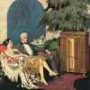
  Ralph,
  It was a pleasure meeting you!
  Thank you for your kind words.
  Best of luck with the Schubert.
  Gene
Top

pughphonos
  Post subject: Re: Inventory of Beethoven and Schubert Edisonic phonographs
  Posted: Sun May 03, 2015 2:16 pm
Joined: Tue Jul 17, 2012 11:35 am  Posts: 670  Location: Homewood, Illinois, USA
  Victor III
  "You must serve music"
  NEW OWNER FOR SCHUBERT EDISONIC #1844
  Gene Emering's friend Richard Gordon has purchased Schubert #1844, which had been advertised via Yankee Trader (from Wisconsin) earlier this year and which I featured on this string on March 11. So, always nice to see these machines gain new homes.
  "You must serve music, because music is so enormous and can envelop you into such a state of perpetual anxiety and torture--but it is our first and main duty"
  -- Maria Callas, 1968 interview.
Top

msherman
  Post subject: Re: Inventory of Beethoven and Schubert Edisonic phonographs
  Posted: Tue Jun 02, 2015 9:12 am
Joined: Thu Apr 30, 2015 10:11 am  Posts: 13
  Victor Jr
  I can add a couple here.
  I have Schubert No. 1020. Interesting that it is named "New Edison" under the lid rather than "Edisonic." Judging by the serial number, I would imagine it's one of the first ones made.
  Also have a Beethoven, acquired recently from the collection of Ron Dethlefson.
  Running out of room, so the Shubert is for sale if anyone is interested.
Top

Previous topic | Next topic

Display posts from previous:  Sort by   

 | Page 14 of 25 | [ 247 posts ] | Go to page Previous 1 ... 11, 12, 13, 14, 15, 16, 17 ... 25 Next

