Lenoirstreetguy
  Post subject: Re: Inventory of Beethoven and Schubert Edisonic phonographs
  Posted: Fri Mar 13, 2015 8:26 pm
Joined: Thu Jan 08, 2009 3:43 pm  Posts: 1183  Location: Toronto, Ontario
  Victor IV
  " By popular demand" as they used to say, here is the rest of the brochure. You can see the list of records on the back are among the first electrical Diamond Discs.
  I was pleased to find this brochure, actually.
  Jim
  Attachments:
  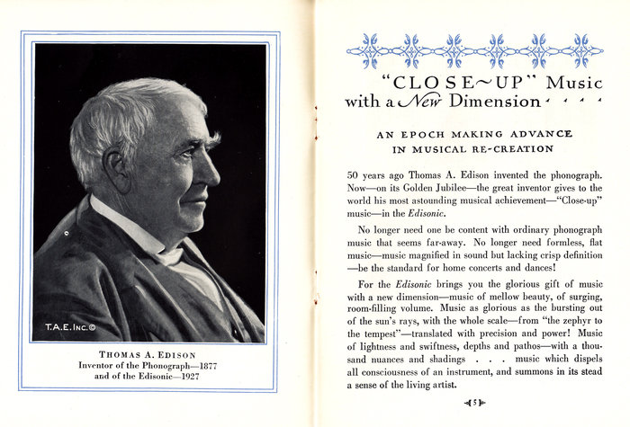
  IMG_0001.jpg [ 1.16 MiB | Viewed 943 times ]
  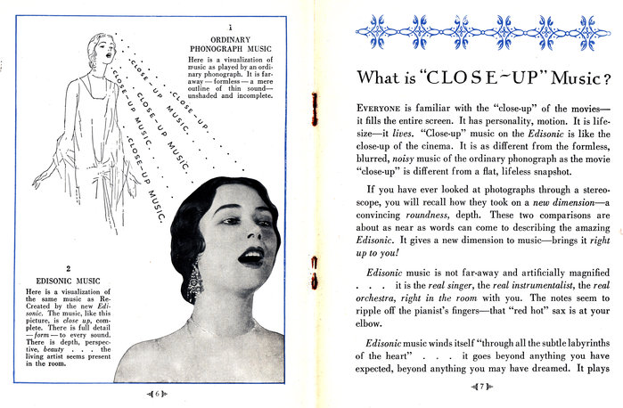
  IMG_0002.jpg [ 1.1 MiB | Viewed 943 times ]
  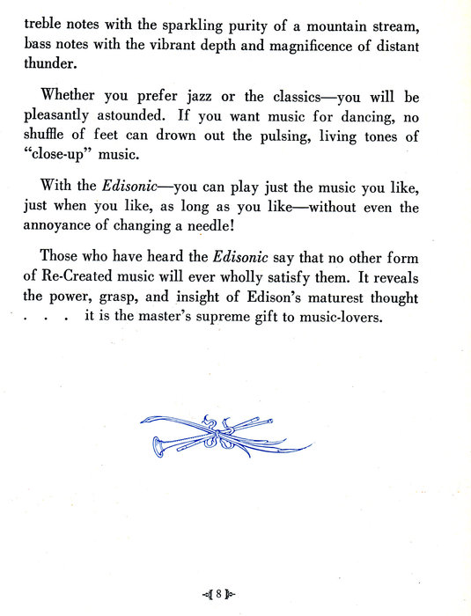
  IMG_0003.jpg [ 357.54 KiB | Viewed 943 times ]
  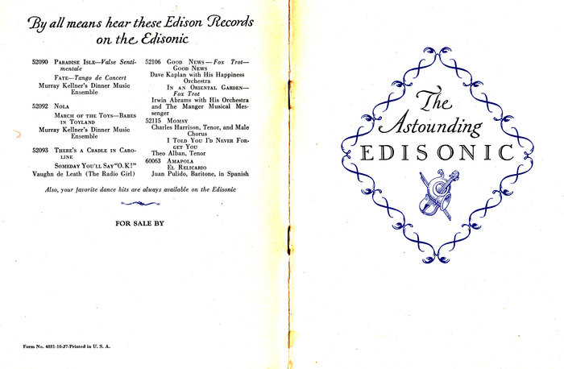
  IMG_0004.jpg [ 683.81 KiB | Viewed 943 times ]
Top

PeterF
  Post subject: Re: Inventory of Beethoven and Schubert Edisonic phonographs
  Posted: Fri Mar 13, 2015 8:34 pm
Joined: Sun Jul 08, 2012 12:06 pm  Posts: 1365
  Victor IV
  Edison, Columbia, Victor, Pathé...and oddball makes
  Thanks VERY much!!
Top

pughphonos
  Post subject: Re: Inventory of Beethoven and Schubert Edisonic phonographs
  Posted: Fri Mar 13, 2015 10:27 pm
Joined: Tue Jul 17, 2012 11:35 am  Posts: 670  Location: Homewood, Illinois, USA
  Victor III
  
  "You must serve music"
  Since so many of us on this forum are very enthusiastic about the 1920s, I wanted to take a moment to tell about one of my special connections to the 1920s. My hometown piano/organ teacher (in Alpena, Michigan) was (many decades before I took lessons) the town's last silent film organist. She died aged 90 without children, so tonight I put together a "Find a Grave" page for her, in tribute.
  http://www.findagrave.com/cgi-bin/fg.cg ... 10&df=all&
  A Chicago-trained musician, at least one of her students (me) has made it back there--where I am the organist at Palos Park Presbyterian Community Church on Sundays and at Temple Anshe Shalom (Reformed Jewish) on Fridays.
  So, I'm in this hobby not primarily as a collector or tinkerer--but because old phonographs give me the music of the past that I want to hear as originally performed.
  Ralph
  "You must serve music, because music is so enormous and can envelop you into such a state of perpetual anxiety and torture--but it is our first and main duty"
  -- Maria Callas, 1968 interview.
Top

marcapra
  Post subject: Re: Inventory of Beethoven and Schubert Edisonic phonographs
  Posted: Sat Mar 14, 2015 2:02 am
Joined: Wed Jun 27, 2012 11:29 pm  Posts: 1915  Location: Temecula, CA
  Victor IV
  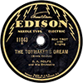
  Man who ride on tiger find it very difficult to dismount! Charlie Chan
  Ralph, that last post is very noble and touching! You sound like a very noble and great guy, not to mention talented and musical!
Top

pughphonos
  Post subject: Re: Inventory of Beethoven and Schubert Edisonic phonographs
  Posted: Sat Mar 14, 2015 11:01 am
Joined: Tue Jul 17, 2012 11:35 am  Posts: 670  Location: Homewood, Illinois, USA
  Victor III
  "You must serve music"
  Marc, thank you! I'm a sentimentalist and do have a sense of gallantry. Also, the rich and famous will never have a shortage of biographers--and so we should do what we can to commemorate the good but "obscure" folk we have met along the way. Most of us will be joining that latter camp ourselves sooner or later.
  "You must serve music, because music is so enormous and can envelop you into such a state of perpetual anxiety and torture--but it is our first and main duty"
  -- Maria Callas, 1968 interview.
Top

fran604g
  Post subject: Re: Inventory of Beethoven and Schubert Edisonic phonographs
  Posted: Sat Mar 14, 2015 11:51 am
Joined: Mon Mar 04, 2013 2:22 pm  Posts: 3276  Location: Livonia, NY
  Victor VI
  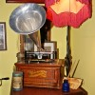
  I'm Feeling Cranky
  Ralph, I agree entirely with Marc. What a wonderful remembrance and touching tribute.
  Fran
  Francis; "i" for him, "e" for her
  "Even a blind squirrel finds a nut once in a while" - the unappreciative supervisor.
Top

pughphonos
  Post subject: Re: Inventory of Beethoven and Schubert Edisonic phonographs
  Posted: Mon Apr 06, 2015 3:21 pm
Joined: Tue Jul 17, 2012 11:35 am  Posts: 670  Location: Homewood, Illinois, USA
  Victor III
  "You must serve music"
  MARC C.'s ("Marcapra") MACHINE
  Model: Beethoven Edisonic
  Serial number: 1977
  As the attentive followers of all things Edisonic would have noticed by now, our very own "Marcapra" is selling his Beethoven serial no. 1977 and has posted photos of it on the E-bay section of this forum. For the sake of this thread's documentation, I am appending the photos to this message.
  Attachments:
  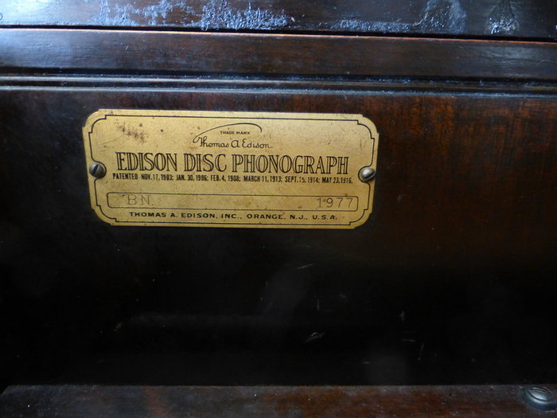
  Beethoven 3.jpg [ 145.95 KiB | Viewed 887 times ]
  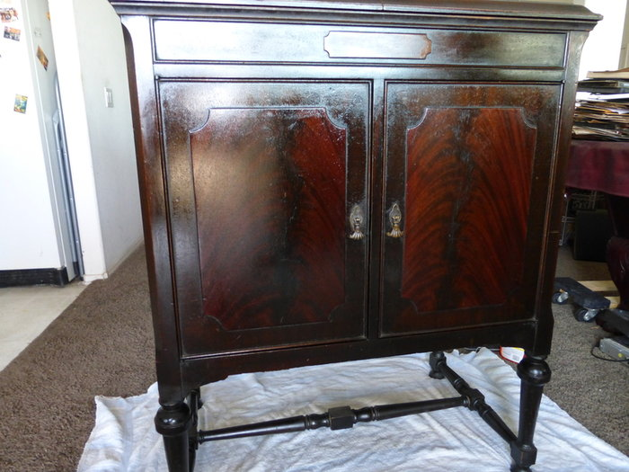
  Beethoven 1.jpg [ 309.43 KiB | Viewed 887 times ]
  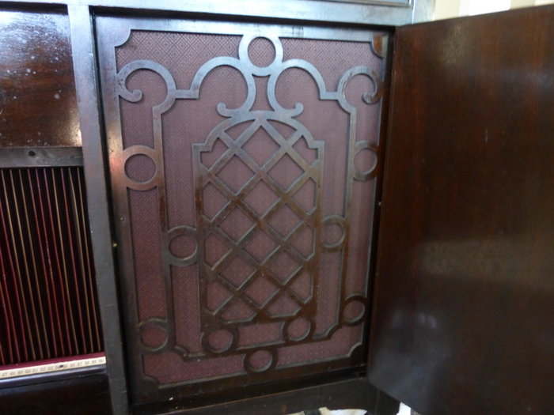
  Beethoven 2.jpg [ 149.19 KiB | Viewed 887 times ]
  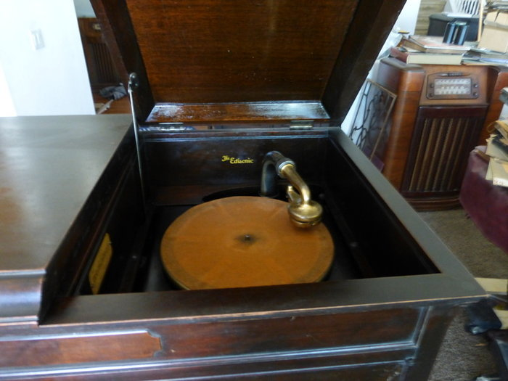
  Beethoven 4.jpg [ 138.46 KiB | Viewed 887 times ]
  "You must serve music, because music is so enormous and can envelop you into such a state of perpetual anxiety and torture--but it is our first and main duty"
  -- Maria Callas, 1968 interview.
Top

pughphonos
  Post subject: Re: Inventory of Beethoven and Schubert Edisonic phonographs
  Posted: Mon Apr 06, 2015 4:00 pm
Joined: Tue Jul 17, 2012 11:35 am  Posts: 670  Location: Homewood, Illinois, USA
  Victor III
  "You must serve music"
  UPDATED INDEX (AS OF APRIL 6, 2015) TO POSTINGS:
  SERIAL NUMBERS of machines posted above (and some below), arranged in order (with dates of posting):
  BEETHOVEN EDISONICS:
  1121 (4/30/2014); 1150 (4/25/2014); 1200 (03/8/2015);
  1220 (4/25/2014); 1238 (4/29/2014); 1262 (4/25/2014);
  1316 (4/25/2014); 1757 (4/25/2014); 1853 (4/23/2014);
  1898 (4/21/2014); 1977 (6/20/2014 & 7/1/2014 & 4/6/2015);
  2036 (4/25/2014); 2157 (4/22/2014); 2292? (4/21/2014);
  2488 (5/1/2014); 2491 (7/12/2014); 2641 (5/14/2014)
  SCHUBERT EDISONICS:
  1150 (4/25/2014); 1187 (4/24/2014); 1216 (4/25/2014, 4/26/2014 & 5/4/2014);
  1217 (4/28/2014 & 5/4/2014); 1246 (4/21/2014); 1329 (5/1/2014 & 05/6/2014);
  1394 (4/25/2014); 1441 (4/25/2014); 1556 (4/22/2014 & 5/2/2015);
  1596 (7/22/2014); 1656 (4/25/2014); 1672 (7/30/2014);
  1765 (4/23/2015 & 4/25/2015); 1844 (3/11/2015 & 5/3/2015);
  1897 (5/14/2014); 1902 (4/22/2014); 1913 (4/25/2014);
  2002 (4/25/2014); 2010 (4/28/2014); 2058 (4/25/2014);
  2288 (4/22/2014 & 5/1/2014); 2673 (4/24/2014 & 5/29/2014);
  2723 (4/23/2014); 2982(4/25/2014); 3020(4/22/2014);
  3023 (4/25/2014); 3398 (4/21/2014); 3618 (4/21/2014);
  3621 (5/18/2014); 3675 (4/21/2014); 3919 (7/7/2014);
  4005 (4/22/2014); 4129 (4/22/2014); 4246 (4/25/2014);
  4484 (4/25/2014); 4752 (4/21/2014); 4869 (4/29/2014);
  5056 (4/22/2014 & 5/23/2014); 5653 (4/21/2014);
  5670 (05/6/2014 & 5/19/2014); 5678 (4/28/2014);
  6025 (4/30/2014 & 6/21/2014)
  +++++++++++++++++++++++++++++++++++++++++++++++++++++++++++++++++++++++++++++++++++++++++++++++
  NON-SERIAL NUMBER DESIGNATION SYSTEM
  As stated at the start of this thread, it is preferred first and foremost that we list information on machines using serial numbers.
  However, in the case of old/inactive on-line listings where serial numbers were not provided and there is no current contact information, I have devised the following designation system whereby we can record information from these listings. It is not a perfect system as the same machines might appear again in listings from other localities. But it will still add to our knowledge base by enabling us to capture unique images and information on particular machines as they work their way through listings. If, in future, we can gain serial numbers for any of these machines, I will link the serial number to the old listings.
  For example, in 2013 I contacted a Craigslist seller in Minnesota who had a Schubert; he would not sell it to me as I could not arrange a local pick-up. I do not know what has since happened with that machine. But I still have the description from 2013. My temporary designation for that machine (so that I can post it here) is USMN2013MAY19.
  How to create a non-serial number designation. For old US postings, use US and then the US state postal code (in this case, MN=Minnesota), followed immediately by the original date of posting. For old foreign postings, spell out the full country name and then the original date of posting: e.g. FRANCE2012JANUARY31.
  The following entries are arranged chronologically by original posting dates:
  BEETHOVEN EDISONICS:
  USMI2007NOVEMBER9 (4/27/2014); US2010DECEMBER19 (5/3/2014)
  SCHUBERT EDISONICS:
  USNJ1997NOVEMBER15 (5/7/2014); AUSTRALIA1997NOVEMBER20 (5/1/2014);
  USNY2005 (5/2/2014); GERMANY2006 (4/25/2014);
  USMD2006JULY7 (4/24/2014 & 5/29/2014--SEE Serial #2673);
  USPA2007 (5/1/2014); USMI2007NOVEMBER9 (4/27/2014); USIL2008JUNE16 (4/27/2014);
  USIL2010JUNE12(4/24/2014); NEW ZEALAND2012MAY3 (4/25/2014);
  USWA2013MARCH17 (5/1/2014); USMN2013MAY19 (4/23/2013);
  USGA2013AUGUST8 (4/25/2014)
  +++++++++++++++++++++++++++++++++++++++++++++++++++++++++++++++++++++++++++++++++++++++++++++
  FINALLY, "YOU TUBE" VIDEOS OF UNIDENTIFIED EDISONICS AND THEIR UNIDENTIFIED OWNERS
  (see posting dated 4/30/2014 for details and links)
  Number of BEETHOVEN EDISONICS portrayed: 0
  Number of SCHUBERT EDISONICS portrayed: 2
  ("Classy8888" has since been identified as Ian Griggs, who owns #6025)
  ("Chagall56" has since been identified as our own "Marcapra"--and therefore the Schubert he taped is either #1246 or #3675. He's told us that #3675 has no stretcher bar, but I can't tell from the video!)
  "You must serve music, because music is so enormous and can envelop you into such a state of perpetual anxiety and torture--but it is our first and main duty"
  -- Maria Callas, 1968 interview.
  Last edited by pughphonos on Sun May 03, 2015 2:22 pm, edited 4 times in total.
Top

marcapra
  Post subject: Re: Inventory of Beethoven and Schubert Edisonic phonographs
  Posted: Tue Apr 07, 2015 2:23 am
Joined: Wed Jun 27, 2012 11:29 pm  Posts: 1915  Location: Temecula, CA
  Victor IV
  Man who ride on tiger find it very difficult to dismount! Charlie Chan
  Ralph, thanks for the heads up on my Beethoven Edisonic phonograph for sale! I should say that if you or your transporter are going to the CAPS show in Buena Park, CA in Aug., I can deliver the Beethoven there free of charge. Speaking of these marketing names of Beethoven and Schubert for the two Edisonics, I have a theory of how such composer's names were chosen in that year of 1927. I know that Ludwig Van Beethoven was getting a lot of press that year as the centennial of his death in 1827. Columbia Masterworks were putting out a slew of Beethoven recordings that year. Also, Columbia put out a slew of Schubert recordings in 1928 for the same reason as it was the centennial of his death. Since these composers' names were in the press already, I think that's why the Edison Co. chose them for the Edisonics.
Top

pughphonos
  Post subject: Re: Inventory of Beethoven and Schubert Edisonic phonographs
  Posted: Tue Apr 07, 2015 6:45 am
Joined: Tue Jul 17, 2012 11:35 am  Posts: 670  Location: Homewood, Illinois, USA
  Victor III
  "You must serve music"
  marcapra wrote:
  Ralph, thanks for the heads up on my Beethoven Edisonic phonograph for sale! I should say that if you or your transporter are going to the CAPS show in Buena Park, CA in Aug., I can deliver the Beethoven there free of charge. Speaking of these marketing names of Beethoven and Schubert for the two Edisonics, I have a theory of how such composer's names were chosen in that year of 1927. I know that Ludwig Van Beethoven was getting a lot of press that year as the centennial of his death in 1827. Columbia Masterworks were putting out a slew of Beethoven recordings that year. Also, Columbia put out a slew of Schubert recordings in 1928 for the same reason as it was the centennial of his death. Since these composers' names were in the press already, I think that's why the Edison Co. chose them for the Edisonics.
  Very astute observation, Marc. I teach history and often see such connections myself--but had missed the Edisonic naming in conjunction with the Beethoven/Schubert death centennials. Good job!
  If the Edisonic models had survived we might have had the Mendelssohn in 1947!
  Ralph
  P.S. Marc, see the very bottom of my last posting. Which of your Schuberts are you playing on You Tube as "Chagall56"? I'm guessing 3675.
  "You must serve music, because music is so enormous and can envelop you into such a state of perpetual anxiety and torture--but it is our first and main duty"
  -- Maria Callas, 1968 interview.
Top

Previous topic | Next topic

Display posts from previous:  Sort by   

 | Page 13 of 25 | [ 247 posts ] | Go to page Previous 1 ... 10, 11, 12, 13, 14, 15, 16 ... 25 Next

