marcapra
  Post subject: Re: Inventory of Beethoven and Schubert Edisonic phonographs
  Posted: Tue Mar 10, 2015 9:38 pm
Joined: Wed Jun 27, 2012 11:29 pm  Posts: 1915  Location: Temecula, CA
  Victor IV
  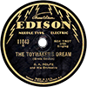
  Man who ride on tiger find it very difficult to dismount! Charlie Chan
  Hi Peter and Ralph! Since both of you added LP mechanisms to your Schuberts, did you use an official Edison LP kit that came out in 1927, or did you take your mechanism out of an existing LP phonograph? Are those official LP kits from Edison readily available or are they as rare as hen's teeth? They cost about $40 back in the late 20's which was a lot of money then. I'll guess that few LP kits were made or sold since there were only a total of 14 LP records made.
  Last edited by marcapra on Wed Mar 11, 2015 1:58 am, edited 1 time in total.
Top

pughphonos
  Post subject: Re: Inventory of Beethoven and Schubert Edisonic phonographs
  Posted: Tue Mar 10, 2015 10:22 pm
Joined: Tue Jul 17, 2012 11:35 am  Posts: 670  Location: Homewood, Illinois, USA
  Victor III
  
  "You must serve music"
  marcapra wrote:
  Hi Peter and Ralph! Since both of you added LP mechanisms to your Schuberts, did you use an official Edison LP kit that came out in 1927, or did you take your mechanism out of an existing LP phonograph? Are those offical LP kits from Edison readily available or are they as rare as hen's teeth? They cost about $40 back in the late 20's which was a lot of money then. I'll guess that few LP kits were made or sold since there were only a total of 14 LP records made.
  I contacted George Vollema and he removed the LP components for me from an LP machine he had in storage. Otherwise I would have been waiting forever for one of those kits--if any are really out there to be found anymore.
  Ralph
  "You must serve music, because music is so enormous and can envelop you into such a state of perpetual anxiety and torture--but it is our first and main duty"
  -- Maria Callas, 1968 interview.
Top

marcapra
  Post subject: Re: Inventory of Beethoven and Schubert Edisonic phonographs
  Posted: Wed Mar 11, 2015 2:00 am
Joined: Wed Jun 27, 2012 11:29 pm  Posts: 1915  Location: Temecula, CA
  Victor IV
  Man who ride on tiger find it very difficult to dismount! Charlie Chan
  Did you also get your LP reproducer from the same machine, or did you buy one elsewhere? What finish is on your LP reproducer? I understand that replacement LP styli are impossible to get.
Top

pughphonos
  Post subject: Re: Inventory of Beethoven and Schubert Edisonic phonographs
  Posted: Wed Mar 11, 2015 10:49 am
Joined: Tue Jul 17, 2012 11:35 am  Posts: 670  Location: Homewood, Illinois, USA
  Victor III
  "You must serve music"
  I bought my LP reproducer on-line and I lucked out; the stylus was good and the antique bronze finish is nice and matches my machine.
  It's unfortunately true that no one at present is making a satisfactory replacement stylus for the Edison Long Play reproducer. Expert Stylus (England) alleges that it does, but their product invariably scars the records. I won't give a name, but I know of at least one prominent antique phonographic repair shop in the U.S. that refuses to use their products anymore.
  The way it was explained to me, the original Edison LP stylus is a regular DD stylus that was ground in such a way that it became oblong--narrowed so that it can sink into the narrower groove, but longer (relatively speaking) from front to back so that the stylus spreads its weight enough to prevent scarring. Expert Stylus has created a "button" stylus that fits the Edison LP groove, but it transfers too much vertical pressure and scarring occurs.
  So, you're lucky to have a good original Edison LP stylus. Collect extra originals if you can.
  Ralph
  P.S. I believe the fellow in Florida (name escapes me) who's developed a replacement regular Edison DD stylus has NOT as yet developed a replacement Edison DD stylus. If I am wrong in this, I'd like to hear what's up.
  "You must serve music, because music is so enormous and can envelop you into such a state of perpetual anxiety and torture--but it is our first and main duty"
  -- Maria Callas, 1968 interview.
Top

PeterF
  Post subject: Re: Inventory of Beethoven and Schubert Edisonic phonographs
  Posted: Wed Mar 11, 2015 4:38 pm
Joined: Sun Jul 08, 2012 12:06 pm  Posts: 1365
  Victor IV
  Edison, Columbia, Victor, Pathé...and oddball makes
  On my Schubert, I simply pulled the complete motor assembly from a 1-C LP console that I also have on hand, and exchanged it for the Schubert's essentially identical motor. The LP console had arrived complete with both reproducers.
  On my C-250, I installed the LP conversion kit myself, using the original Edison instructions, reprinted and available from various sources. I think I bought the gearing and shifter loose from Charlie Hummel, and had found the LP reproducer separately. I kind of forget some of the details now, because this was in 2001! I remember the date with precision because I was listening to game 7 of the 2001 World Series as I did the installation. The despicable Yankees (and by extension, their idiot mayor Rudy G.) were defeated by the D-Backs: 11/4/2001.
Top

AudioAntique
  Post subject: Re: Inventory of Beethoven and Schubert Edisonic phonographs
  Posted: Wed Mar 11, 2015 8:21 pm
Joined: Fri May 30, 2014 2:48 pm  Posts: 113  Location: Northeast Wisconsin
  Victor I
  "There is always a way to do it better....find it" Thomas Edison
  Model: Schubert Edisonic
  Serial number: 1844
  Cabinet: Refinished
  Location: Wisconsin
  This item is for sale and listed with photos in “Yankee Trader.”
  http://www.audioantique.com - Books featuring Nipper Collectibles,Nipper items,Phonograph Dolls & Toys; Items for sale.
Top

pughphonos
  Post subject: Re: Inventory of Beethoven and Schubert Edisonic phonographs
  Posted: Wed Mar 11, 2015 10:32 pm
Joined: Tue Jul 17, 2012 11:35 am  Posts: 670  Location: Homewood, Illinois, USA
  Victor III
  "You must serve music"
  AudioAntique wrote:
  Model: Schubert Edisonic
  Serial number: 1844
  Cabinet: Refinished
  Location: Wisconsin
  This item is for sale and listed with photos in “Yankee Trader.”
  For the sake of having the images preserved on this string, I'm attaching below the photos that AudioAntique has posted in the "Yankee Trader" section. I think $250 is a VERY reasonable price, even with the unsatisfactory refinish job (which eliminated the decal and also the color contrasts on the doors). One still gets the Edisonic horn--and the reproducer can always be replaced.
  Here is the link to the web-site that directly features this machine:
  http://my.athenet.net/~nipper/
  Attachments:
  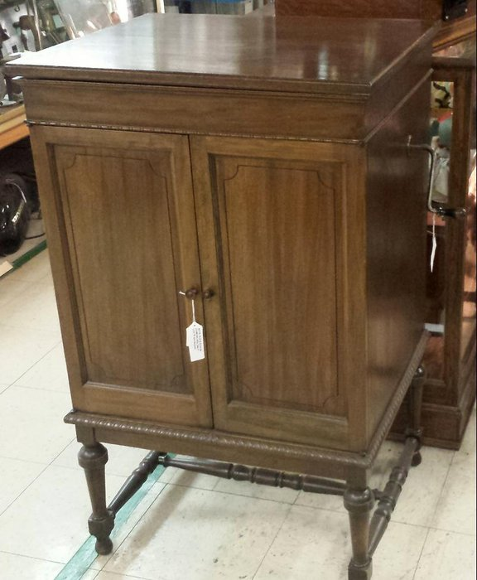
  20150310_142109-XLR.jpg [ 65.74 KiB | Viewed 800 times ]
  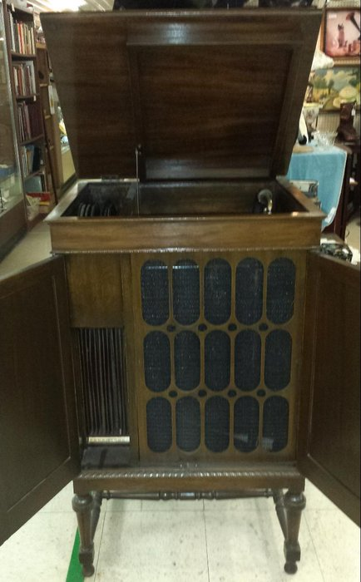
  20150310_141933-XLR.jpg [ 51.92 KiB | Viewed 800 times ]
  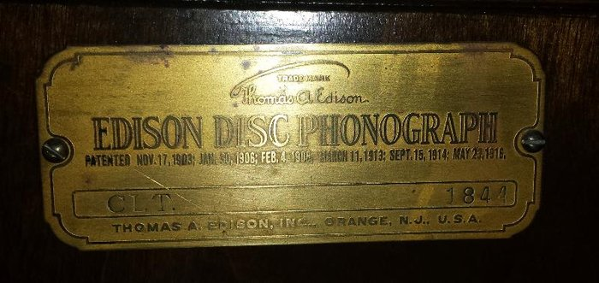
  20150310_141909-XLR.jpg [ 60.13 KiB | Viewed 800 times ]
  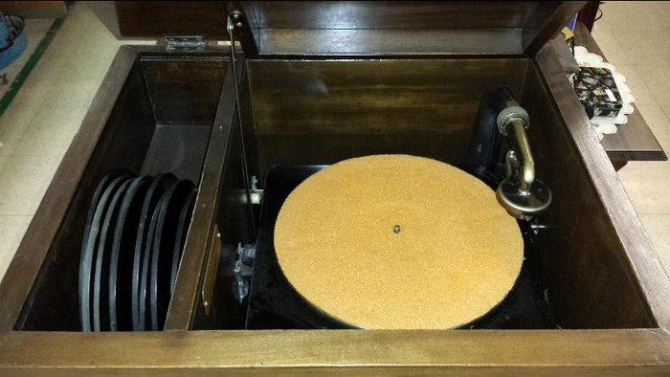
  20150310_141850-XLR.jpg [ 57.15 KiB | Viewed 800 times ]
  "You must serve music, because music is so enormous and can envelop you into such a state of perpetual anxiety and torture--but it is our first and main duty"
  -- Maria Callas, 1968 interview.
Top

Lenoirstreetguy
  Post subject: Re: Inventory of Beethoven and Schubert Edisonic phonographs
  Posted: Thu Mar 12, 2015 3:38 pm
Joined: Thu Jan 08, 2009 3:43 pm  Posts: 1183  Location: Toronto, Ontario
  Victor IV
  I just bought the first Edisonic brochure...or at least close to it... dated October , 1927. I thought I'd scan a few pages from it. I've seen these pictures of the machines reprinted many times, but I've never seen the whole brochure before. Did I tell you that a friend of mine in the States has a beautiful Beethoven Edisonic, unfortunately I don't know the serial number.
  Jim
  Attachments:
  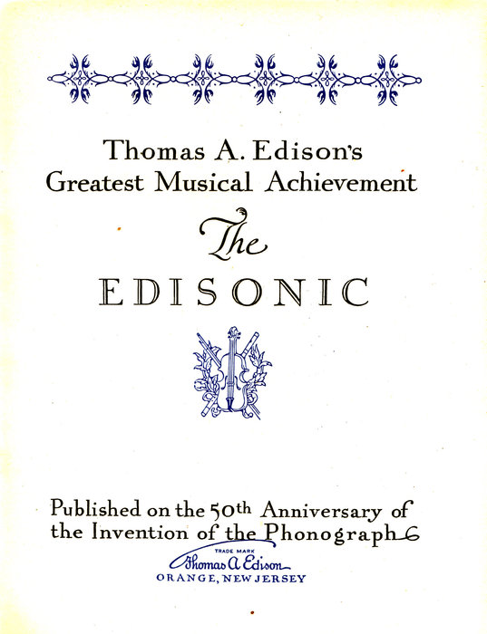
  IMG_0001.jpg [ 410.01 KiB | Viewed 787 times ]
  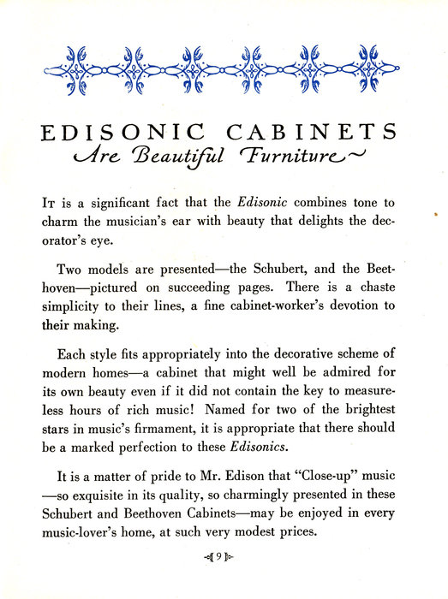
  IMG_0003.jpg [ 530.9 KiB | Viewed 787 times ]
  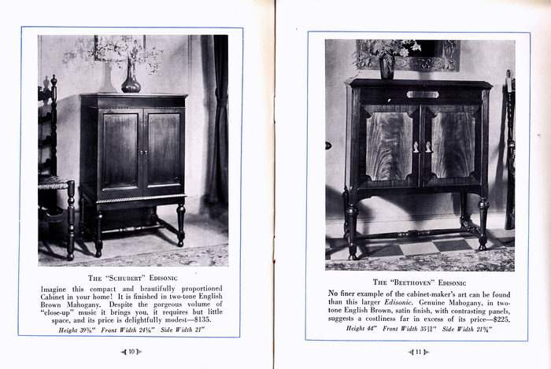
  IMG_0002.jpg [ 1.54 MiB | Viewed 787 times ]
Top

pughphonos
  Post subject: Re: Inventory of Beethoven and Schubert Edisonic phonographs
  Posted: Thu Mar 12, 2015 8:44 pm
Joined: Tue Jul 17, 2012 11:35 am  Posts: 670  Location: Homewood, Illinois, USA
  Victor III
  "You must serve music"
  Jim, thank you for such a nice addition to this string; your scans turned out beautifully.
  Looking forward to receiving the serial number of your friend's Beethoven in due course.
  "You must serve music, because music is so enormous and can envelop you into such a state of perpetual anxiety and torture--but it is our first and main duty"
  -- Maria Callas, 1968 interview.
Top

PeterF
  Post subject: Re: Inventory of Beethoven and Schubert Edisonic phonographs
  Posted: Thu Mar 12, 2015 9:08 pm
Joined: Sun Jul 08, 2012 12:06 pm  Posts: 1365
  Victor IV
  Edison, Columbia, Victor, Pathé...and oddball makes
  Any chance we could see the rest of the booklet, please?
Top

Previous topic | Next topic

Display posts from previous:  Sort by   

 | Page 12 of 25 | [ 247 posts ] | Go to page Previous 1 ... 9, 10, 11, 12, 13, 14, 15 ... 25 Nex

