barnettrp21122
  Post subject: Re: Inventory of Beethoven and Schubert Edisonic phonographs
  Posted: Tue Jul 22, 2014 8:45 pm
Joined: Thu Jan 08, 2009 4:19 pm  Posts: 1433
  Victor IV
  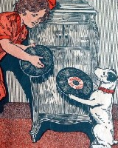
  "Did you ever stop to think that pleasure is a duty?" (Victor sales pamphlet)
  Damfino59 wrote:
  From what I saw of this Schubert at the sale it was very nice. Slight crazing to the lacquer. I may be wrong but I don't think it was refinished. It was on my list but you can't buy them all!
  I saw this machine in person too, and in my opinion it looks like it was given a brush coat of polyurethane from top to bottom. I have a Schubert and its surface is nothing like that.
  Bob
  "Comparison is the thief of joy" Theodore Roosevelt
Top

Damfino59
  Post subject: Re: Inventory of Beethoven and Schubert Edisonic phonographs
  Posted: Wed Jul 23, 2014 7:30 pm
Joined: Thu Feb 14, 2013 8:37 pm  Posts: 233  Location: Stillman Valley, IL
  Victor II
  Maybe it was coated with polyurethane or lacquer. It wasn't a wash with "brown gravy" as I've seen with badly refinished 1920's bedroom and dining room sets. But it doesn't matter as it's tainted. Taint mine nor yours. May the new owner enjoy it!
Top

pughphonos
  Post subject: Re: Inventory of Beethoven and Schubert Edisonic phonographs
  Posted: Wed Jul 30, 2014 9:36 am
Joined: Tue Jul 17, 2012 11:35 am  Posts: 670  Location: Homewood, Illinois, USA
  Victor III
  
  "You must serve music"
  UPDATED INDEX (AS OF JULY 30, 2014) TO POSTINGS:
  SERIAL NUMBERS of machines posted above (and some below), arranged in order (with dates of posting):
  BEETHOVEN EDISONICS:
  1121 (4/30/2014); 1150 (4/25/2014); 1220 (4/25/2014);
  1238 (4/29/2014); 1262 (4/25/2014); 1316 (4/25/2014);
  1757 (4/25/2014); 1853 (4/23/2014); 1898 (4/21/2014);
  1977 (6/20/2014 & 7/1/2014); 2036 (4/25/2014); 2157 (4/22/2014);
  2292? (4/21/2014); 2488 (5/1/2014); 2491 (7/12/2014);
  2641 (5/14/2014)
  SCHUBERT EDISONICS:
  1150 (4/25/2014); 1187 (4/24/2014); 1216 (4/25/2014, 4/26/2014 & 5/4/2014);
  1217 (4/28/2014 & 5/4/2014); 1246 (4/21/2014); 1329 (5/1/2014 & 05/6/2014);
  1394 (4/25/2014); 1441 (4/25/2014); 1556 (4/22/2014); 1596 (7/22/2014);
  1656 (4/25/2014); 1672 (7/30/2014); 1897 (5/14/2014); 1902 (4/22/2014);
  1913 (4/25/2014); 2002 (4/25/2014); 2010 (4/28/2014);
  2058 (4/25/2014); 2288 (4/22/2014 & 5/1/2014);
  2673 (4/24/2014 & 5/29/2014); 2723 (4/23/2014);
  2982(4/25/2014); 3020(4/22/2014); 3023 (4/25/2014);
  3398 (4/21/2014); 3618 (4/21/2014); 3621 (5/18/2014);
  3675 (4/21/2014); 3919 (7/7/2014); 4005 (4/22/2014);
  4129 (4/22/2014); 4246 (4/25/2014); 4484 (4/25/2014);
  4752 (4/21/2014); 4869 (4/29/2014); 5056 (4/22/2014 & 5/23/2014);
  5653 (4/21/2014); 5670 (05/6/2014 & 5/19/2014);
  5678 (4/28/2014); 6025 (4/30/2014 & 6/21/2014)
  +++++++++++++++++++++++++++++++++++++++++++++++++++++++++++++++++++++++++++++++++++++++++++++++
  NON-SERIAL NUMBER DESIGNATION SYSTEM
  As stated at the start of this thread, it is preferred first and foremost that we list information on machines using serial numbers.
  However, in the case of old/inactive on-line listings where serial numbers were not provided and there is no current contact information, I have devised the following designation system whereby we can record information from these listings. It is not a perfect system as the same machines might appear again in listings from other localities. But it will still add to our knowledge base by enabling us to capture unique images and information on particular machines as they work their way through listings. If, in future, we can gain serial numbers for any of these machines, I will link the serial number to the old listings.
  For example, in 2013 I contacted a Craigslist seller in Minnesota who had a Schubert; he would not sell it to me as I could not arrange a local pick-up. I do not know what has since happened with that machine. But I still have the description from 2013. My temporary designation for that machine (so that I can post it here) is USMN2013MAY19.
  How to create a non-serial number designation. For old US postings, use US and then the US state postal code (in this case, MN=Minnesota), followed immediately by the original date of posting. For old foreign postings, spell out the full country name and then the original date of posting: e.g. FRANCE2012JANUARY31.
  The following entries are arranged chronologically by original posting dates:
  BEETHOVEN EDISONICS:
  USMI2007NOVEMBER9 (4/27/2014); US2010DECEMBER19 (5/3/2014)
  SCHUBERT EDISONICS:
  USNJ1997NOVEMBER15 (5/7/2014); AUSTRALIA1997NOVEMBER20 (5/1/2014);
  USNY2005 (5/2/2014); GERMANY2006 (4/25/2014);
  USMD2006JULY7 (4/24/2014 & 5/29/2014--SEE Serial #2673);
  USPA2007 (5/1/2014); USMI2007NOVEMBER9 (4/27/2014); USIL2008JUNE16 (4/27/2014);
  USIL2010JUNE12(4/24/2014); NEW ZEALAND2012MAY3 (4/25/2014);
  USWA2013MARCH17 (5/1/2014); USMN2013MAY19 (4/23/2013);
  USGA2013AUGUST8 (4/25/2014)
  +++++++++++++++++++++++++++++++++++++++++++++++++++++++++++++++++++++++++++++++++++++++++++++
  FINALLY, "YOU TUBE" VIDEOS OF UNIDENTIFIED EDISONICS AND THEIR UNIDENTIFIED OWNERS
  (see posting dated 4/30/2014 for details and links)
  Number of BEETHOVEN EDISONICS portrayed: 0
  Number of SCHUBERT EDISONICS portrayed: 2
  ("Classy8888" has since been identified as Ian Griggs, who owns serial number 6025)
  "You must serve music, because music is so enormous and can envelop you into such a state of perpetual anxiety and torture--but it is our first and main duty"
  -- Maria Callas, 1968 interview.
  Last edited by pughphonos on Wed Jul 30, 2014 10:23 am, edited 3 times in total.
Top

pughphonos
  Post subject: Re: Inventory of Beethoven and Schubert Edisonic phonographs
  Posted: Wed Jul 30, 2014 9:55 am
Joined: Tue Jul 17, 2012 11:35 am  Posts: 670  Location: Homewood, Illinois, USA
  Victor III
  "You must serve music"
  SCHUBERT OWNED BY COLLECTOR IN THE WESTERN U.S.
  Model: Schubert Edisonic
  Serial number: 1672
  I've received report of another Schubert. The person involved is willing to share a description of the machine's recent purchase history and condition (without photos), which is fine. As I have said many times on this thread, I am willing to accommodate everyone's comfort zone: share as much or as little as you like about your machines.
  The description reads:
  "...the Edisonic—stamped onto the small tag: CLT 1672. Yes it is a Schubert model. Sorry, I do not know when I purchased it—was about 1996, 1997, or 1998. I paid six hundred for it from a fellow in Florida, of all places. It cost about another hundred to have it packed and shipped. It arrived in fine condition -- insulated and packed in a very large form-fitting cardboard box. Sorry, I do not know the fellow’s name or how I came to know about the unit. I may have that information somewhere in my files, but I doubt it."
  "The Edisonic cabinet arrived in fine condition and I did not need to make any cabinet repairs; I would estimate the condition to be very good to excellent, but not mint. Still, these late 1920’s dark cabinets were never as high quality or as interesting as the cabinets from the 1910’s. I did check the motor works and added some lubrication here and there, but noted no problems with the cabinet or the mechanical works. The only obvious problem was the rather unpleasant odor it emitted when the lid was open. I sent the reproducer to [Bob] Waltrip for his special restoration with the Styrofoam diaphragm. No special features; it appears to be a standard model."
  "You must serve music, because music is so enormous and can envelop you into such a state of perpetual anxiety and torture--but it is our first and main duty"
  -- Maria Callas, 1968 interview.
Top

pughphonos
  Post subject: Re: Inventory of Beethoven and Schubert Edisonic phonographs
  Posted: Wed Feb 25, 2015 3:11 pm
Joined: Tue Jul 17, 2012 11:35 am  Posts: 670  Location: Homewood, Illinois, USA
  Victor III
  "You must serve music"
  BEETHOVEN EDISONIC FOR SALE BY HAWTHORN'S ANTIQUE AUDIO (via E-bay)
  Model: Beethoven Edisonic
  Serial number: 2491
  I'm coming out of virtual phonographic retirement (it seems) to announce the appearance (for sale) of a well-preserved Beethoven Edisonic: serial number 2491. Mr. Hawthorn (as you will see below) does not name the seller, so I will not do so here. But I had posted earlier on this string about this particular machine (7/13/2014)--so do your own research.
  As part of his on-line ad (posted in late February 2015, with a requested opening bid for $3495), Mr. Hawthorn writes the following (and also posts these excellent photographs):
  "This instrument is being offered on behalf of a collector friend, and is located in Central California. The phonograph runs perfectly and plays with surprising tone and volume. The Edisonic reproducer that came with the machine had a little wear, so it has been replaced with an unused one from a new/old dealer stock. The interior of the cabinet is in excellent condition and the original finish is still bright and shiny. All metal parts are antique bronze and the turntable felt is original and intact. The top and front doors have been professionally refinished, and the burl walnut on the front doors is absolutely stunning. The sides have not been refinished, but this would be an easy task. The records in the pictures are not included with the machine."
  Attachments:
  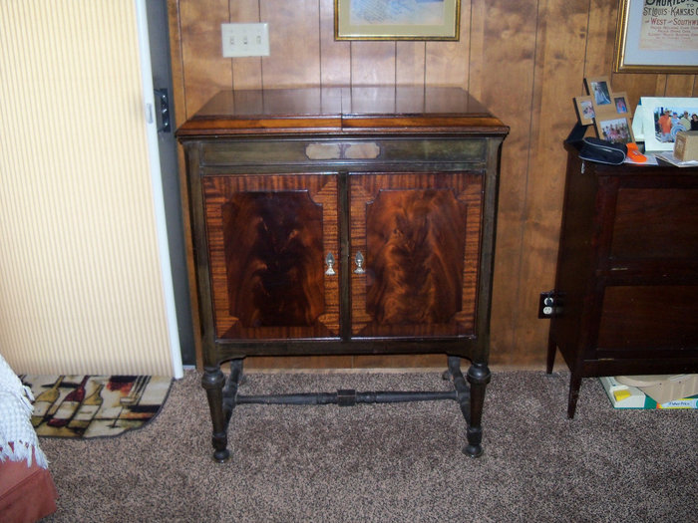
  Beethoven1.JPG [ 411.64 KiB | Viewed 830 times ]
  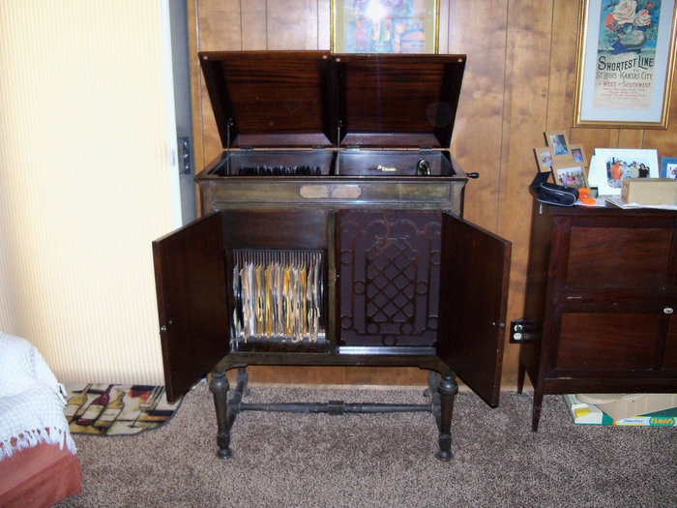
  Beethoven2.JPG [ 408.87 KiB | Viewed 830 times ]
  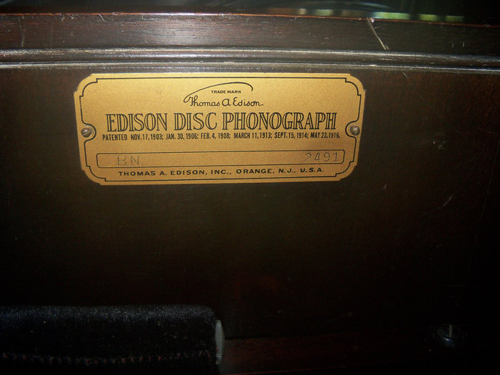
  Beethoven3.JPG [ 337.17 KiB | Viewed 830 times ]
  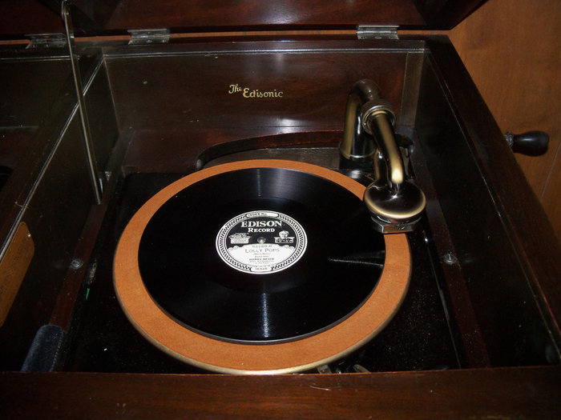
  Beethoven4.JPG [ 293.28 KiB | Viewed 830 times ]
  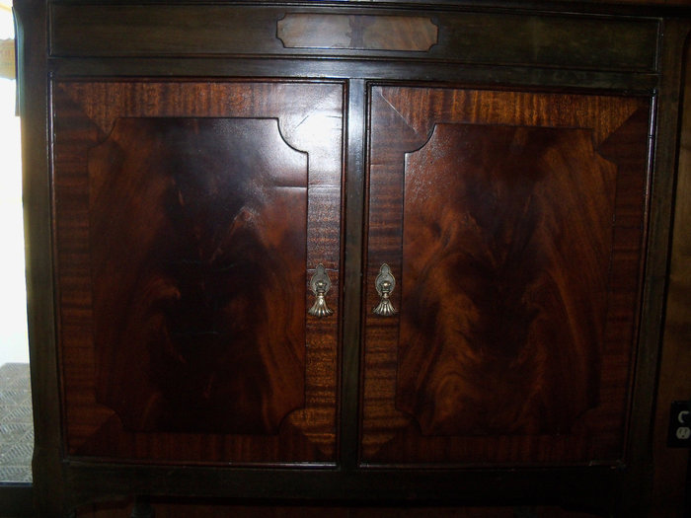
  Beethoven5.JPG [ 286.04 KiB | Viewed 830 times ]
  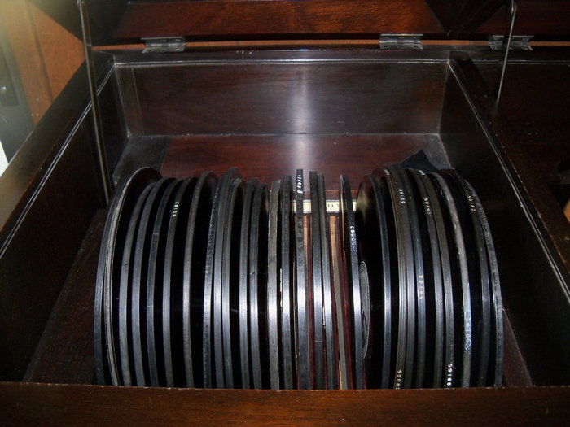
  Beethoven6.JPG [ 336.4 KiB | Viewed 830 times ]
  "You must serve music, because music is so enormous and can envelop you into such a state of perpetual anxiety and torture--but it is our first and main duty"
  -- Maria Callas, 1968 interview.
Top

Mr Grumpy
  Post subject: Re: Inventory of Beethoven and Schubert Edisonic phonographs
  Posted: Wed Feb 25, 2015 4:00 pm
Joined: Sat Nov 10, 2012 5:59 pm  Posts: 772  Location: Ontario Canada
  Victor III
  
  pughphonos wrote:
  I'm coming out of virtual phonographic retirement (it seems) to announce...
  Does this mean you're officially out of retirement? Semi-retired?
  I hope so!
  Vince
  Redcar Music Company
  Youtube
Top

brianu
  Post subject: Re: Inventory of Beethoven and Schubert Edisonic phonographs
  Posted: Wed Feb 25, 2015 4:18 pm
Joined: Wed Jan 07, 2009 3:35 pm  Posts: 2057  Location: just outside Philadelphia, PA
  Victor V
  on instagram as "oncedeadsound"
  that's pretty nice, but pretty steep price wise.
Top

pughphonos
  Post subject: Re: Inventory of Beethoven and Schubert Edisonic phonographs
  Posted: Wed Feb 25, 2015 4:54 pm
Joined: Tue Jul 17, 2012 11:35 am  Posts: 670  Location: Homewood, Illinois, USA
  Victor III
  "You must serve music"
  Mr Grumpy wrote:
  pughphonos wrote:
  I'm coming out of virtual phonographic retirement (it seems) to announce...
  Does this mean you're officially out of retirement? Semi-retired?
  I hope so!
  Vince, it was worth returning to the board just to see the exotic icon you've put up. I used to be the most risque one by lurking under Maria Callas; but people can now slip dollar bills under your belt....
  "You must serve music, because music is so enormous and can envelop you into such a state of perpetual anxiety and torture--but it is our first and main duty"
  -- Maria Callas, 1968 interview.
Top

Mr Grumpy
  Post subject: Re: Inventory of Beethoven and Schubert Edisonic phonographs
  Posted: Wed Feb 25, 2015 5:10 pm
Joined: Sat Nov 10, 2012 5:59 pm  Posts: 772  Location: Ontario Canada
  Victor III
  pughphonos wrote:
  Mr Grumpy wrote:
  pughphonos wrote:
  I'm coming out of virtual phonographic retirement (it seems) to announce...
  Does this mean you're officially out of retirement? Semi-retired?
  I hope so!
  Vince, it was worth returning to the board just to see the exotic icon you've put up. I used to be the most risque one by lurking under Maria Callas; but people can now slip dollar bills under your belt....
  The more nut-jobs the merrier.
  Vince
  Redcar Music Company
  Youtube
Top

marcapra
  Post subject: Re: Inventory of Beethoven and Schubert Edisonic phonographs
  Posted: Sun Mar 08, 2015 4:37 am
Joined: Wed Jun 27, 2012 11:29 pm  Posts: 1915  Location: Temecula, CA
  Victor IV
  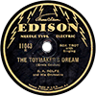
  Man who ride on tiger find it very difficult to dismount! Charlie Chan
  I just bought a new Beethoven Edisonic phonograph. It is serial number 1200. It is the most pristine example that I've ever seen in that it appears untouched. It is left over dealer stock! The cabinet finish has not darkened like my other Beethoven. It could use a cleaning and a waxing, but then it's just been sitting around for the last 88 years! The interior looks especially clean. There are no chips that you usually see on the record dividers! I got it from a friend who just happened to be in a music store where he happened to mention that he collects old Victrolas. The lady said "Oh I have a Victrola made by Edison". "You see my grandfather was an Edison dealer in Phoenix." So he went over to see what the lady had and she had hundreds of DDs, a Beethoven Edisonic, a Diamond Disc cabinet, some literature, etc. She had a letter from the Edison Co. saying that the upcoming year will be the best year ever for Edison musical products, dated September, 1929! The Beethoven I bought has the Long Play attachment installed as well as an NOS Long Play reproducer still in the cradle with a cloth sack over it. I believe this equipment was installed back when the machine was in his store in 27 or 28 because there were 9 Long Play records in his left over record stock including some duplicates. They are all 10" records and I bought five of them for the Long Play mechanism. Did the Long Play kit that dealers installed include the 10/12 keys? My Beethoven does not have them. Unfortunately, my new Beethoven is missing the original Edisonic reproducer, but I already have several anyway. I'm probably one of the few people on Earth who own two Beethovens! A couple of years ago, after looking for some ten years, I gave up hope of ever finding a Beethoven for sale. Now it looks like I have one to sell.
Top

Previous topic | Next topic

Display posts from previous:  Sort by   

 | Page 10 of 25 | [ 247 posts ] | Go to page Previous 1 ... 7, 8, 9, 10, 11, 12, 13 ... 25 Next

