pughphonos
  Post subject: Re: Inventory of Beethoven and Schubert Edisonic phonographs
  Posted: Wed Jun 04, 2014 12:58 pm
Joined: Tue Jul 17, 2012 11:35 am  Posts: 670  Location: Homewood, Illinois, USA
  Victor III
  
  "You must serve music"
  UPDATED INDEX (AS OF JUNE 4, 2014) TO POSTINGS ABOVE:
  The information in this posting became outdated and has been replaced by a new "Updated Index" that can be found at or near the end of this thread.
  "You must serve music, because music is so enormous and can envelop you into such a state of perpetual anxiety and torture--but it is our first and main duty"
  -- Maria Callas, 1968 interview.
  Last edited by pughphonos on Fri Jun 20, 2014 9:47 am, edited 1 time in total.
Top

pughphonos
  Post subject: Re: Inventory of Beethoven and Schubert Edisonic phonographs
  Posted: Fri Jun 20, 2014 9:37 am
Joined: Tue Jul 17, 2012 11:35 am  Posts: 670  Location: Homewood, Illinois, USA
  Victor III
  "You must serve music"
  BEETHOVEN EDISONIC OFFERED ON E-BAY & CRAIGLIST (DOUGLASVILLE, GEORGIA), POSTED JUNE 19, 2014
  Model: Beethoven Edisonic
  Serial number: 1977
  Thanks to the keen eyes of Gene ("gemering") another Beethoven Edisonic has been spotted for sale; hope one of our Edisonic fans on this forum can give it a nice home.
  Here's the link to the Craigslist posting, which will no doubt disappear soon:
  http://atlanta.craigslist.org/wat/atq/4528810155.html
  Here's the link to the E-bay posting:
  http://www.ebay.com/itm/Vintage-record- ... 3a92684a84
  The ad begins with this curious header:
  "edisonic phonographer 1977 thomas edison record player - $600 (douglasville ga)"
  This same ad is also on E-bay, but with better photos; below are the E-bay photos.
  The text of the ad reads:
  "vintage thomas edison record player needs wiped down with wood cleaner other than that in good condition. missing one handle to open door $600 or best offer. please contact through email."
  Attachments:
  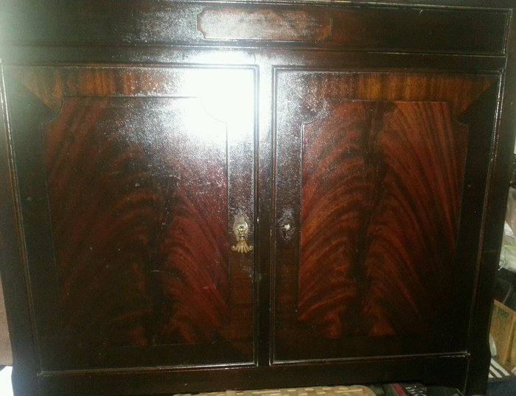
  $_57.JPG [ 322.94 KiB | Viewed 785 times ]
  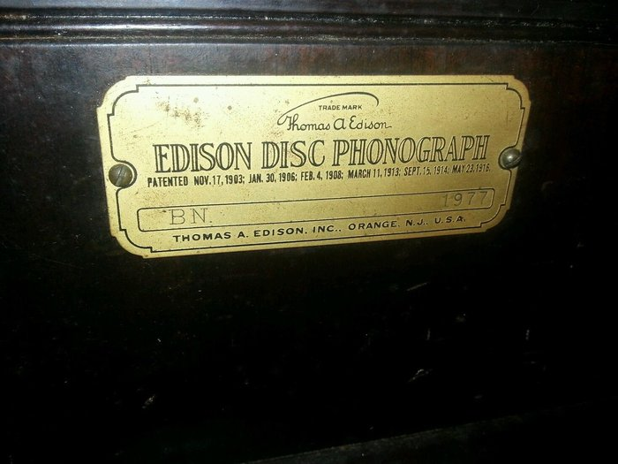
  $_57 (4).jpg [ 209.46 KiB | Viewed 785 times ]
  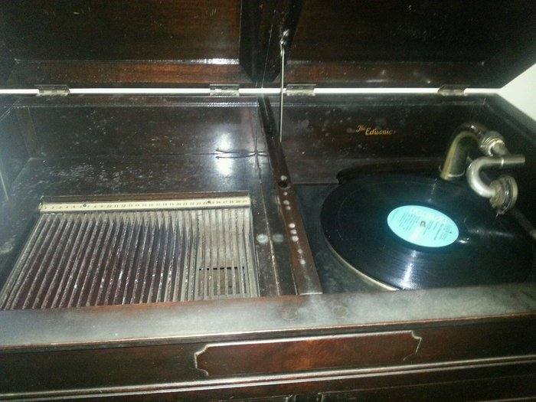
  $_57 (3).jpg [ 316.43 KiB | Viewed 785 times ]
  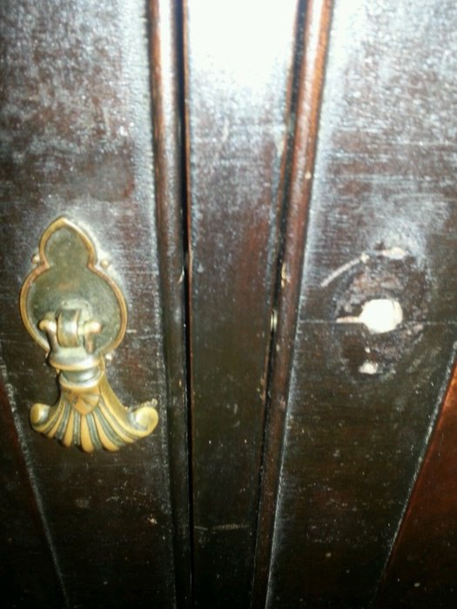
  $_57 (2).jpg [ 192.56 KiB | Viewed 785 times ]
  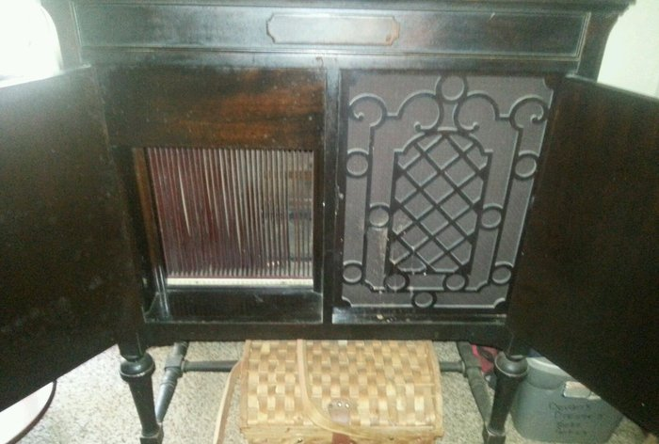
  $_57 (1).jpg [ 234.89 KiB | Viewed 785 times ]
  "You must serve music, because music is so enormous and can envelop you into such a state of perpetual anxiety and torture--but it is our first and main duty"
  -- Maria Callas, 1968 interview.
  Last edited by pughphonos on Fri Jun 20, 2014 3:41 pm, edited 2 times in total.
Top

pughphonos
  Post subject: Re: Inventory of Beethoven and Schubert Edisonic phonographs
  Posted: Fri Jun 20, 2014 9:44 am
Joined: Tue Jul 17, 2012 11:35 am  Posts: 670  Location: Homewood, Illinois, USA
  Victor III
  "You must serve music"
  UPDATED INDEX (AS OF JUNE 20, 2014) TO POSTINGS ABOVE:
  The information in this posting became outdated and has been replaced by a new "Updated Index" that can be found at or near the end of this thread.
  "You must serve music, because music is so enormous and can envelop you into such a state of perpetual anxiety and torture--but it is our first and main duty"
  -- Maria Callas, 1968 interview.
  Last edited by pughphonos on Thu Jul 10, 2014 10:34 am, edited 5 times in total.
Top

pughphonos
  Post subject: Re: Inventory of Beethoven and Schubert Edisonic phonographs
  Posted: Fri Jun 20, 2014 11:24 pm
Joined: Tue Jul 17, 2012 11:35 am  Posts: 670  Location: Homewood, Illinois, USA
  Victor III
  "You must serve music"
  Good news! Marc of our forum ("Marcapra"), who already owns two Schuberts (serial nos. 1246 and 3675; see 4/21/2014 above), has just bought Beethoven serial no. 1977.
  "You must serve music, because music is so enormous and can envelop you into such a state of perpetual anxiety and torture--but it is our first and main duty"
  -- Maria Callas, 1968 interview.
Top

marcapra
  Post subject: Re: Inventory of Beethoven and Schubert Edisonic phonographs
  Posted: Sat Jun 21, 2014 2:23 am
Joined: Wed Jun 27, 2012 11:29 pm  Posts: 1915  Location: Temecula, CA
  Victor IV
  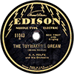
  Man who ride on tiger find it very difficult to dismount! Charlie Chan
  Yes I got it and a friend just so happens to be driving my way from Florida to pick up a phonograph in San Diego and he will pick it up for me. I've only had a few chances to buy a Beethoven in the past. Only once did I find one in good condition and complete, but someone else got to it before I did. That was on Craigslist. If anyone knows where i can purchase another door knob for it, let me know. I wonder if I can have one made or cast?
Top

marcapra
  Post subject: Re: Inventory of Beethoven and Schubert Edisonic phonographs
  Posted: Sat Jun 21, 2014 5:23 pm
Joined: Wed Jun 27, 2012 11:29 pm  Posts: 1915  Location: Temecula, CA
  Victor IV
  Man who ride on tiger find it very difficult to dismount! Charlie Chan
  When I asked about the condition of the feet, the seller of the Beethoven said that it had rusty castors. Did Beethovens come with castors? Neither of my Schubert machines have them.
Top

pughphonos
  Post subject: Re: Inventory of Beethoven and Schubert Edisonic phonographs
  Posted: Sat Jun 21, 2014 8:09 pm
Joined: Tue Jul 17, 2012 11:35 am  Posts: 670  Location: Homewood, Illinois, USA
  Victor III
  "You must serve music"
  Marc, I'll ask a local friend of mine who has a Beethoven.
  "You must serve music, because music is so enormous and can envelop you into such a state of perpetual anxiety and torture--but it is our first and main duty"
  -- Maria Callas, 1968 interview.
Top

pughphonos
  Post subject: Re: Inventory of Beethoven and Schubert Edisonic phonographs
  Posted: Sat Jun 21, 2014 8:36 pm
Joined: Tue Jul 17, 2012 11:35 am  Posts: 670  Location: Homewood, Illinois, USA
  Victor III
  "You must serve music"
  SERIAL NUMBER GAINED FOR SCHUBERT EDISONIC BELONGING TO IAN GRIGGS OF AUSTRALIA--THE LATEST ONE YET
  Model: Schubert Edisonic
  Serial number: 6025
  On 4/30/2014 (above) I posted about two Schuberts that were featured separately on YouTube by two separate gentlemen. At that time I sent messages to both men, and today I heard from "Classy8888," who had posted the following video on December 12, 2012 (link below). He has told me that his machine's serial number is 6025--which is the latest one for a Schubert I have ever heard of.
  https://www.youtube.com/watch?v=ZC3MxM8BAQ0
  "Classy8888" is Ian Griggs of Darlinghurst, New South Wales, Australia--where for some years he was (is?) the organist at St. John's Anglican Church there.
  "You must serve music, because music is so enormous and can envelop you into such a state of perpetual anxiety and torture--but it is our first and main duty"
  -- Maria Callas, 1968 interview.
Top

marcapra
  Post subject: Re: Inventory of Beethoven and Schubert Edisonic phonographs
  Posted: Tue Jul 01, 2014 1:56 am
Joined: Wed Jun 27, 2012 11:29 pm  Posts: 1915  Location: Temecula, CA
  Victor IV
  Man who ride on tiger find it very difficult to dismount! Charlie Chan
  Just an update on my newly acquired Beethoven phonograph. I successfully removed the stuck Victrola tonearm from the Edison horn neck by using a hacksaw and screwdriver to pry it out. I inserted an Edisonic reproducer and played a record, but it was spinning at 88 rpms! Now I have to find out how to adjust the speed, since Edisonics don't have a speed control on the motor board. I also put an announcement on the Yankee Trader that I am trying to find out how many Beethoven owners would be interested in going in on having repro sets of door pulls made. I could use my one original as a model or mold. It would a bit more challenging than an average door knob which are usually in one piece. The Beethoven door pull is in three parts: the escutcheon, the pin, and the hanging pull. So let me know. Thanks, Marc.
Top

pughphonos
  Post subject: Re: Inventory of Beethoven and Schubert Edisonic phonographs
  Posted: Mon Jul 07, 2014 9:37 am
Joined: Tue Jul 17, 2012 11:35 am  Posts: 670  Location: Homewood, Illinois, USA
  Victor III
  "You must serve music"
  GREGBOGANTZ'S SCHUBERT EDISONIC
  Model: Schubert Edisonic
  Serial number: 3919
  Greg has provided the serial number to his Schubert; much appreciated.
  This would be a good time to repeat that my approach to this thread ("Edisonic inventory") is that everyone is welcome to contribute as much or as little information about their Edisonics as they wish. As the Edisonics were in production only for a couple of years (1927-1929) they apparently experienced no modifications along the way (unlike most other Edison phonographs) and therefore I am not trying to obtain serial numbers as a way of tracking the appearance of those modifications. Rather, as there were relatively fewer Edisonics produced that other Edison models, the prime goal here is to get a sense of how many of them have survived to the present day. For those who want to share more, that's all the more interest and fun for the rest of us.
  Reviewing my investigations to date, all indications are that there are around 50 Schuberts that have been either directly reported by their owners or have made some sort of appearance on-line (including those covered by my "Non-serial number designation" system). The Beethovens come in at 17.
  The survey also shows (see my summary of June 20, above) that there was a wide range of serial numbers involved in production (both models starting at 1000, with the Beethovens going up past 2600 and the Schuberts past 6000). So, there were potentially as many as 6600 Edisonics produced. If one liberally discounts that (allowing the possibility that some of the serial numbers might not have been utilized), one could still reasonably expect a production figure in the 4500-5500 range. But also note that we appear to have a pretty "spread out" representation of serial numbers; there are few notable gaps that would allow for large groups of unused numbers.
  So, at the widely-accepted antique phonograph 20% survival rate, there should be around 900-1100 Edisonics still out there.
  So, either we have many, many more yet to discover, or the Edisonics have a much poorer survival rate than many other antique phonographs.
  I wonder how much an "annoyance factor" might have been at play re. survivability. That is, many Edison disc machine owners must have been frustrated by the obsolescence of their machines by 1930 (no more discs to be had) and I'd assume that many more made their way to the trash in the years immediately following 1929 than did lateral machines.
  Ralph
  "You must serve music, because music is so enormous and can envelop you into such a state of perpetual anxiety and torture--but it is our first and main duty"
  -- Maria Callas, 1968 interview.
Top

Previous topic | Next topic

Display posts from previous:  Sort by   

 | Page 8 of 25 | [ 247 posts ] | Go to page Previous 1 ... 5, 6, 7, 8, 9, 10, 11 ... 25 Next

