pughphonos
  Post subject: Re: Inventory of Beethoven and Schubert Edisonic phonographs
  Posted: Sun May 18, 2014 7:24 pm
Joined: Tue Jul 17, 2012 11:35 am  Posts: 670  Location: Homewood, Illinois, USA
  Victor III
  
  "You must serve music"
  MY (RALPH'S) MACHINE ("PUGHPHONOS")
  I've decided to remove my machine's submission from the opening message on this thread, which had made that opening message too long. I've also snapped a few more photos for better documentation of my machine, even though my camera isn't great.
  Model: Schubert Edisonic
  Serial number: 3621
  When purchased: September 2013
  From whom purchased: Ron Haring of Plano, Illinois, who had bought it for me at an auction held in Michigan September 20-21, 2013.
  Cabinet condition when purchased: C+ or B- level; woodwork and veneering almost entirely intact, but much "weathered"; doors over horn somewhat warped. Grille cloth is wholly intact but has a top lateral fade stripe in addition to the usual vertical fade line one finds on these machines (via door crack)
  Upgrades made by present owner: Installed Long Play gearing and switch; installed double spring (formerly single spring); installed rack for extra reproducers.
  Attachments:
  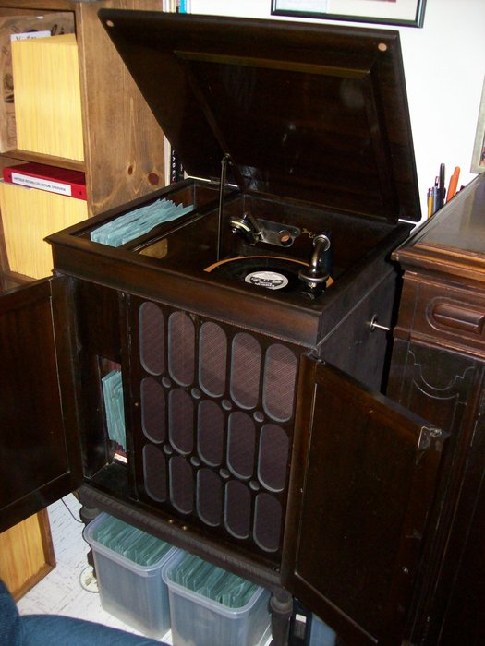
  PughSchubert.JPG [ 564.52 KiB | Viewed 1198 times ]
  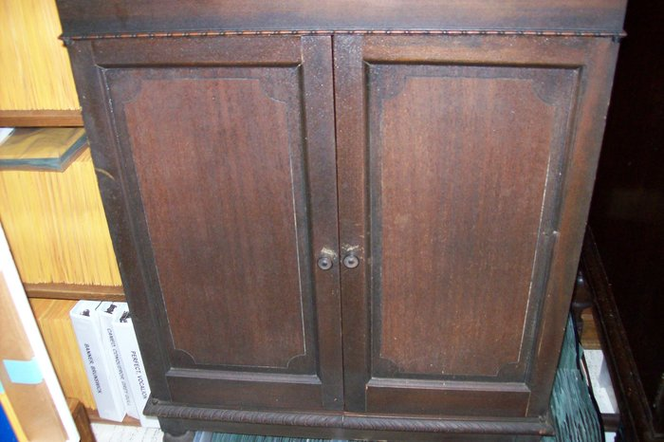
  sun 175.JPG [ 883.84 KiB | Viewed 1198 times ]
  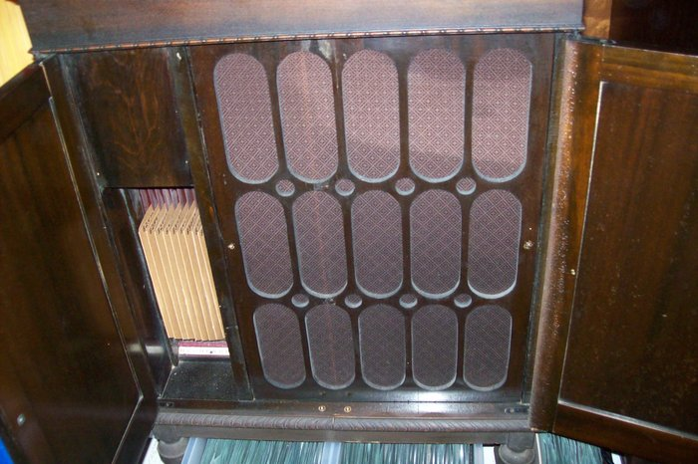
  sun 174.JPG [ 887.75 KiB | Viewed 1198 times ]
  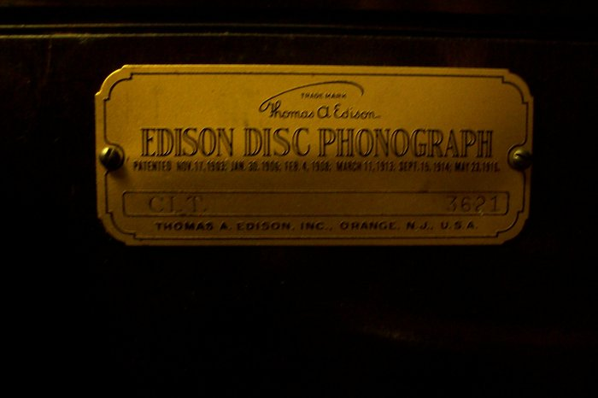
  sun 173.JPG [ 803.5 KiB | Viewed 1198 times ]
  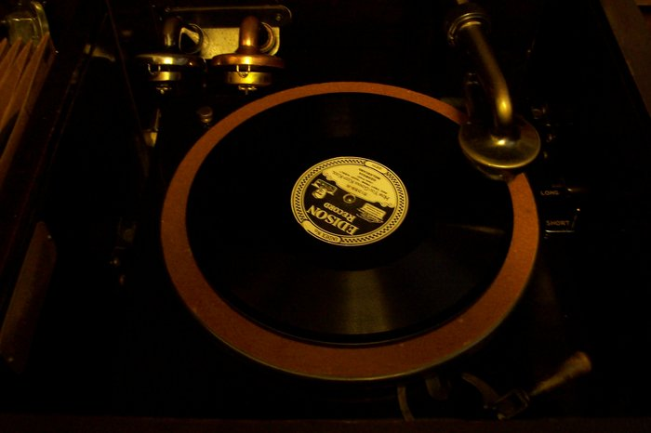
  sun 171.JPG [ 818.93 KiB | Viewed 1198 times ]
  "You must serve music, because music is so enormous and can envelop you into such a state of perpetual anxiety and torture--but it is our first and main duty"
  -- Maria Callas, 1968 interview.
Top

budsta
  Post subject: Re: Inventory of Beethoven and Schubert Edisonic phonographs
  Posted: Mon May 19, 2014 7:33 pm
Joined: Fri Jul 17, 2009 5:11 pm  Posts: 89
  Victor O
  Hi all
  Here are some pictures of mine.
  I keep my machines in a room with the blinds down all the time so no natural light shines in on them.
  cheers
  Attachments:
  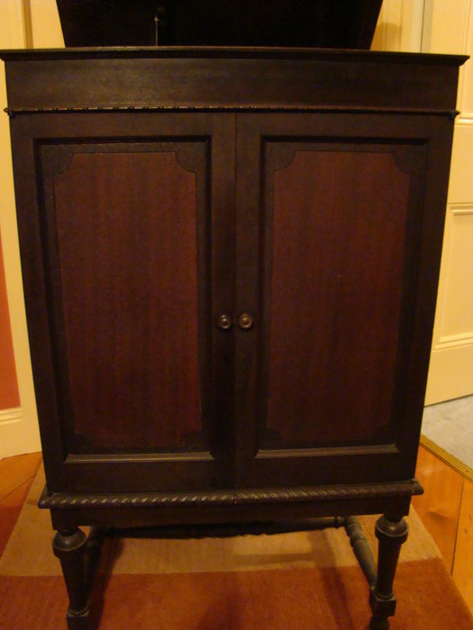
  DSC02567.JPG [ 777.76 KiB | Viewed 1168 times ]
  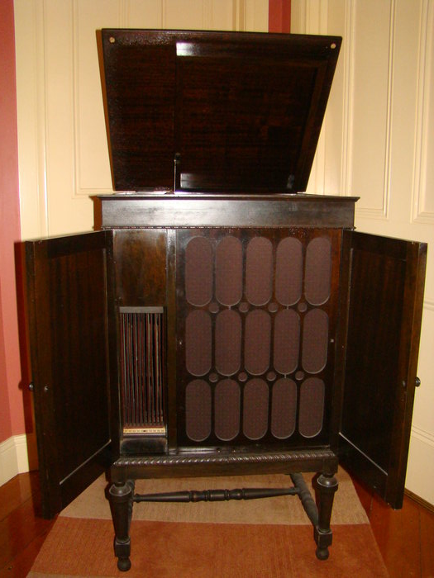
  DSC02562.JPG [ 941.58 KiB | Viewed 1168 times ]
  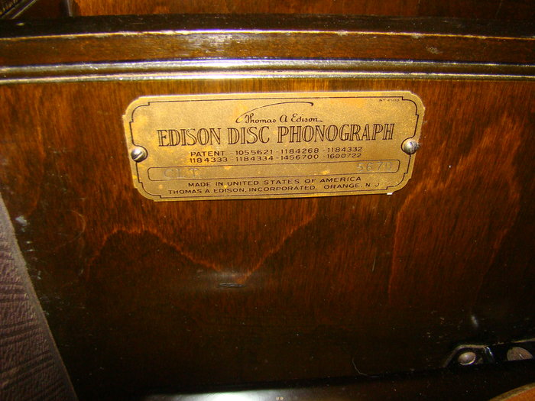
  DSC02561.JPG [ 1 MiB | Viewed 1168 times ]
  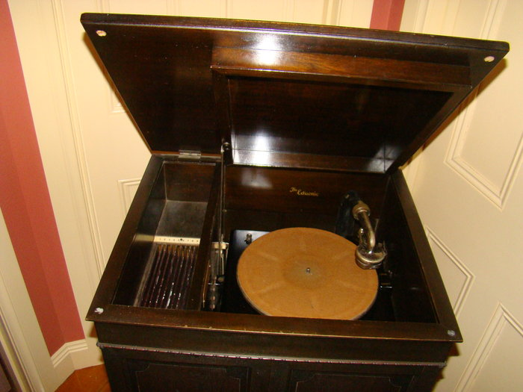
  DSC02558.JPG [ 1014.1 KiB | Viewed 1168 times ]
Top

pughphonos
  Post subject: Re: Inventory of Beethoven and Schubert Edisonic phonographs
  Posted: Fri May 23, 2014 9:15 am
Joined: Tue Jul 17, 2012 11:35 am  Posts: 670  Location: Homewood, Illinois, USA
  Victor III
  "You must serve music"
  UPDATED INDEX (AS OF MAY 23, 2014) TO POSTINGS ABOVE:
  The information in this posting became outdated and has been replaced by a new "Updated Index" that can be found at or near the end of this thread.
  "You must serve music, because music is so enormous and can envelop you into such a state of perpetual anxiety and torture--but it is our first and main duty"
  -- Maria Callas, 1968 interview.
  Last edited by pughphonos on Wed Jun 04, 2014 1:06 pm, edited 7 times in total.
Top

Edisone
  Post subject: Re: Inventory of Beethoven and Schubert Edisonic phonographs
  Posted: Fri May 23, 2014 8:50 pm
Joined: Sat Aug 01, 2009 4:17 pm  Posts: 1140  Location: Can see Canada from Attic Window
  Victor IV
  A Schubert (with a Dance Reproducer) is on Da Bay right now - description says " # 3695", but the tag clearly has 5056.
  Attachments:
  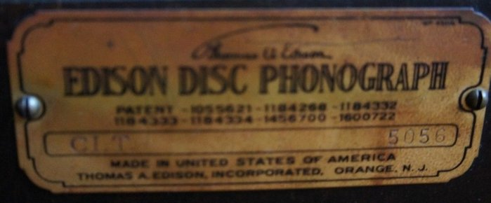
  Edisonic 5056 tag.jpg [ 130.47 KiB | Viewed 1124 times ]
Top

pughphonos
  Post subject: Re: Inventory of Beethoven and Schubert Edisonic phonographs
  Posted: Fri May 23, 2014 11:26 pm
Joined: Tue Jul 17, 2012 11:35 am  Posts: 670  Location: Homewood, Illinois, USA
  Victor III
  "You must serve music"
  Edisone wrote:
  A Schubert (with a Dance Reproducer) is on Da Bay right now - description says " # 3695", but the tag clearly has 5056.
  Right. That Schubert has been lingering on E-bay for some weeks; see my posting above dated 4/22/2014. It's beat up and perhaps the price should be a bit lower--but in any case I hope someone buys it and has a knack for restoration.
  "You must serve music, because music is so enormous and can envelop you into such a state of perpetual anxiety and torture--but it is our first and main duty"
  -- Maria Callas, 1968 interview.
Top

drh
  Post subject: Re: Inventory of Beethoven and Schubert Edisonic phonographs
  Posted: Thu May 29, 2014 11:37 pm
Joined: Tue May 27, 2014 11:24 am  Posts: 381
  Victor II
  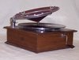
  pughphonos wrote:
  2006 POSTING ON "STEVE HOFFMAN MUSIC FORUMS"
  Model: Schubert Edisonic
  Non-serial number designation: USMD2006JULY7
  The following link
  http://forums.stevehoffman.tv/threads/l ... st-1891985
  contains the following description and photos posted of a Schubert by "drh" of Silver Spring, MD on July 7, 2006:
  "My most recent equipment purchase was this Edison Edisonic "Schubert" model diamond disc player, which I bought in April and which pretty much swallowed my equipment budget for the rest of the year."
  Well, it's taken me since May 14, when pughphonos posted a query on the Hoffman forum, but I'm finally registered as a member of this forum, of which I was not previously aware. Yes, I'm the same drh mentioned above, and, yes, I still have my Edisonic Schubert. It's no. 2673, and the photos at the Hoffman forum were taken before I restored the original finish with a product called "black wax" and lots and lots of elbow grease.
  I bought the machine in March 2006 from an eBay seller in upstate New York and then had it shipped as truck freight to Maryland. It had belonged to the seller's mother. Included were a few diamond discs, one or two electrically recorded (the standout being Vernon Dalhart in Bum Song no. 2 and The Big Rock Candy Mountain). The records were, on the whole, much worn, which leads me to think that the heavy weight of the Edisonic reproducer is more than they really should be asked to handle; accordingly, I save that for special occasions and usually play records on this machine with a standard reproducer instead. Ever since I got the machine, it ran about 2-3 RPM fast, and I didn't know how to adjust it, since it doesn't have the speed control knob through the bedplate. A couple of nights ago I got brave, went into the motor compartment, and, with the help of my trusty digital tachometer, figured out how to get it running at pretty close to exactly 80 RPM--certainly closer than most users would have achieved counting revolutions with a stopwatch.
  Here are some photos of the machine as it now appears:
  Attachment:
  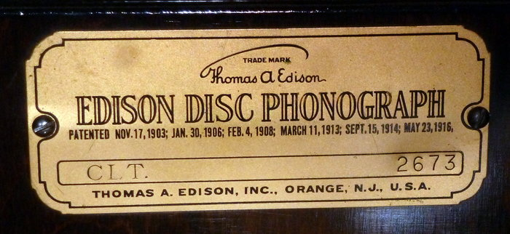
  plate.jpg [ 1.79 MiB | Viewed 1063 times ]
  Attachment:
  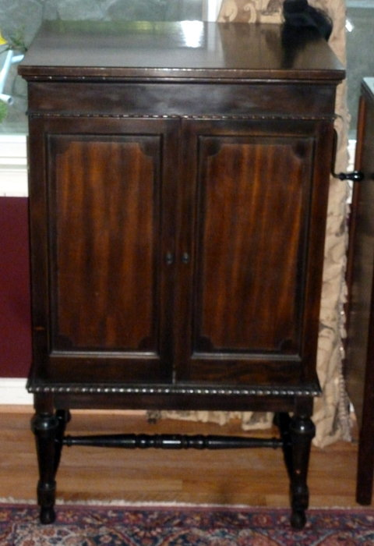
  front view, closed.jpg [ 3.25 MiB | Viewed 1063 times ]
  Attachment:
  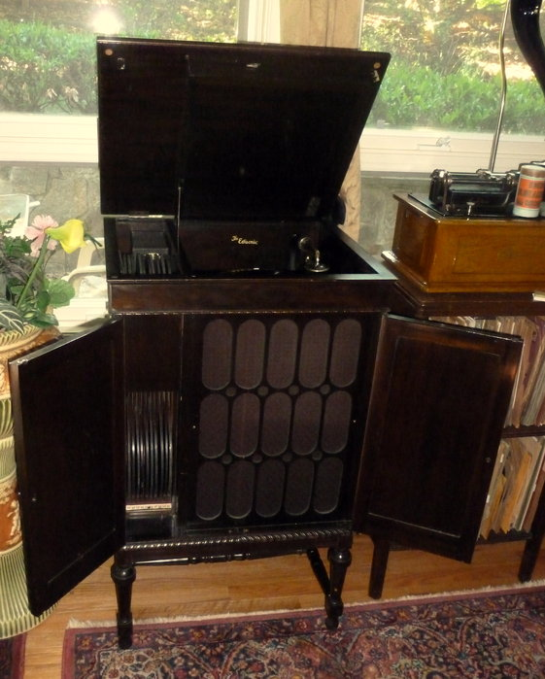
  front view, lid up, doors open.jpg [ 3.08 MiB | Viewed 1063 times ]
  Attachment:
  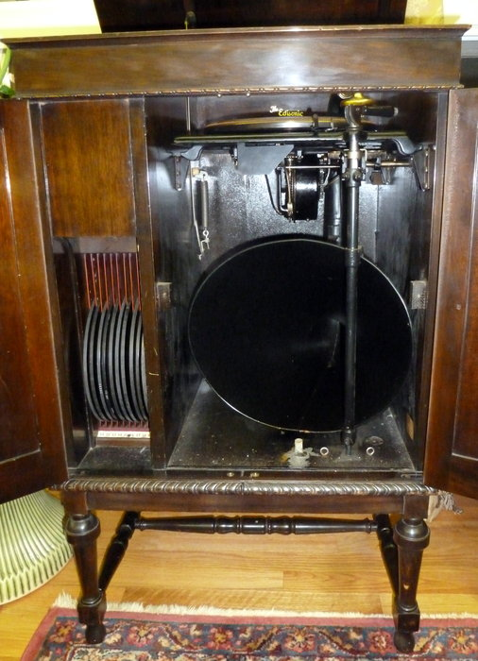
  grille removed.jpg [ 3.67 MiB | Viewed 1063 times ]
  Attachment:
  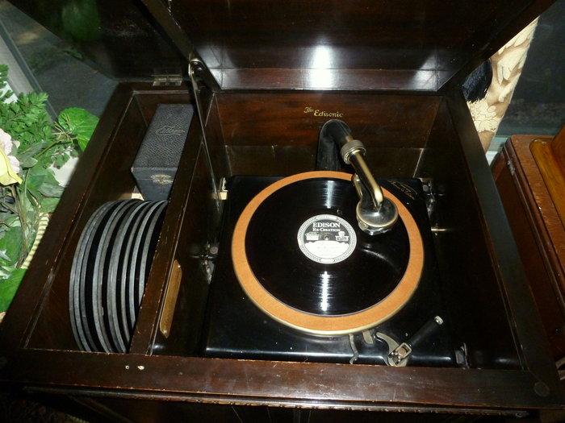
  turntable compartment.jpg [ 4.74 MiB | Viewed 1063 times ]
  Attachment:
  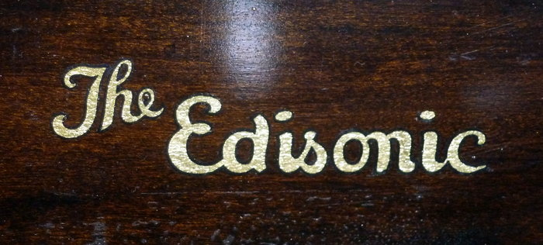
  decal.jpg [ 1.22 MiB | Viewed 1063 times ]
Top

pughphonos
  Post subject: Re: Inventory of Beethoven and Schubert Edisonic phonographs
  Posted: Fri May 30, 2014 10:39 am
Joined: Tue Jul 17, 2012 11:35 am  Posts: 670  Location: Homewood, Illinois, USA
  Victor III
  "You must serve music"
  DRH, it's marvelous to hear from you about your Schubert Edisonic, and also have you on the Talking Machine Forum! What a nice machine. Interesting anecdote about the record wear--how a machine that has come down to you intact with only one family preceding you DOES really testify as to how much wear the Edisonic reproducer can inflict. I had an Edisonic reproducer for awhile (actually did NOT come with my Schubert) and decided to sell it as it didn't sound any better than the standard reproducers I have.
  Digital tachometers are wonderful (I have one)--far more accurate than trying to count RPMs with a watch. Glad you've got your machine to 80 RPM.
  Thank you for the detailed history of your machine. The Edisonic inventory is becoming more and more interesting and useful due to the contributions made by you and others.
  Ralph
  NOTE: USMD2006JULY7, originally posted by me (above) on April 24, 2014, is now known as Schubert #2673.
  "You must serve music, because music is so enormous and can envelop you into such a state of perpetual anxiety and torture--but it is our first and main duty"
  -- Maria Callas, 1968 interview.
  Last edited by pughphonos on Fri May 30, 2014 12:50 pm, edited 1 time in total.
Top

drh
  Post subject: Re: Inventory of Beethoven and Schubert Edisonic phonographs
  Posted: Fri May 30, 2014 11:28 am
Joined: Tue May 27, 2014 11:24 am  Posts: 381
  Victor II
  pughphonos wrote:
  DRH, it's marvelous to hear from you about your Schubert Edisonic, and also have you on the Talking Machine Forum! What a nice machine. ...
  Thanks for the warm welcome! I'll confess that I got pretty frustrated trying to join up here; for whatever reason, I just could not get the server to agree with my interpretations of those miserable distorted figures required to prove that one isn't a bot of some sort. (Apologies to the admininstrator(s) for a somewhat dyspeptic e-mail that I sent during that unduly protracted process.)
  I really love my Schubert; it's a good-looking, great sounding little machine, and after all how could I not when it's the last flowering of my favorite "recording technology" of the acoustic era? But that said, when I look at it critically, certain aspects just scream "company on the ropes." One is that the finish on the sides is noticeably more uneven, and the wood noticeably of lower grade, than that of the front and lid, rather in the manner of one of those modern tract houses with a brick front and vinyl siding everywhere else. Then there's the lack of falsework around the bedplate and the general level of construction that just doesn't quite measure up to that of my C-250 or A-150, and of course the subterfuge of a big grille, screwed in to discourage investigation, covering a much smaller horn opening, presumably to evoke those huge Orthophonic "speakers." Add in a mechanism shorn of its speed control knob, which I strongly suspect was in part a bid to repurpose units already in hand for the London series, and I just get the feeling of "last gasp." What a shame, as author Frow has noted, that Edison never managed to mate up electric reproduction with his long-playing records. That might well have changed the whole course of recording history, not to mention been the salvation of his company.
  Well, enough such maundering. Here's one more photo, showing the miracles wrought by Black Wax bringing back the original finish. I was very happy with the results, but it took several expensive tins of the stuff and off-and-on months of evenings spent applying it with ultrafine steel wool to get there!
  Attachment:
  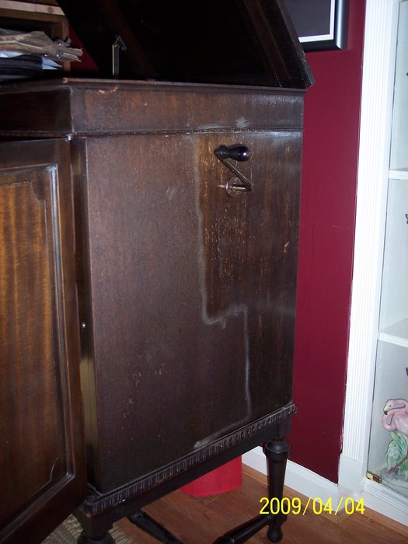
  refinishing.jpg [ 933.55 KiB | Viewed 1038 times ]
Top

pughphonos
  Post subject: Re: Inventory of Beethoven and Schubert Edisonic phonographs
  Posted: Fri May 30, 2014 12:42 pm
Joined: Tue Jul 17, 2012 11:35 am  Posts: 670  Location: Homewood, Illinois, USA
  Victor III
  "You must serve music"
  drh wrote:
  I really love my Schubert; it's a good-looking, great sounding little machine, and after all how could I not when it's the last flowering of my favorite "recording technology" of the acoustic era? But that said, when I look at it critically, certain aspects just scream "company on the ropes." One is that the finish on the sides is noticeably more uneven, and the wood noticeably of lower grade, than that of the front and lid, rather in the manner of one of those modern tract houses with a brick front and vinyl siding everywhere else. Then there's the lack of falsework around the bedplate and the general level of construction that just doesn't quite measure up to that of my C-250 or A-150, and of course the subterfuge of a big grille, screwed in to discourage investigation, covering a much smaller horn opening, presumably to evoke those huge Orthophonic "speakers." Add in a mechanism shorn of its speed control knob, which I strongly suspect was in part a bid to repurpose units already in hand for the London series, and I just get the feeling of "last gasp." What a shame, as author Frow has noted, that Edison never managed to mate up electric reproduction with his long-playing records. That might well have changed the whole course of recording history, not to mention been the salvation of his company.
  What a well-put, unflinching assessment of the shortcomings of the Schubert, a product of a "company on the ropes." Most Schubert owners (myself included) will readily agree in these particulars. But we also join you in the joy and wonder of owning one of Edison's last two DD machines--which does have a different tone, due to its different horn configuration.
  Your perspectives are good ones, and offer up food for thought. It never occurred to me that the screwed-on big grille was likely meant to "discourage investigation" and evoke the Orthophonic "speakers." The lack of falsework around the motor board is also annoying as one can't mount the 10" and 12" adjustment knobs--and I used to have those on my S-19. Finally, the lack of speed control is also no doubt (as you say) due to the company wanting to use up motor boards that had been made for the London line of phonographs.
  That said, I used to own a C-250, and it was indeed a beautifully-preserved example (oak, with the Duncan stop). But I'm happier having moved on to an Edisonic as it represents more history, as it were. I believe it sounds roughly as good as the C-250 (how much slightly more or less is subjective). Also, if one is history-minded (as I am) it is also a better roommate for an Orthophonic (I have a VV 8-4) as the Edisonics were of course meant to compete (however imperfectly) with the Orthophonics.
  Thanks for the "tough love" posting on the Schubert: I do agree with it entirely. Hope others have comments to offer on yours.
  Now that you're on board the TMF, you'll see that Fran has started a database for the C-250s/C-19s and will be pleased to get your information.
  "You must serve music, because music is so enormous and can envelop you into such a state of perpetual anxiety and torture--but it is our first and main duty"
  -- Maria Callas, 1968 interview.
  Last edited by pughphonos on Wed Jun 04, 2014 1:07 pm, edited 1 time in total.
Top

drh
  Post subject: Re: Inventory of Beethoven and Schubert Edisonic phonographs
  Posted: Fri May 30, 2014 1:02 pm
Joined: Tue May 27, 2014 11:24 am  Posts: 381
  Victor II
  pughphonos wrote:
  Now that you're on board the TMF, you'll see that Fran has started a database for the C-250s/C-19s and will be pleased to get your information.
  Already done!
  And I agree with you 100% about that "historical feel" thing. I actually have three diamond disc players, which I like to think give a nice summary of the line: an A-150, from the christening; a C-250, the pillar of the line's palmy days, fitted with gears for the long playing discs, for my money the company's most audacious offering and, when it failed, the beginning of the end; and the Schubert, the "sunset" machine corresponding to the A-150. Each has its own charms. The C-250 has been my "daily driver" in no small part because of that speed issue. Now that I've resolved that, the Edisonic will undoubtedly be getting more exercise. No more couch potato phonographs!
Top

Previous topic | Next topic

Display posts from previous:  Sort by   

 | Page 7 of 25 | [ 247 posts ] | Go to page Previous 1 ... 4, 5, 6, 7, 8, 9, 10 ... 25 Next

