pughphonos
  Post subject: Re: Inventory of Beethoven and Schubert Edisonic phonographs
  Posted: Fri May 02, 2014 9:04 pm
Joined: Tue Jul 17, 2012 11:35 am  Posts: 670  Location: Homewood, Illinois, USA
  Victor III
  
  "You must serve music"
  SCHUBERT OWNED BY DAN AND SANDY KRYGIER
  Model: Schubert Edisonic
  Non-serial number designation: USNY2005
  Source: The Talking Machine: An Illustrated Compendium, 1877-1929 by Timothy C. Fabrizio & George F. Paul. Revised & Expanded 2nd Edition (Atglen, PA; Schiffer Publishing Ltd., 2005), p. 241.
  As far as I can determine, the Krygiers were living in Burt, NY at the time their Schubert Edisonic was photographed for the Fabrizio & Paul book.
  Attachments:
  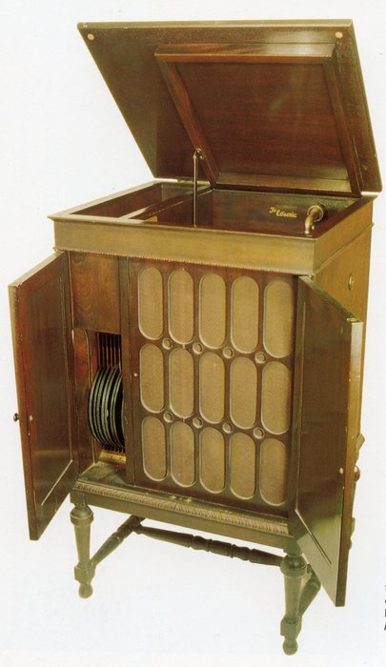
  NY.jpg [ 488.88 KiB | Viewed 981 times ]
  "You must serve music, because music is so enormous and can envelop you into such a state of perpetual anxiety and torture--but it is our first and main duty"
  -- Maria Callas, 1968 interview.
Top

pughphonos
  Post subject: Re: Inventory of Beethoven and Schubert Edisonic phonographs
  Posted: Sat May 03, 2014 10:14 pm
Joined: Tue Jul 17, 2012 11:35 am  Posts: 670  Location: Homewood, Illinois, USA
  Victor III
  "You must serve music"
  MATT BROWN'S BEETHOVEN
  Model: Beethoven Edisonic
  Non-serial number designation: US2010DECEMBER19
  On December 19, 2010 a "Matthew" joined the On-line Edison Phonograph Discussion Board to announce his acquisition of (and restoration plans for) a Beethoven. The only member over there who engaged him in conversation was "Condensite"--who is none other than our Bob Barnett. Unfortunately, Matthew disappeared from the Edison board after only a few posts (without providing photographs or a serial number for his machine). I don't know if he transferred to this form (TMF) under a different name; if anyone has any information on him, please let me know.
  I am calling him Matt Brown as elsewhere on his Edison board account he gives the tag "mattjacobbrown."
  http://edisonphonos.proboards.com/threa ... -beethoven
  "You must serve music, because music is so enormous and can envelop you into such a state of perpetual anxiety and torture--but it is our first and main duty"
  -- Maria Callas, 1968 interview.
Top

pughphonos
  Post subject: Re: Inventory of Beethoven and Schubert Edisonic phonographs
  Posted: Sun May 04, 2014 5:37 pm
Joined: Tue Jul 17, 2012 11:35 am  Posts: 670  Location: Homewood, Illinois, USA
  Victor III
  "You must serve music"
  There apparently IS Edisonic karma
  Today I heard from one of the submitters to this inventory: Michael, aka "Tubaphone." He has two Schuberts and had previously informed me that his "nice" one (the one he bought from the family of Art Wilmoth) has the serial number 1216. Well, today he said he has now gotten around to checking for the serial number on his other, "rougher" machine--and found that its serial number is 1217! What are the odds of that, hey?
  What can top that? Perhaps a story that you fell into a fast-flowing river and your Edisonic jumped in to save your life. Or your Edisonic donated one of its kidneys to a needy neighbor (you never knew they had kidneys until then).
  Edisonic karma: watch for it!!!
  Ralph
  P.S. Attached is a photo of Michael's nice machine, #1216. He hopes to take some clearer photos in future, but I thought it would not hurt to at least start the documentation with this image.
  Attachments:
  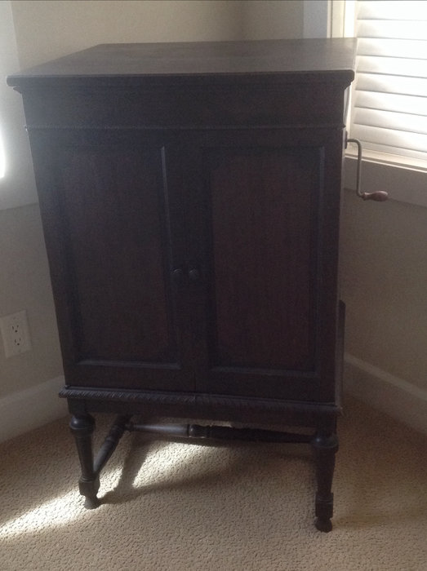
  No. 2016.JPG [ 52.69 KiB | Viewed 925 times ]
  "You must serve music, because music is so enormous and can envelop you into such a state of perpetual anxiety and torture--but it is our first and main duty"
  -- Maria Callas, 1968 interview.
  Last edited by pughphonos on Mon May 05, 2014 3:23 pm, edited 1 time in total.
Top

tubaphone
  Post subject: Re: Inventory of Beethoven and Schubert Edisonic phonographs
  Posted: Sun May 04, 2014 7:22 pm
Joined: Sat Mar 30, 2013 11:45 pm  Posts: 43
  Victor Jr
  As promised I finally had an opportunity to remove all of the boxes of piano rolls that were stacked on and around my other Edisonic Schubert model. When I check the serial number of it I was floored, it is the next sequential serial number from my other one that was posted previously. My "good" Edisonic Schubert is serial number 1216 and this one is 1217. I bought these about 6 months apart from 2 different places in Northern CA. What are the odds of this?
  Model:Schubert Edisonic
  Serial number: 1217
  When purchased: about Nov. 29, 2011
  From whom purchased (general description): private party in Sonoma CA
  Cabinet condition when purchased: rough, legs have pieces knocked off but the good news is they were all saved so the can be reattached, veneer missing from the top and cabinet needs refinishing.
  Upgrades made by present owner: none, machine is unrestored
  Michael
Top

budsta
  Post subject: Re: Inventory of Beethoven and Schubert Edisonic phonographs
  Posted: Tue May 06, 2014 8:44 am
Joined: Fri Jul 17, 2009 5:11 pm  Posts: 89
  Victor O
  Hi all
  Model: Schubert Edisonic
  Serial number: 5670
  When purchased: about 1996
  From whom purchased (general description): Antique shop here in Melbourne Australia
  Cabinet condition when purchased: Was and still is untouched original. Fine crazing to the finish. Its a nice example
  Upgrades made by present owner: Have added long play attachment. Single barrel spring.
  regards
  Stephen
Top

pughphonos
  Post subject: Re: Inventory of Beethoven and Schubert Edisonic phonographs
  Posted: Tue May 06, 2014 9:00 am
Joined: Tue Jul 17, 2012 11:35 am  Posts: 670  Location: Homewood, Illinois, USA
  Victor III
  "You must serve music"
  Stephen, thanks for this!!! Always great to learn of Edisonics Down Under. Your serial number (#5670) is very late; on our database there is only one that is later (#5678).
  When you get a chance, we'd all love to see photos; add them to your original post if possible.
  Ralph
  "You must serve music, because music is so enormous and can envelop you into such a state of perpetual anxiety and torture--but it is our first and main duty"
  -- Maria Callas, 1968 interview.
  Last edited by pughphonos on Tue May 06, 2014 3:43 pm, edited 1 time in total.
Top

pughphonos
  Post subject: Re: Inventory of Beethoven and Schubert Edisonic phonographs
  Posted: Tue May 06, 2014 1:57 pm
Joined: Tue Jul 17, 2012 11:35 am  Posts: 670  Location: Homewood, Illinois, USA
  Victor III
  "You must serve music"
  BRIAN'S ("BRIANU") FORMER SCHUBERT
  Model: Schubert Edisonic
  Serial number: 1329
  For a couple years (ca. 2010-2012) Brian was the owner of the nice-looking Schubert pictured below (photos by him). He posted the following thread on our forum (October 2012) when he was seeking interested buyers:
  viewtopic.php?f=9&t=11003&hilit=schubert
  Today Brian kindly provided me with the recent sales history of this machine. He writes that he had bought Schubert #1329 "from lyn bylton from that intertique site. I had it for a couple of years and then sold it when I downsized and moved....the buyer was that collector in japan, hideki umeya or something like that."
  We have a match!!! This thread, now that it has a fair number of entries, is starting to fulfill one of its potentialities: tracing the sales progress of specific machines. Brian's machine also appears on this thread as JAPAN2014MAY1 (5/1/2014), under "UMEYA SELECTION." Compare photos from both entries and look at the wood grain on the doors. Even if Brian had not provided us with the name of his buyer, we still could have made a physical match with near certitude.
  Attachments:
  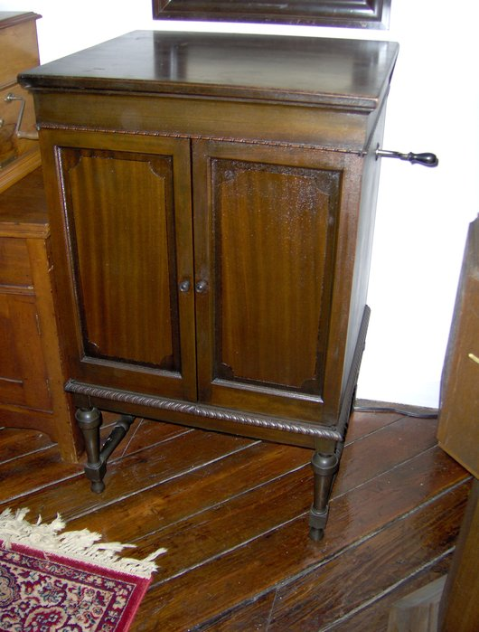
  Brians1.JPG [ 89.13 KiB | Viewed 903 times ]
  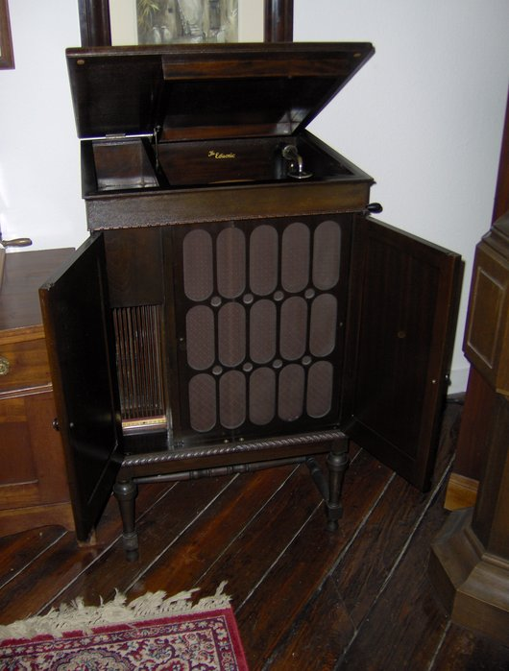
  Brians2.JPG [ 75.68 KiB | Viewed 903 times ]
  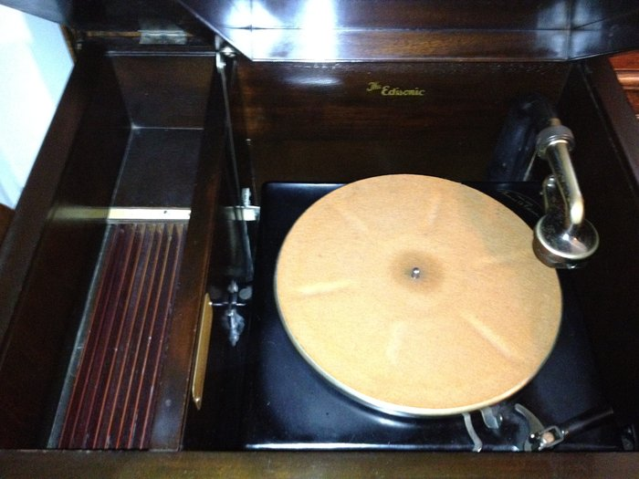
  Brians3.JPG [ 73.46 KiB | Viewed 903 times ]
  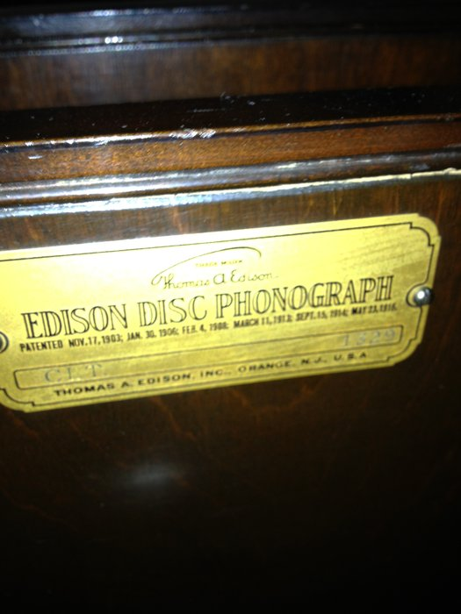
  Brians4.JPG [ 57.82 KiB | Viewed 903 times ]
  "You must serve music, because music is so enormous and can envelop you into such a state of perpetual anxiety and torture--but it is our first and main duty"
  -- Maria Callas, 1968 interview.
Top

pughphonos
  Post subject: Re: Inventory of Beethoven and Schubert Edisonic phonographs
  Posted: Tue May 06, 2014 3:00 pm
Joined: Tue Jul 17, 2012 11:35 am  Posts: 670  Location: Homewood, Illinois, USA
  Victor III
  "You must serve music"
  SCHUBERT #1329 AGAIN: FROM "INTERTIQUE" AD, CA. 2010 ("BRIANU" BOUGHT FROM THESE FOLKS)
  Model: Schubert Edisonic
  Serial number: 1329
  Here is the on-line ad from ca. 2010 of the machine that Brian bought from "Intertique" (Lynn Bilton) of Hartville, Ohio. The ad is still on-line as of May 6, 2014, even though the machine has since passed through Brian's hands and is now in Japan.
  http://www.intertique.com/SchubertEdisonicID.html
  I will not give this ad a "non-serial number designation" as we now know its serial number.
  Attachments:
  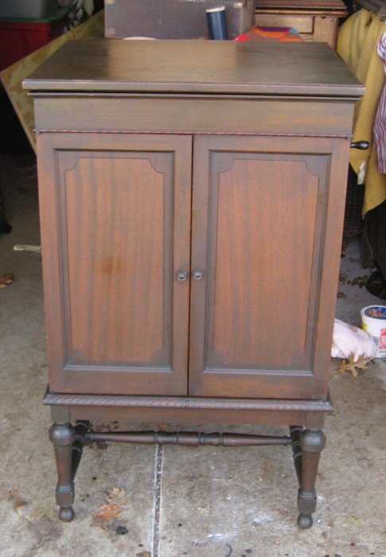
  Intertique1.jpg [ 106.5 KiB | Viewed 894 times ]
  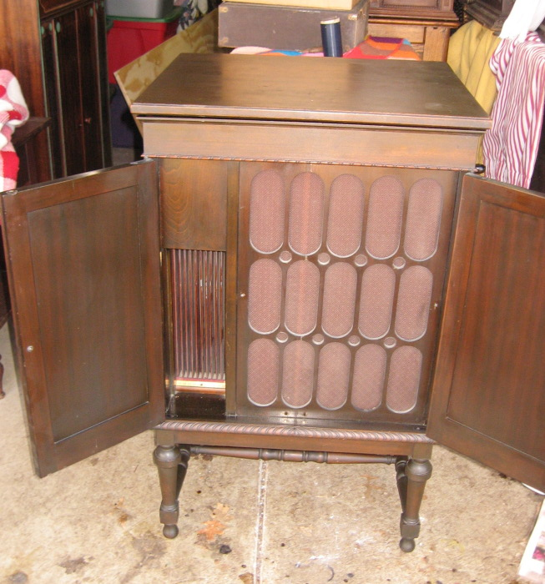
  Intertique2.jpg [ 166.13 KiB | Viewed 894 times ]
  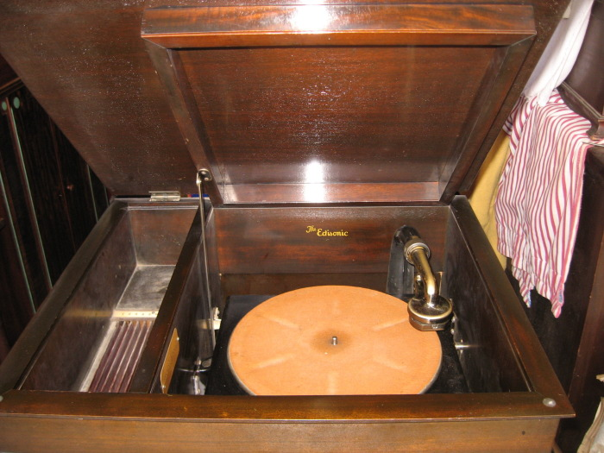
  Intertique3.jpg [ 130.48 KiB | Viewed 894 times ]
  "You must serve music, because music is so enormous and can envelop you into such a state of perpetual anxiety and torture--but it is our first and main duty"
  -- Maria Callas, 1968 interview.
Top

pughphonos
  Post subject: Re: Inventory of Beethoven and Schubert Edisonic phonographs
  Posted: Wed May 07, 2014 3:10 pm
Joined: Tue Jul 17, 2012 11:35 am  Posts: 670  Location: Homewood, Illinois, USA
  Victor III
  "You must serve music"
  SCHUBERT AT THE THOMAS EDISON MEMORIAL TOWER AND MUSEUM
  Model: Schubert Edisonic
  Non-serial number designation: USNJ1997NOVEMBER15
  One of the interesting illustrated essays on-line about the Edisonics was posted on November 15, 1997 by Jack Stanley as part of his “History in the Raw” series. The essay (linked below) includes several clear photographs of a Schubert Edisonic, some of which I am appending at the end of this present post:
  http://edisoneffect.blogspot.com/2007/1 ... -disc.html
  The question for me, of course, becomes “Where is that particular machine located?” I am inclined to believe that it is at the Thomas Edison Memorial Tower and Museum (Edison, New Jersey), where Mr. Stanley worked as its Museum Director from the late 1990s onwards (though I believe he is no longer there). I will try to contact Mr. Stanly about this (and also seek the serial number for this machine) and will edit this posting as more information becomes available.
  Attachments:
  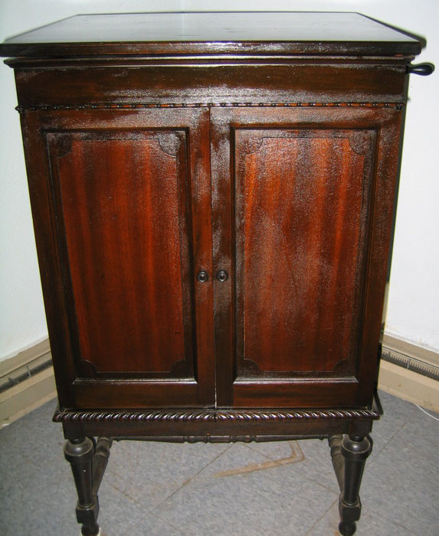
  Stanley1.JPG [ 174.09 KiB | Viewed 869 times ]
  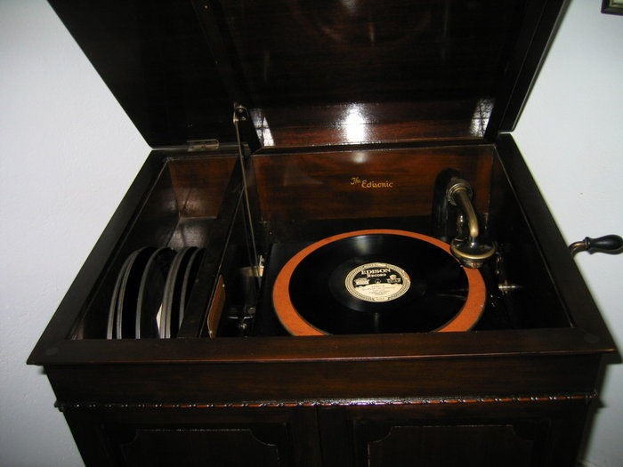
  Stanley2.JPG [ 158.22 KiB | Viewed 869 times ]
  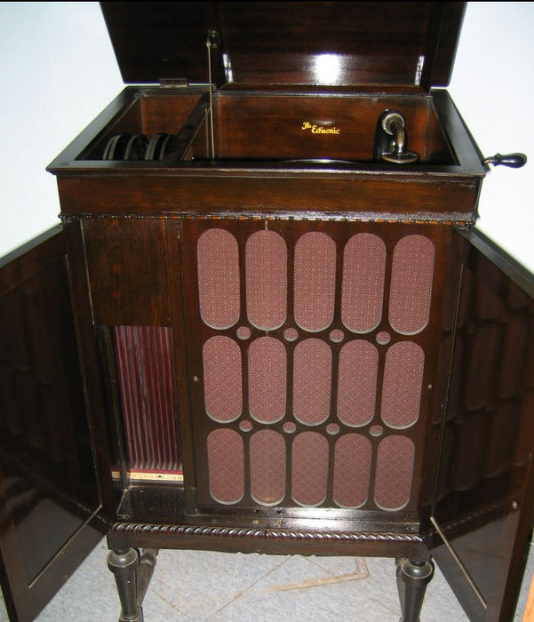
  Stanley3.JPG [ 141.78 KiB | Viewed 869 times ]
  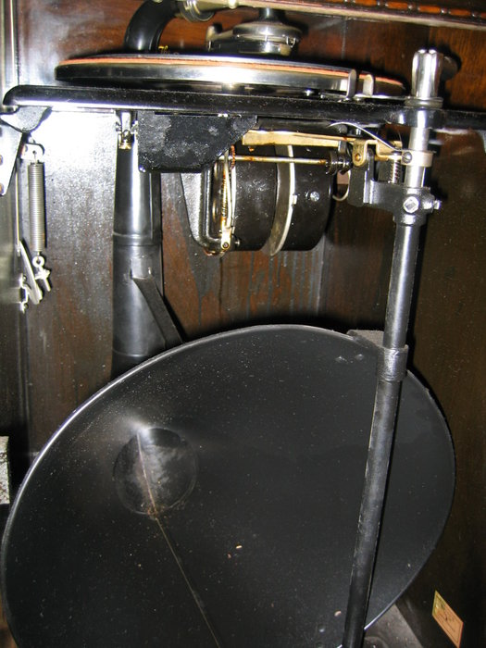
  stanley4.JPG [ 247.08 KiB | Viewed 869 times ]
  "You must serve music, because music is so enormous and can envelop you into such a state of perpetual anxiety and torture--but it is our first and main duty"
  -- Maria Callas, 1968 interview.
Top

pughphonos
  Post subject: Re: Inventory of Beethoven and Schubert Edisonic phonographs
  Posted: Wed May 14, 2014 11:52 pm
Joined: Tue Jul 17, 2012 11:35 am  Posts: 670  Location: Homewood, Illinois, USA
  Victor III
  "You must serve music"
  A BEETHOVEN AND A SCHUBERT IN A PRIVATE COLLECTION
  Model: Beethoven Edisonic
  Serial number: 2641
  Model: Schubert Edisonic
  Serial number: 1897
  On the evening of May 14 I was graciously received by a collector who has a wonderful array of antique phonographs and records. This collector wishes to remain anonymous but did consent to the photographing of the Edisonic machines--along with my recording of their serial numbers.
  It will not compromise the collector's identity to record that the person bought the Beethoven from Don Maxwell of Texas around twenty years ago and bought the Schubert from Ron Haring of Illinois at an unspecified point.
  At present the Beethoven in this collection holds the honor of being the latest serial number recorded in our inventory.
  Attachments:
  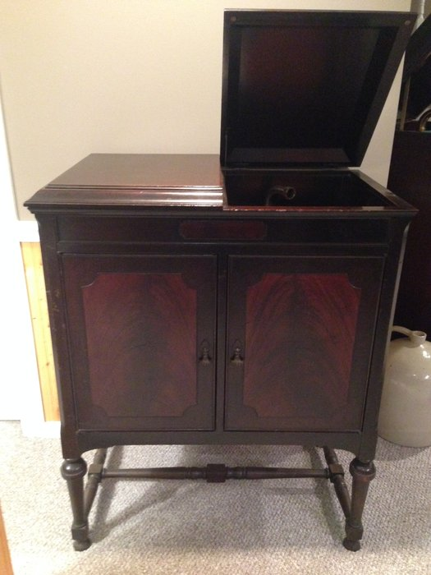
  Beethoven1a.JPG [ 1.94 MiB | Viewed 815 times ]
  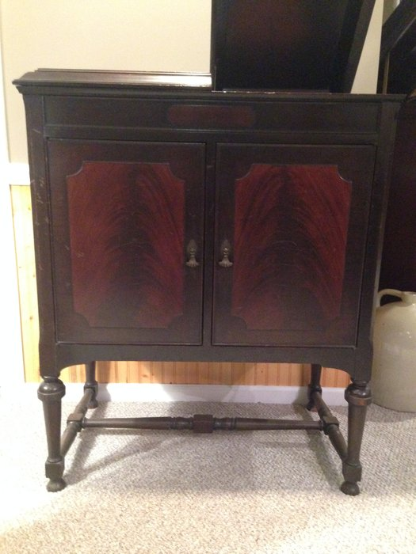
  Beethoven2b.JPG [ 1.97 MiB | Viewed 815 times ]
  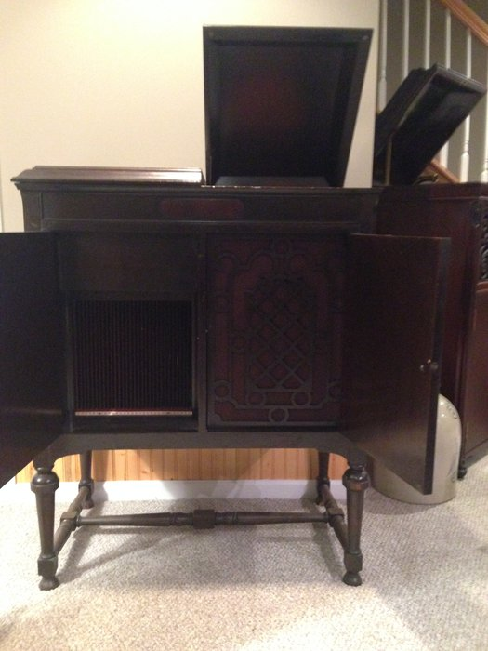
  Beethoven3a.JPG [ 1.89 MiB | Viewed 815 times ]
  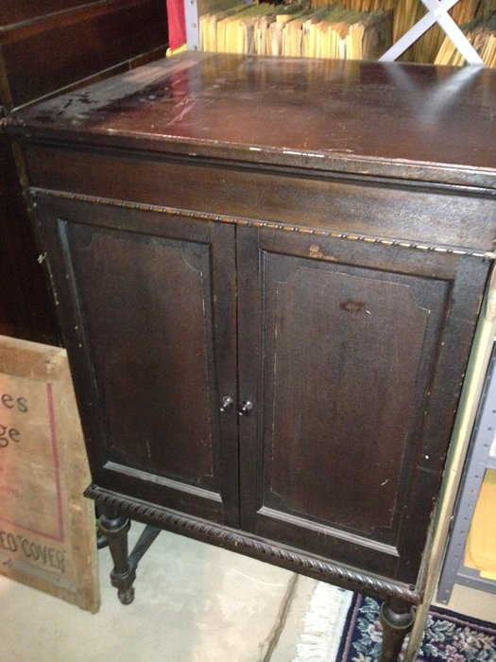
  Schubert1b.JPG [ 2.17 MiB | Viewed 815 times ]
  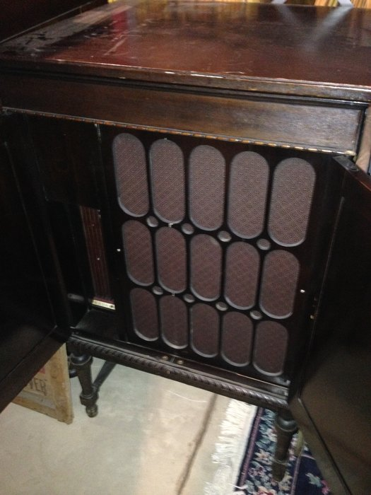
  Schubert2b.JPG [ 1.96 MiB | Viewed 815 times ]
  "You must serve music, because music is so enormous and can envelop you into such a state of perpetual anxiety and torture--but it is our first and main duty"
  -- Maria Callas, 1968 interview.
Top

Previous topic | Next topic

Display posts from previous:  Sort by   

 | Page 6 of 25 | [ 247 posts ] | Go to page Previous 1 ... 3, 4, 5, 6, 7, 8, 9 ... 25 Next

