pughphonos
  Post subject: Re: Inventory of Beethoven and Schubert Edisonic phonographs
  Posted: Wed Apr 30, 2014 9:49 am
Joined: Tue Jul 17, 2012 11:35 am  Posts: 670  Location: Homewood, Illinois, USA
  Victor III
  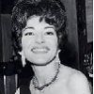
  "You must serve music"
  "YOU TUBE" VIDEOS OF UNIDENTIFIED EDISONICS AND THEIR UNIDENTIFIED OWNERS
  This will be the "parking space" for links to "You Tube" videos that feature Edisonics--but which provide no information on the machines nor on their owners (besides visual clues). I know from personal experience that many "You Tube" videos tend to be abandoned by their creators, and trying to reach those creators for more information is likely futile. One can spot such candidates right off: they do not respond to any comments made on their videos, and often they have posted only a few videos total.
  But these videos at least provide some visual information on other surviving Edisonics out there and add to our calculation of how many Edisonics still might exist. Also, hope springs eternal: maybe some of you might be able to identify the owners/authors and enable us to bring them in from the cold.
  OK. Here's what we have:
  1)
  "You Tube" tag: Chagall56
  Model: Schubert Edisonic
  When posted: May 8, 2013
  http://www.youtube.com/watch?v=_eY38RdNtWg
  2)
  "You Tube" tag: Classy8888
  Model: Schubert Edisonic
  When posted: December 12, 2012
  https://www.youtube.com/watch?v=ZC3MxM8BAQ0
  This one shows some promise. It appears from internal evidence in the videos that they might have been created by Ian Griggs of Darlinghurst, New South Wales, Australia--where for some years he was (is?) the organist at St. John's Anglican Church there. I have posted on this site and hope for a response.
  "You must serve music, because music is so enormous and can envelop you into such a state of perpetual anxiety and torture--but it is our first and main duty"
  -- Maria Callas, 1968 interview.
  Last edited by pughphonos on Tue May 06, 2014 9:21 pm, edited 2 times in total.
Top

pughphonos
  Post subject: Re: Inventory of Beethoven and Schubert Edisonic phonographs
  Posted: Wed Apr 30, 2014 10:47 am
Joined: Tue Jul 17, 2012 11:35 am  Posts: 670  Location: Homewood, Illinois, USA
  Victor III
  "You must serve music"
  STATUS REPORT ON THIS THREAD
  OK, after a flurry of activity since this thread was created early last week, I find I have pretty much reached the limits of what information (on Edisonics) I can find readily on-line. So, there will now be a slowing down from the daily postings you have seen up to this point.
  There is obviously much work remaining to be done--but as Churchill said, "we have reached the end of the beginning." From here on out I will be all the more dependent upon owners and their associates to report on additional machines. Also, my guess is that there are a number of Edisonics displayed/stored in various museums around the world, and I would appreciate it if you would either contact them or forward the contact information to me. Also, ask about the Edisonics whenever you meet with other collectors; pick up leads and let me know. We've made a great start: let's keep it up!
  THANKS!!!!!!!!!!!!!!!!!!!!!!!!!!!!!!!!!!!!!!!!!!!!!!!!!!!
  Ralph
  "You must serve music, because music is so enormous and can envelop you into such a state of perpetual anxiety and torture--but it is our first and main duty"
  -- Maria Callas, 1968 interview.
  Last edited by pughphonos on Thu May 01, 2014 10:53 am, edited 1 time in total.
Top

pughphonos
  Post subject: Re: Inventory of Beethoven and Schubert Edisonic phonographs
  Posted: Wed Apr 30, 2014 1:43 pm
Joined: Tue Jul 17, 2012 11:35 am  Posts: 670  Location: Homewood, Illinois, USA
  Victor III
  "You must serve music"
  BEETHOVEN FORMERLY OWNED BY CARSTEN FISCHER
  Model: Beethoven Edisonic
  Serial number: 1121
  Many of you Edisonic enthusiasts have no doubt seen the great web page (link immediately below), put on-line on behalf of prominent collector Carsten Fischer (in San Francisco, CA) some five years ago. It contains wonderful photos of a Beethoven he was then trying to sell, along with a You Tube link.
  http://myvintagetv.com/updatepages1/cha ... isonic.htm
  Well, today I thought I should give it a try and sent him an e-mail, asking about the machine and its serial number. VERY kindly and promptly he sent me the following response:
  "Hello, thank you for your interest. I sold the Beethoven about 5 years ago to a local buyer."
  "Pls see attached photo for the ID Plate. Don't know about any other Edisonics, other than what turns up on the web. Best, Carsten."
  Below you will see three of the photos I have copied from his web site, along with the one of the ID plate that he just sent me today.
  Attachments:
  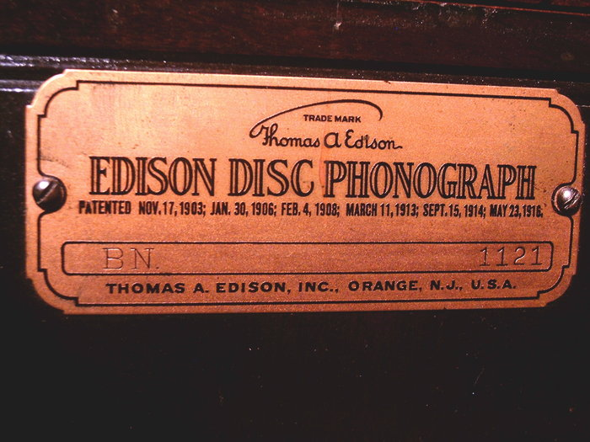
  Fischer1.JPG [ 757.8 KiB | Viewed 2263 times ]
  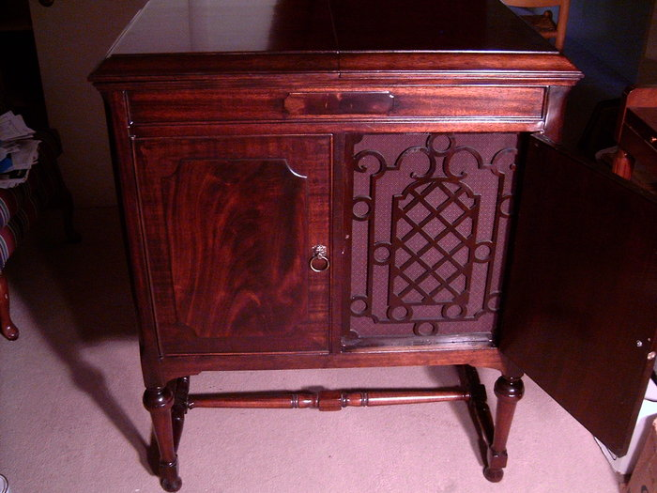
  Fischer2.jpg [ 928.92 KiB | Viewed 2263 times ]
  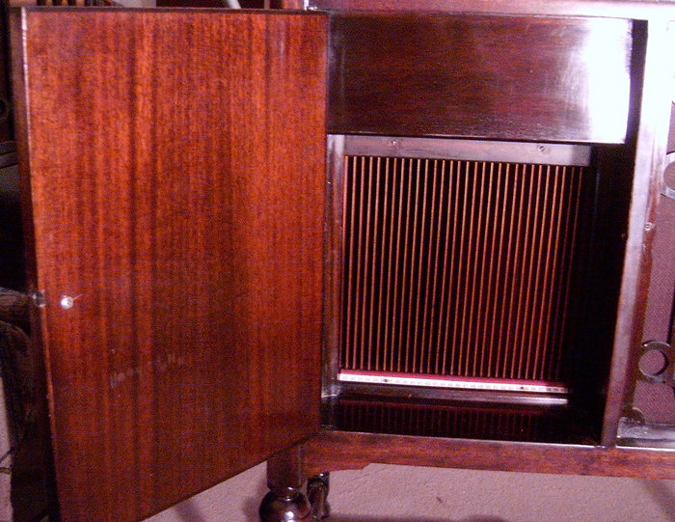
  Fischer3.jpg [ 1.05 MiB | Viewed 2263 times ]
  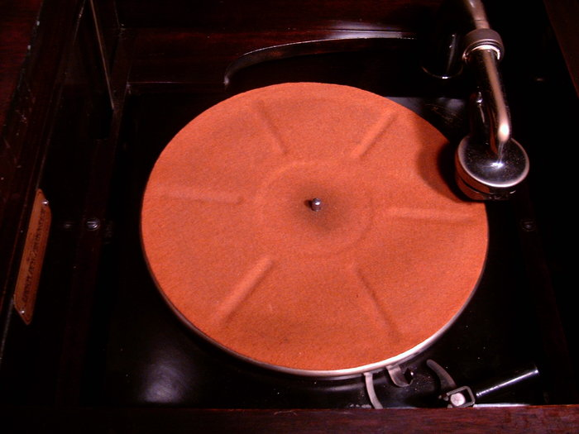
  Fischer4.jpg [ 594.39 KiB | Viewed 2263 times ]
  "You must serve music, because music is so enormous and can envelop you into such a state of perpetual anxiety and torture--but it is our first and main duty"
  -- Maria Callas, 1968 interview.
  Last edited by pughphonos on Thu May 01, 2014 10:42 am, edited 1 time in total.
Top

pughphonos
  Post subject: Re: Inventory of Beethoven and Schubert Edisonic phonographs
  Posted: Thu May 01, 2014 9:50 am
Joined: Tue Jul 17, 2012 11:35 am  Posts: 670  Location: Homewood, Illinois, USA
  Victor III
  "You must serve music"
  SCHUBERT FOR SALE IN SPOKANE, WASHINGTON IN MARCH 2013
  Model: Schubert Edisonic
  Non-serial number designation: USWA2013MARCH17
  I actually discovered this machine on our forum here, on a string titled "Why are so many Edison Disc machines for sale?" The string reproduced several photographs that had been lifted from a Craigslist ad from Washington State but did not provide a link to that ad. One of the machines photographed was a Schubert (see below). Scott ("MTPhono") of this forum posted the following comment on the string on March 17, 2013:
  "I went and saw the Shubert in person last week. It sounds fantastic - never heard one before and was blown away! The cabinet is rough. Much rougher that shown in the photos. She had a few nice records but those too were rough so I decided to pass. Enough projects in the shop that I will never get to. I have her contact info if you are interested. Scott."
  +++++++++++++++++++++++++
  Given that a few on our forum purchased their Schuberts in 2013, perhaps this was one of them.
  Attachments:
  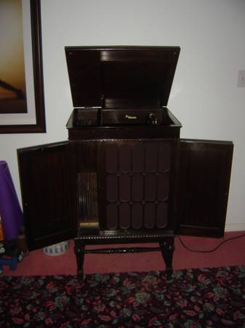
  Schubert2013Spokane.jpg [ 14.15 KiB | Viewed 2229 times ]
  "You must serve music, because music is so enormous and can envelop you into such a state of perpetual anxiety and torture--but it is our first and main duty"
  -- Maria Callas, 1968 interview.
Top

pughphonos
  Post subject: Re: Inventory of Beethoven and Schubert Edisonic phonographs
  Posted: Thu May 01, 2014 10:29 am
Joined: Tue Jul 17, 2012 11:35 am  Posts: 670  Location: Homewood, Illinois, USA
  Victor III
  "You must serve music"
  SCHUBERT IN THE ON-LINE "DENNIS D. HEINDL PHONOGRAPH COLLECTION"
  Model: Schubert Edisonic
  Non-serial number designation: 2007USPA
  I have just discovered this marvelous on-line exhibition of photos of phonographs belonging to Dennis D. Heindl. A Schubert is included among them. Three photos of that machine are provided, which I have reproduced below. I have just sent an e-mail to Mr. Heindl, asking for the serial number of his machine.
  http://phono-fun.com/DIAMONDDISC/
  http://phono-fun.com/index3.html
  From what I can find on-line, Mr. Heindl is a prominent Pennsylvania businessman and philanthropist (residing in Ridgway as recently as 2011), where he also owns FM station WDDH. He has, among other things, made donations to medical facilities and to historic landmark projects. His phonograph website appears to have been created in 2007, so I am using that as the basis of a non-serial number designation until such point as I hear from him about the serial number.
  Attachments:
  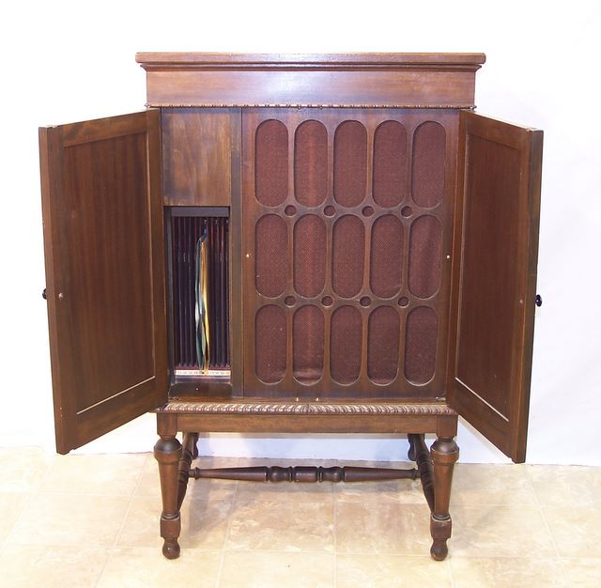
  Heindl1.jpg [ 57.28 KiB | Viewed 2220 times ]
  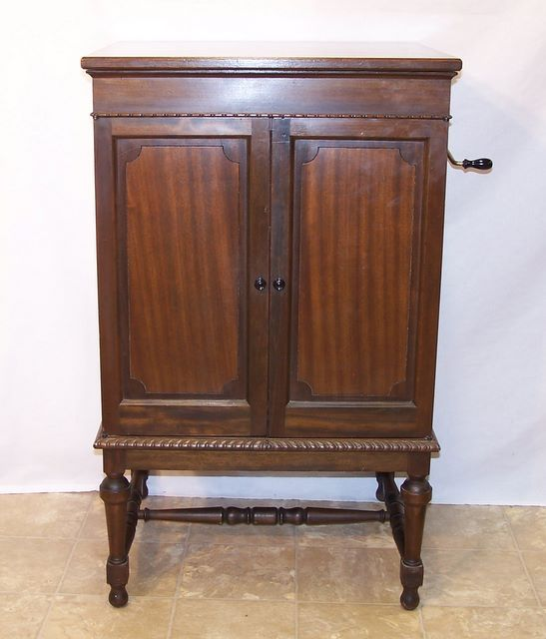
  Heindl2.jpg [ 48.29 KiB | Viewed 2220 times ]
  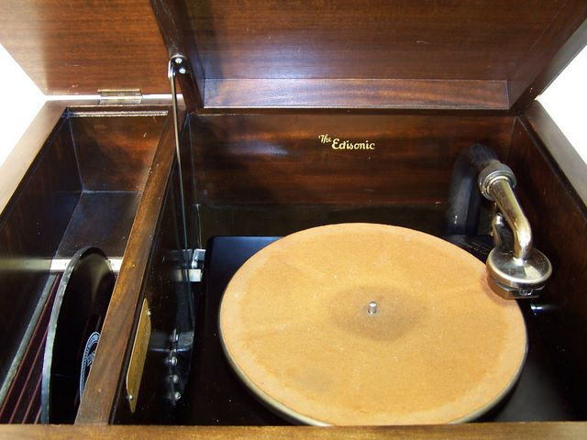
  Heindl3.jpg [ 53.11 KiB | Viewed 2220 times ]
  "You must serve music, because music is so enormous and can envelop you into such a state of perpetual anxiety and torture--but it is our first and main duty"
  -- Maria Callas, 1968 interview.
Top

pughphonos
  Post subject: Re: Inventory of Beethoven and Schubert Edisonic phonographs
  Posted: Thu May 01, 2014 1:58 pm
Joined: Tue Jul 17, 2012 11:35 am  Posts: 670  Location: Homewood, Illinois, USA
  Victor III
  "You must serve music"
  SCHUBERT IN "ESTES AUCTION" FOR DECEMBER 15, 2007 (MEDINA, OHIO)
  Model: Schubert Edisonic
  Serial number: 2288
  A somewhat battered-looking Schubert was sold by Estes Auction of Medina, Ohio, apparently as part of an auction concluded on December 15, 2007 (based on link below):
  http://www.estesauctions.com/December152007page2.html
  Recognize it? It's the same machine that was submitted by its current owner ("Coyote") on 4/22/2014 (see above).
  Attachments:
  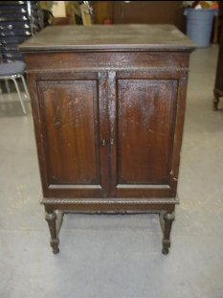
  DDD_Edison_Edisonic.jpg [ 14.08 KiB | Viewed 2192 times ]
  "You must serve music, because music is so enormous and can envelop you into such a state of perpetual anxiety and torture--but it is our first and main duty"
  -- Maria Callas, 1968 interview.
  Last edited by pughphonos on Thu May 08, 2014 9:35 am, edited 2 times in total.
Top

pughphonos
  Post subject: Re: Inventory of Beethoven and Schubert Edisonic phonographs
  Posted: Thu May 01, 2014 2:22 pm
Joined: Tue Jul 17, 2012 11:35 am  Posts: 670  Location: Homewood, Illinois, USA
  Victor III
  "You must serve music"
  SCHUBERT IN "UMEYA SELECTION" AUCTION, APPARENTLY CURRENT (MAY 1, 2014); JAPAN
  Model: Schubert Edisonic
  Serial number: 1329
  I've just found this auction/sales site. It's almost entirely in Japanese. I ran "Babelfish" on the item description and find that it does not include the serial number.
  This auction is apparently still on-going as the link below has the word "New" flashing next to the photo and description of the Schubert Edisonic.
  http://umeya.bz/php/gramophone/detail.php?num=261
  P.S. Since I posted this on May 1, 2014 I have discovered that this is serial number 1329 and that Umeya bought this machine from Brian in 2012 ("Brianu" of our forum)--ed. (05/6/2014).
  P.P.S. Here's another discovery. "Nipper Shippo" is the You Tube name for "Umeya Selection." Here, in the following video, Brian's former Schubert makes yet another appearance. There is no doubt, as the phonograph to the left of the Schubert is so distinctive and can be see both in the "Umeya Selection" web site and in this "Nipper Shippo" video (which was posted January 24, 2013):
  http://www.youtube.com/watch?v=bDxHC16fCgI
  Attachments:
  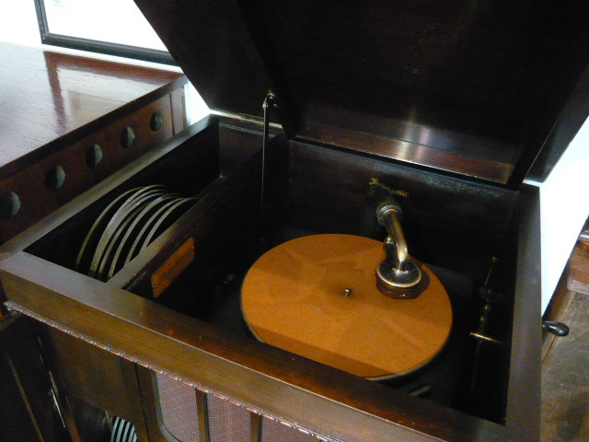
  Umeya2.JPG [ 176.4 KiB | Viewed 2125 times ]
  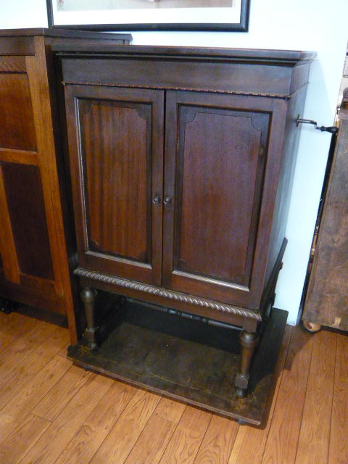
  umeya1.JPG [ 185.67 KiB | Viewed 2186 times ]
  "You must serve music, because music is so enormous and can envelop you into such a state of perpetual anxiety and torture--but it is our first and main duty"
  -- Maria Callas, 1968 interview.
  Last edited by pughphonos on Tue May 06, 2014 9:18 pm, edited 6 times in total.
Top

pughphonos
  Post subject: Re: Inventory of Beethoven and Schubert Edisonic phonographs
  Posted: Thu May 01, 2014 3:25 pm
Joined: Tue Jul 17, 2012 11:35 am  Posts: 670  Location: Homewood, Illinois, USA
  Victor III
  "You must serve music"
  STEVE'S (SCHWEG'S) FIRST BEETHOVEN
  Model: Beethoven Edisonic
  Serial number: 2488
  I've just figured out that our Steve ("Schweg") has owned TWO Beethovens along the way. The one he directly submitted above (on 4/21/2014)--with photos--is serial number 1898. He bought #1898 on May 10, 2010 after being alerted to its availability by Jeff Lee ("Moo").
  But if you go to the "Antique Talking Machines" forum you will find a fascinating thread in which Steve discusses how (before buying #1898) he had bought and restored serial number 2488--a heavily damaged machine that initially lacked legs, a grille, and was "antiqued" green. Steve apparently bought #2488 at the end of 2009 and might have kept it a year (my guess; I could check with him).
  http://victrolagramophones.proboards.co ... -beethoven
  I am being liberal with reposting photos of #2488 here (from the "Antique Talking Machines" thread) as 1) it shows how much work Steve did in restoring it; and 2) he has since sold it and it is back out there somewhere--and so the wood patterns and non-Edison legs shown in his 2010 photos might help with its identification should it show up in future on-line photos.
  Initially I was confusing #2488 with #1898, but Steve has now set me straight. He e-mailed me today to explain: "No, that was a different Beethoven. I found that poor thing in Ark and decided to do my best to fix it. However, Jeff (Moo) found the 2nd one at an estate sale near San Antonio and told me so I grabbed it and sent the first one off to a local auction."
  Attachments:
  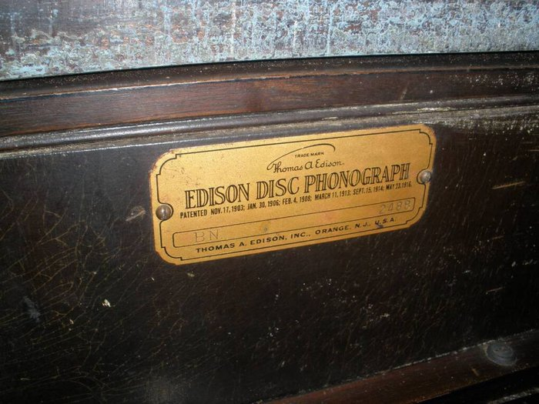
  Steve1.jpg [ 108.68 KiB | Viewed 2179 times ]
  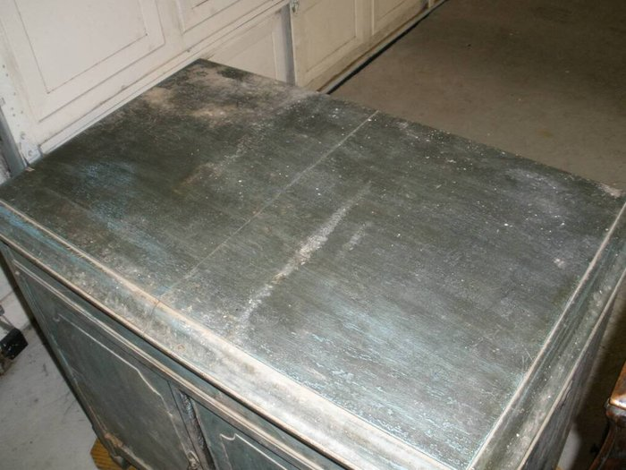
  Steve2.jpg [ 87.58 KiB | Viewed 2179 times ]
  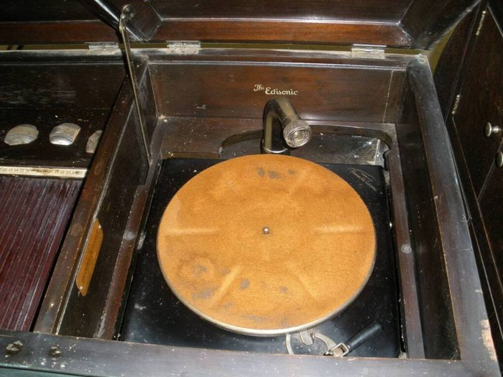
  Steve3.jpg [ 93.88 KiB | Viewed 2179 times ]
  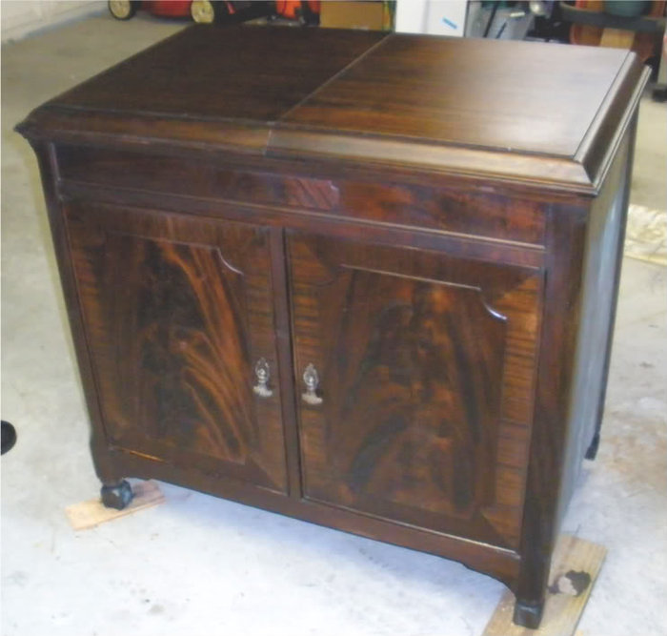
  Steve4.jpg [ 54.43 KiB | Viewed 2179 times ]
  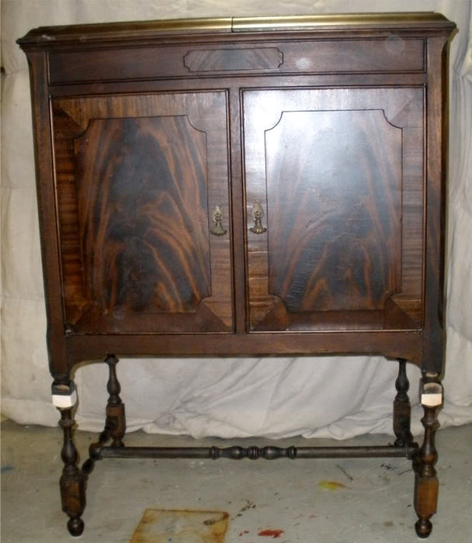
  Steve5.jpg [ 75.08 KiB | Viewed 2179 times ]
  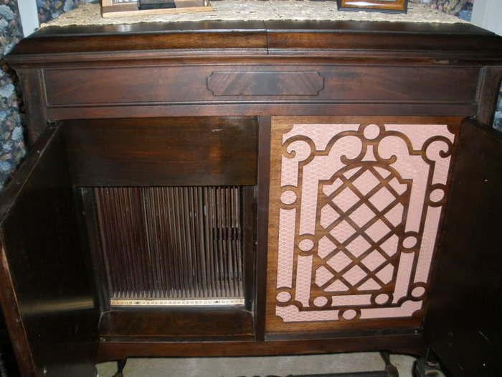
  Steve6.jpg [ 153.56 KiB | Viewed 2179 times ]
  "You must serve music, because music is so enormous and can envelop you into such a state of perpetual anxiety and torture--but it is our first and main duty"
  -- Maria Callas, 1968 interview.
  Last edited by pughphonos on Fri May 02, 2014 9:55 am, edited 1 time in total.
Top

kirtley2012
  Post subject: Re: Inventory of Beethoven and Schubert Edisonic phonographs
  Posted: Thu May 01, 2014 4:13 pm
Joined: Sat Feb 11, 2012 3:10 pm  Posts: 1218  Location: North Shields, UK
  Victor IV
  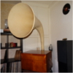
  Buyer of broken things
  I don't know if you've seen this one or not but there's one on this site
  http://www.zipworld.com.au/~job/html/bo ... raphs.html
Top

pughphonos
  Post subject: Re: Inventory of Beethoven and Schubert Edisonic phonographs
  Posted: Thu May 01, 2014 4:31 pm
Joined: Tue Jul 17, 2012 11:35 am  Posts: 670  Location: Homewood, Illinois, USA
  Victor III
  "You must serve music"
  SCHUBERT SHOWN IN WEB SITE FOR "AUSTRALIAN COLLECTORS OF MECHANICAL MUSICAL INSTRUMENTS (ACMMI)"
  Model: Schubert Edisonic
  Non-serial number designation: AUSTRALIA1997NOVEMBER20
  A hearty thank you to Alex ("Kirtley") for finding the following Schubert on an Australian web site (I will repeat the link here):
  http://www.zipworld.com.au/~job/html/bo ... raphs.html
  I will try to contact this organization and see if I can't get the serial number for this fine-looking machine. Might be a futile effort, though, as this is a pretty old website (last updated November 20, 1997).
  Attachments:
  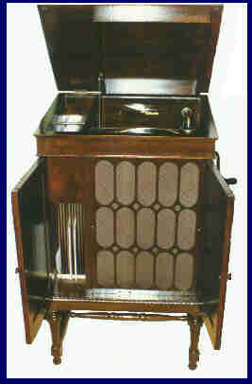
  edisonicAUS.jpg [ 10.13 KiB | Viewed 2159 times ]
  "You must serve music, because music is so enormous and can envelop you into such a state of perpetual anxiety and torture--but it is our first and main duty"
  -- Maria Callas, 1968 interview.
Top

Previous topic | Next topic

Display posts from previous:  Sort by   

 | Page 5 of 25 | [ 247 posts ] | Go to page Previous 1, 2, 3, 4, 5, 6, 7, 8 ... 25 Next

