pughphonos
  Post subject: Re: Inventory of Beethoven and Schubert Edisonic phonographs
  Posted: Fri Apr 25, 2014 10:00 pm
Joined: Tue Jul 17, 2012 11:35 am  Posts: 670  Location: Homewood, Illinois, USA
  Victor III
  
  "You must serve music"
  E-BAY LISTING FROM ROSWELL, GEORGIA, AUGUST 2013
  Model: Schubert Edisonic
  Non-serial number designation: USGA2013AUGUST8
  This machine did not meet the $99.00 reserve and was re-listed. Do not know what became of it afterwards.
  http://www.ebay.com/itm/Antique-record- ... _25wt_1252
  Attachments:
  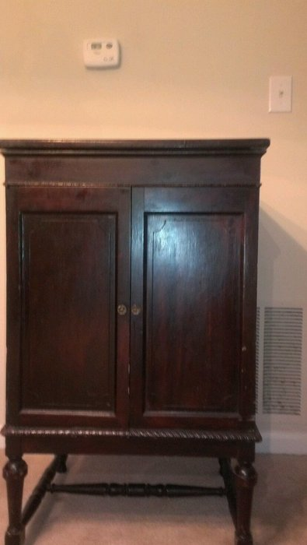
  $(KGrHqMOKo4FG5,83yjGBR-vf+eB3w~~60_57.jpg [ 122.76 KiB | Viewed 3070 times ]
  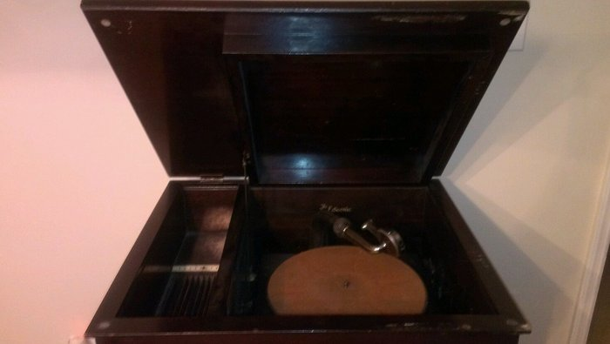
  $(KGrHqJHJBQFHmbMIkUzBR-vfHm0ww~~60_57.jpg [ 101.17 KiB | Viewed 3070 times ]
  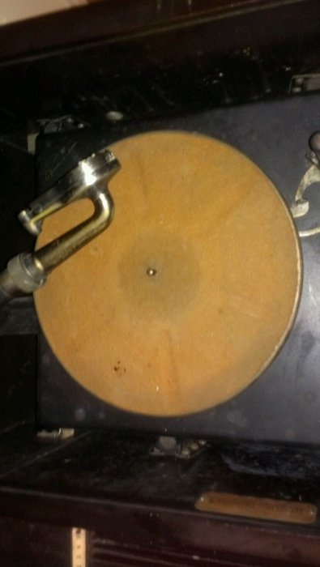
  $(KGrHqV,!oEFHgy17YO6BR-vfc((HQ~~60_57.jpg [ 111.08 KiB | Viewed 3070 times ]
  "You must serve music, because music is so enormous and can envelop you into such a state of perpetual anxiety and torture--but it is our first and main duty"
  -- Maria Callas, 1968 interview.
Top

tubaphone
  Post subject: Re: Inventory of Beethoven and Schubert Edisonic phonographs
  Posted: Sat Apr 26, 2014 3:18 pm
Joined: Sat Mar 30, 2013 11:45 pm  Posts: 43
  Victor Jr
  I have 2 Schubert model Edisonic phonographs. One is complete and in very nice condition while the other one is rough but restorable. The unrestored one is buried under boxes of piano rolls (my other hobby) right now so I can't get the serial number. If time permits I'll try and get the information on the second one this weekend. Here is the information on the nice original that resides in my living room.
  Serial#: 1216
  When Purchased: April 4, 2013
  From Whom: originally from the collection of Art Wilmoth, a San Francisco CA Edison collector, sold by his descendants in Los Gatos CA.
  Cabinet Condition: very good original condition
  Upgrades: The wooden knobs were broken so they were replaced by me with metal ones that are very close in design to the original wooden ones.
  Michael
Top

pughphonos
  Post subject: Re: Inventory of Beethoven and Schubert Edisonic phonographs
  Posted: Sun Apr 27, 2014 3:17 pm
Joined: Tue Jul 17, 2012 11:35 am  Posts: 670  Location: Homewood, Illinois, USA
  Victor III
  "You must serve music"
  LOCATION/OWNER PRESENTLY UNKNOWN
  "Sharon Maurer's machine"
  From on-line sources I have learned about Sharon Maurer (of Berryville, Virginia), who used the tag "3Victrolas" on several antique phonograph sites between 2009 and 2011. She had a nice collection of antique phonographs and records, including a Schubert Edisonic. I have read all of the postings from her I can find but could not find any mention of a serial number for this fine machine. It appears that she bought it at the 2008 Union show, and the nice photo attached below (dated June 16, 2008) shows the phonograph while still at the show. So I am creating a non-serial number designation for this machine, using the place and approximate date at which she purchased it.
  The other photo (of the machine with its doors closed) also comes from one of the on-line forums.
  Sadly, Sharon died on August 27, 2012 and "Mooperator" (Jeff Lee) posted the following notice on this forum the next day:
  "For those of you who knew Sharon, her husband Ken emailed me last night and said that she died around 5 pm yesterday in a local Hospice. Sharon was diagnosed with a tumor in her lungs in the early spring I believe. Although she has never been a smoker, the disease grew quickly. In July she was told she would not see a new year and she was still in good spirits."
  "Sharon was one of the few female collectors of phonographs and she loved to learn about every machine. I joked with her years ago that she would have to change her 'Handle' as her collection grew because phonographs are like Layes potato chips... you just can't have just one... or three!"
  "Sharon was such a joy to know and be around and I enjoyed her surprise emails updating me on their never ending improvements on their homes and collection."
  "Please keep her husband Ken and family in your prayers and thoughts. I'll miss you 3victrolas!"
  "Sincerely, Jeff Lee Moooperator"
  Model: Schubert Edisonic
  Non-serial number designation: USIL2008JUNE16
  Present location: Unknown
  Identifying characteristics: The right door panel shows wood grain with a definite "northeast to southwest" orientation.
  Attachments:
  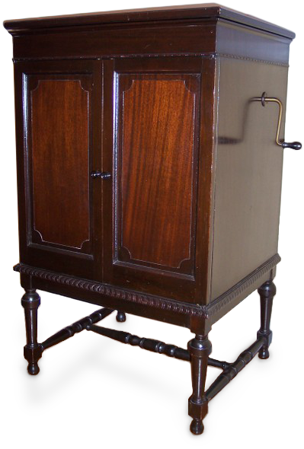
  edisonic-closed-3victrolas.png [ 279.25 KiB | Viewed 3003 times ]
  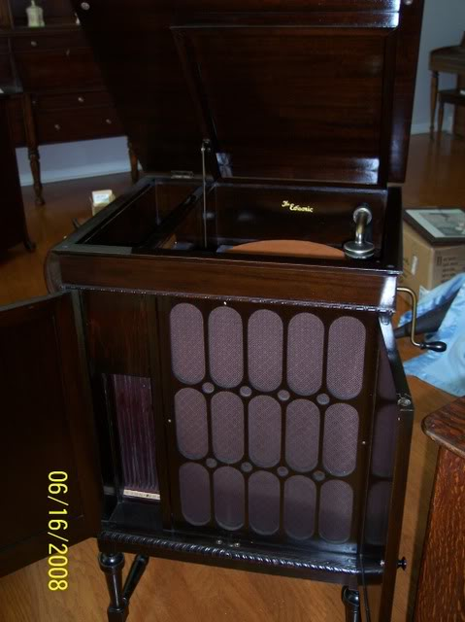
  Union2008095.jpg [ 44.61 KiB | Viewed 3007 times ]
  "You must serve music, because music is so enormous and can envelop you into such a state of perpetual anxiety and torture--but it is our first and main duty"
  -- Maria Callas, 1968 interview.
  Last edited by pughphonos on Thu May 01, 2014 4:52 pm, edited 1 time in total.
Top

pughphonos
  Post subject: Re: Inventory of Beethoven and Schubert Edisonic phonographs
  Posted: Sun Apr 27, 2014 8:07 pm
Joined: Tue Jul 17, 2012 11:35 am  Posts: 670  Location: Homewood, Illinois, USA
  Victor III
  "You must serve music"
  MACHINE OWNED BY "VITANOLA" OF JONESVILLE, MICHIGAN AS OF 2007 (PRETTY SURE THIS IS OUR "UNCLE VANYA")
  Model: 1 Beethoven Edisonic
  Model: 2 Schubert Edisonics (not documented in this post but only mentioned)
  Non-serial number designation: USMI2007NOVEMBER9
  The following website
  http://www.antiqueradios.com/forums/vie ... w=previous
  has two photos of a Beethoven owned by "Vitanola," posted on November 9, 2007. His statement reads:
  "I have a couple of Schuberts and a Beethoven. Many Edisonic horns appear to have been pieced together from left-over smaller horns (the Edison works had an immense number of unused mechanisms for earlier machines in stock at the time of the introduction of the Edisonic models.) The Edisonic machines were intended to be interim models, which would allow the company to work off their stocks of existing parts. The 1929 models were planned to use electric amplification exclusively."
  "Oddly enough, in side by side comparisons, using the same reproducer and record, the Edisonic does not perform much better than a large (250 model) machine. The apparent Bass response of the older machine is actually noticeably greater, despite the longer horn of the Edisonic, although the Edisonic models (which share the same horn) are noticeably louder and brighter."
  Attachments:
  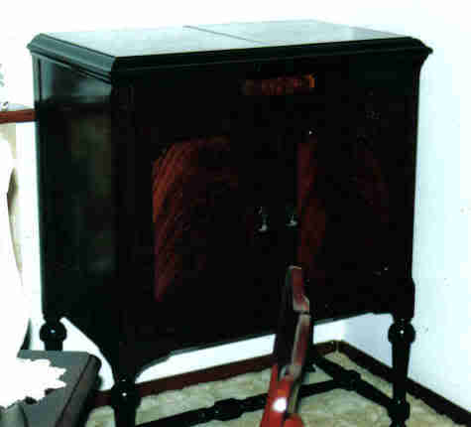
  lastscan.jpg [ 9.12 KiB | Viewed 2989 times ]
  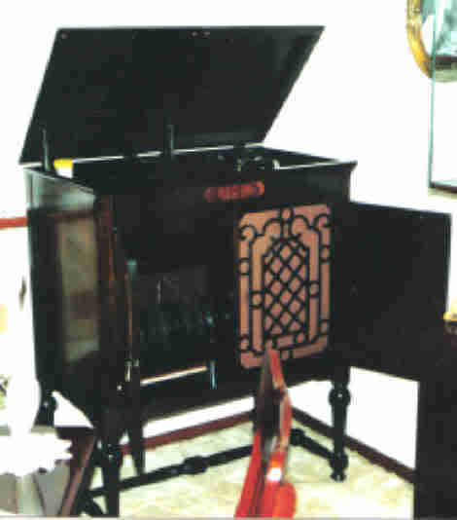
  lastscan2.jpg [ 12.46 KiB | Viewed 2989 times ]
  "You must serve music, because music is so enormous and can envelop you into such a state of perpetual anxiety and torture--but it is our first and main duty"
  -- Maria Callas, 1968 interview.
Top

pughphonos
  Post subject: Re: Inventory of Beethoven and Schubert Edisonic phonographs
  Posted: Mon Apr 28, 2014 1:39 pm
Joined: Tue Jul 17, 2012 11:35 am  Posts: 670  Location: Homewood, Illinois, USA
  Victor III
  "You must serve music"
  AUCTION BY THE THREE RIVERS AUCTION COMPANY OF WASHINGTON, PA (CONCLUDED 1/20/2014)
  Model: Schubert Edisonic
  Serial number: 2010
  The following text has been cut-and-pasted from an on-line notice from the above-mentioned company (and the photographs taken from the same notice).
  Phonograph Collection INTERNET ONLY Auction Jan. 20, 2014
  Auctioneer: The Three Rivers Auction Company
  Type: Online-Only Auction
  Date(s): 12/27/2013 - 1/20/2014
  Monday, January 20th at 6pm
  Preview Date/Time: Monday, January 13th 3pm to 6pm Monday, January 20th 12 Noon to 6pm (or by appointment)
  Checkout Date/Time: Pick up & Pay Dates: Tuesday & Wednesday, January 21st & 22nd , 12pm to 6pm. All
  items be paid for by 6pm on January 22nd. Arrangements may be made to alternate pick up time.
  Location: 382 W. Chestnut Street, Washington, PA 15301
  Description: We are pleased to offer this fresh-to-the-market private collection. This Auction will feature many hard to find phonographs by Victor Victrola, Columbia, and Edison dating from 1910 through 1930, including floor models, tabletop & cylinder machines. All are original in as found condition; many are in working condition. This Auction will also include parts, accessories, related ephemera, along with records & cylinders. Whether you are a collector or just want a great piece of antique technology, do not miss this sale
  Attachments:
  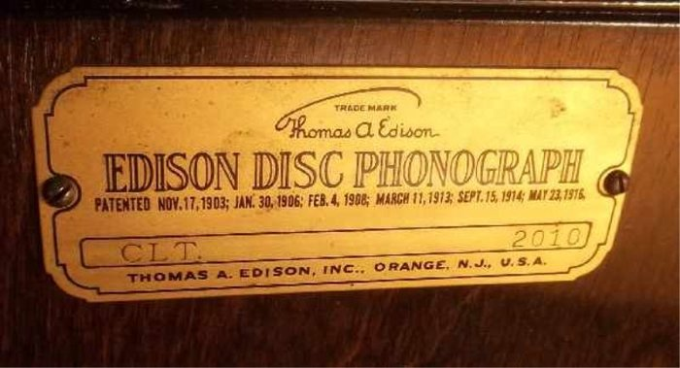
  PA2.jpg [ 53.64 KiB | Viewed 2963 times ]
  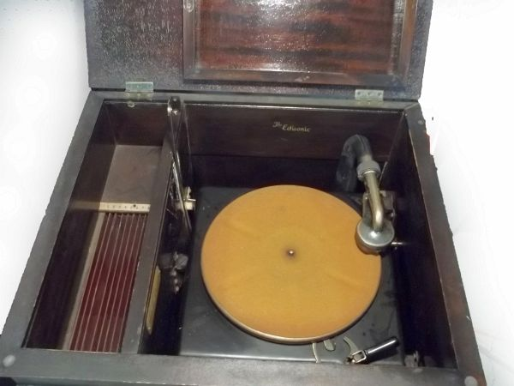
  PA3.jpg [ 62.99 KiB | Viewed 2963 times ]
  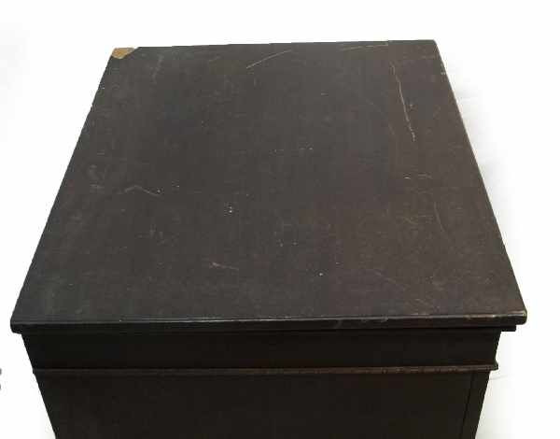
  PA4.jpg [ 28.29 KiB | Viewed 2963 times ]
  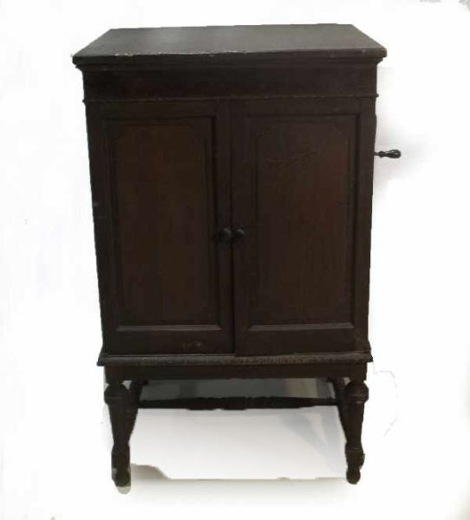
  PA5.jpg [ 20.32 KiB | Viewed 2963 times ]
  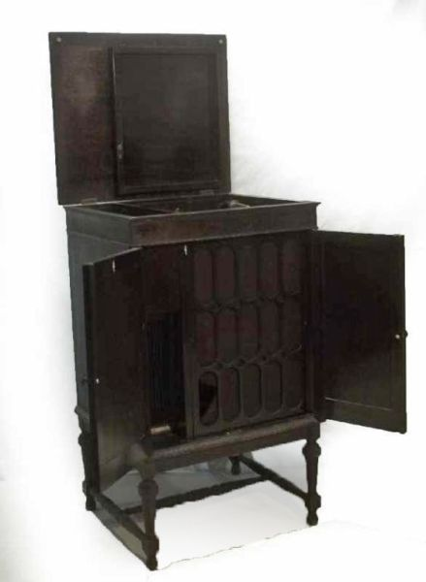
  PA6.jpg [ 20.73 KiB | Viewed 2963 times ]
  "You must serve music, because music is so enormous and can envelop you into such a state of perpetual anxiety and torture--but it is our first and main duty"
  -- Maria Callas, 1968 interview.
  Last edited by pughphonos on Mon Apr 28, 2014 3:55 pm, edited 1 time in total.
Top

pughphonos
  Post subject: Re: Inventory of Beethoven and Schubert Edisonic phonographs
  Posted: Mon Apr 28, 2014 3:54 pm
Joined: Tue Jul 17, 2012 11:35 am  Posts: 670  Location: Homewood, Illinois, USA
  Victor III
  "You must serve music"
  "SPECIAL AUCTION SERVICES" SALE IN NEWBURY, BERKSHIRE, UK IN 2011
  Model: Schubert Edisonic
  Serial number: 5678
  The following link
  http://www.the-saleroom.com/de-de/aucti ... t-11645316
  connects to information on a sale that was conducted by Special Auction Services of Newbury, Berkshire, UK, on July 29-30, 2011, with a projected value of £400 - £600. Below is text, and then one photograph, that feature in the above link:
  "An Edison Edisonic Diamond Disc phonograph, Type CLT (Schubert), No. 5678, with LP attachment, standard and LP reproducers and transit cradles (one with Edison, Wardour St. label), in console cabinet with record compartment at left and doors enclosing horn grille, on baluster turned legs with stretchers – 39 ¾ in. high, 24 in.wide; and thirty discs."
  Note: On April 29, 2014 I received an e-mail from Paul Collenette (former Director of the City of London Phonograph and Gramophone Society, Ltd.) which discussed Edisonics in the United Kingdom (UK). He has been active in the antique phonograph community in the UK for some time and therefore his testimony carries great weight. He wrote: "I remember the one at Christie’s in 1998 – there was a rough one at SAS Auctions, Newbury, Berkshire, 2 or 3 years ago. They must certainly be rare in the UK – I don’t know of anyone who has one."
  Attachments:
  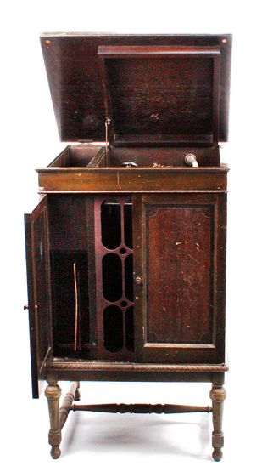
  5678.jpg [ 179.29 KiB | Viewed 2948 times ]
  "You must serve music, because music is so enormous and can envelop you into such a state of perpetual anxiety and torture--but it is our first and main duty"
  -- Maria Callas, 1968 interview.
  Last edited by pughphonos on Tue Apr 29, 2014 2:20 pm, edited 1 time in total.
Top

pughphonos
  Post subject: Re: Inventory of Beethoven and Schubert Edisonic phonographs
  Posted: Mon Apr 28, 2014 10:13 pm
Joined: Tue Jul 17, 2012 11:35 am  Posts: 670  Location: Homewood, Illinois, USA
  Victor III
  "You must serve music"
  TUBAPHONE'S "ROUGH BUT RESTORABLE" SCHUBERT
  Model: Schubert Edisonic
  Serial number: 1217
  Michael, aka "Tubaphone," has just sent me the following photos of his "rough" Schubert, which is mentioned above in his posting of April 26. He obtained #1217 from a private individual in Sonoma CA over a year ago.
  Michael can boast of the "most amazing coincidence" on our Edisonic inventory thread thus far. Our inventory so far only has one pair of adjacent serial numbers reported (nos. 1216 & 1217)--and Michael owns them both!!!
  Attachments:
  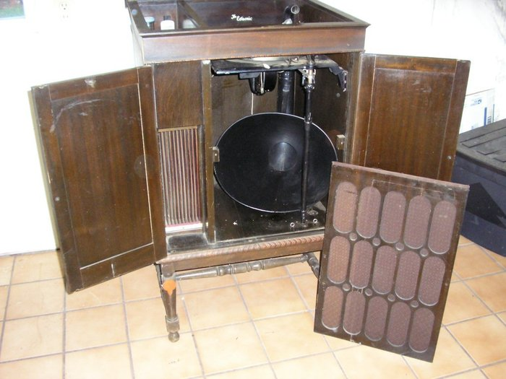
  Michael2.jpg [ 64.15 KiB | Viewed 2924 times ]
  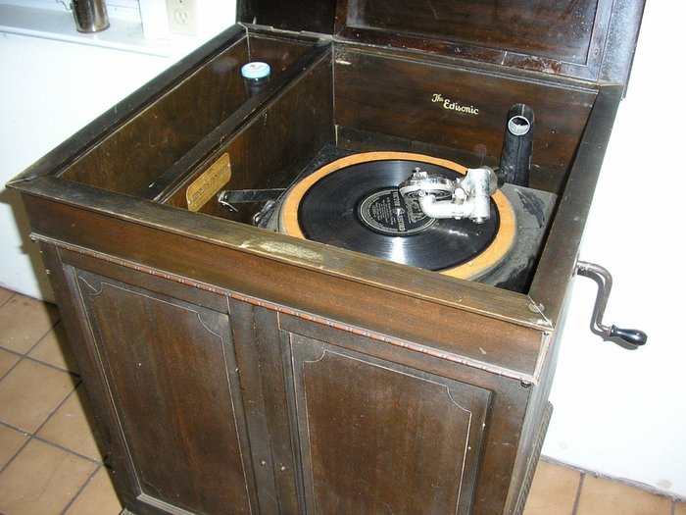
  Michael1.jpg [ 163.59 KiB | Viewed 2924 times ]
  "You must serve music, because music is so enormous and can envelop you into such a state of perpetual anxiety and torture--but it is our first and main duty"
  -- Maria Callas, 1968 interview.
  Last edited by pughphonos on Sun May 04, 2014 1:47 pm, edited 1 time in total.
Top

pughphonos
  Post subject: Re: Inventory of Beethoven and Schubert Edisonic phonographs
  Posted: Tue Apr 29, 2014 12:29 pm
Joined: Tue Jul 17, 2012 11:35 am  Posts: 670  Location: Homewood, Illinois, USA
  Victor III
  "You must serve music"
  EDISONICS IN THE BRITISH EMPIRE
  I'll pause from posting about machines for a moment to reproduce the following vintage advertisement that was sent to me earlier today by Paul Collenette of the UK. Paul was Director of the City of London Phonograph & Gramophone Society, Ltd. from 2003 to 2009 (in our community it doesn't get any more prestigious than that). I had the honor to meet this thoroughly nice fellow at the 2013 annual meeting of the Association for Recorded Sound Collections (ARSC) in Kansas City, MO.
  I thought you Edisonic enthusiasts might like to see Paul's scan as it's taken from an Australian publication; I've certainly never seen it before. So far, my inventory includes two Schuberts from "Down Under" (see above non-serial number designation NEW ZEALAND2012MAY3, posted 4/25/2014; and serial number 5670 of Melbourne, Australia, posted 05/6/2014).
  Paul also made some interesting comments on Edisonics in the UK, which I will append to a couple of the UK machines posted above.
  Ralph
  Attachments:
  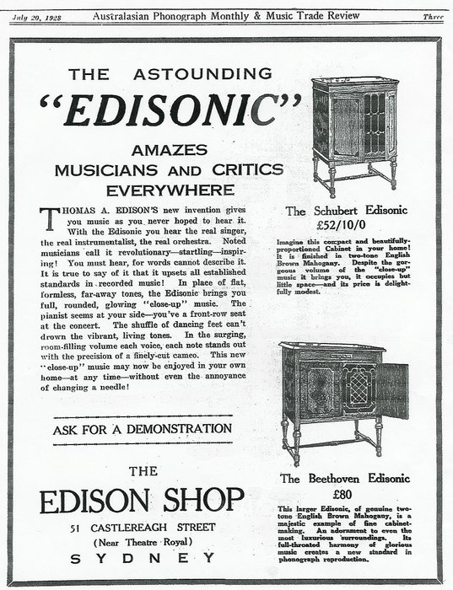
  Edisonic.jpg [ 322.38 KiB | Viewed 2883 times ]
  "You must serve music, because music is so enormous and can envelop you into such a state of perpetual anxiety and torture--but it is our first and main duty"
  -- Maria Callas, 1968 interview.
  Last edited by pughphonos on Tue May 06, 2014 10:32 am, edited 2 times in total.
Top

pughphonos
  Post subject: Re: Inventory of Beethoven and Schubert Edisonic phonographs
  Posted: Tue Apr 29, 2014 3:59 pm
Joined: Tue Jul 17, 2012 11:35 am  Posts: 670  Location: Homewood, Illinois, USA
  Victor III
  "You must serve music"
  "PHONOPHAN79's" SCHUBERT
  Model: Schubert Edisonic
  Serial number: 4869
  Our member Phonophan has posted twice (as far as I can find) about his Schubert Edisonic, once in 2009 and once in 2011.
  The 2009 (June 18) posting was on the "Antique Talking Machines" site and included the photos found below:
  http://victrolagramophones.proboards.com/user/55/recent
  The 2009 posting also included the following statement: "So, here is the deal... it is a piece I saved from destruction, the mechanics were all there but the cabinet needed help. The lid, decal and grill cloth are not original, but as the piece has been completely restored and they all look good now."
  The 2011 (January 1) posting was on our site and linked to a You Tube video of the same machine:
  http://www.youtube.com/watch?v=ugTDl9ZP ... D526677750
  Attachments:
  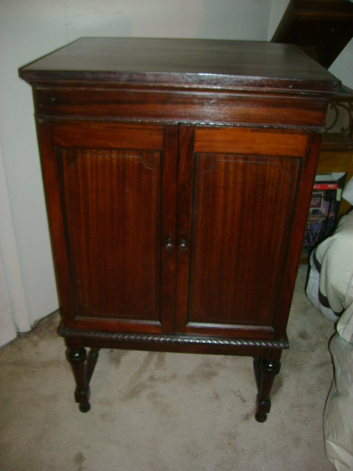
  edisonicschubert14869.jpg [ 129.77 KiB | Viewed 2864 times ]
  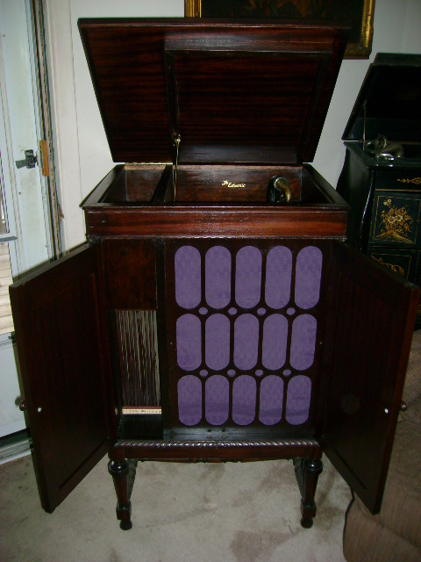
  edisonicschubert24869.jpg [ 132.2 KiB | Viewed 2864 times ]
  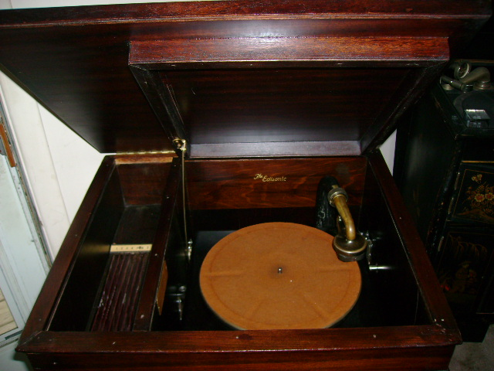
  edisonicschubert34869.jpg [ 131.62 KiB | Viewed 2864 times ]
  "You must serve music, because music is so enormous and can envelop you into such a state of perpetual anxiety and torture--but it is our first and main duty"
  -- Maria Callas, 1968 interview.
  Last edited by pughphonos on Tue Apr 29, 2014 6:40 pm, edited 1 time in total.
Top

pughphonos
  Post subject: Re: Inventory of Beethoven and Schubert Edisonic phonographs
  Posted: Tue Apr 29, 2014 6:29 pm
Joined: Tue Jul 17, 2012 11:35 am  Posts: 670  Location: Homewood, Illinois, USA
  Victor III
  "You must serve music"
  "MOOPERATOR's" (JEFF LEE'S) BEETHOVEN
  Model: Beethoven Edisonic
  Serial number: 1238
  "Mooperator" (of Mississippi) posted on our forum early in its life but since 2009 has been more active on a forum of his own creation, the "Antique Talking Machine" site. He clearly has an extensive collection and was featured in the following publication:
  http://lfg.live.mediaspanonline.com/ass ... 1711_1.pdf
  The only visual evidence I currently have for his Beethoven is on You Tube, which can be accessed by this link. Pay especial attention to marker 3:45, where he shows the original receipt for the machine; it appears to show the Beethoven's serial number (see if you agree that the number is 1238).
  http://www.youtube.com/watch?v=IBdB73SOpi4
  Attachments:
  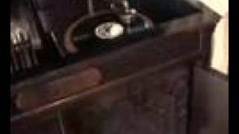
  mqdefault.jpg [ 6.29 KiB | Viewed 2847 times ]
  "You must serve music, because music is so enormous and can envelop you into such a state of perpetual anxiety and torture--but it is our first and main duty"
  -- Maria Callas, 1968 interview.
Top

Previous topic | Next topic

Display posts from previous:  Sort by   

 | Page 4 of 25 | [ 247 posts ] | Go to page Previous 1, 2, 3, 4, 5, 6, 7 ... 25 Next

