pughphonos
  Post subject: Re: Inventory of Beethoven and Schubert Edisonic phonographs
  Posted: Wed Apr 23, 2014 12:23 pm
Joined: Tue Jul 17, 2012 11:35 am  Posts: 670  Location: Homewood, Illinois, USA
  Victor III
  
  "You must serve music"
  MINNESOTA CRAIGSLIST POSTING FROM 2013MAY19
  Non-serial number designation: USMN2013MAY19
  I expressed an interest in this Schubert machine at the time of this posting, but the seller ("Chuck") did not want to make arrangements to ship, preferring to sell locally; so there is a good chance that the machine is still in or near Minnesota.
  His description read: "75 year old 1928 Edison Edisonic Schubert Diamond Disc Phonograph in excellent condition. All original and has not had any restoration done to it. It has two different reproducers, needles included, and has 13 Edison phonograph records. This model was only made for a few years. $1100.00. Call 320-309-7568."
  Note attached photo, dated January 10, 2003, apparently taken ten years before this guy's posting; probably means he owned it for at least that long and might have been using a photo provided at the point he bought it from a previous owner. (Unless the date setting on his camera was messed up; ah, the challenges of history....).
  Attachments:
  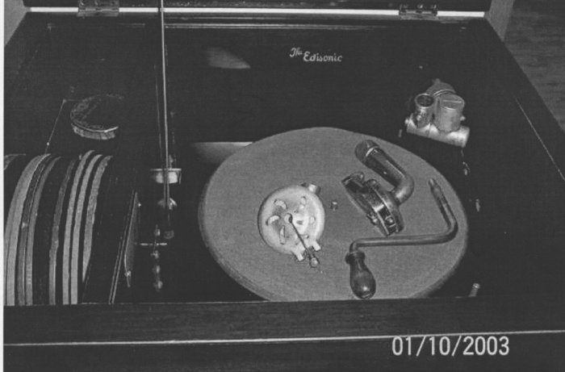
  MN.jpg [ 462.85 KiB | Viewed 1241 times ]
  "You must serve music, because music is so enormous and can envelop you into such a state of perpetual anxiety and torture--but it is our first and main duty"
  -- Maria Callas, 1968 interview.
  Last edited by pughphonos on Mon Apr 28, 2014 9:59 am, edited 1 time in total.
Top

coyote
  Post subject: Re: Inventory of Beethoven and Schubert Edisonic phonographs
  Posted: Thu Apr 24, 2014 11:49 am
Joined: Thu Jan 08, 2009 12:41 am  Posts: 374  Location: Pittsburgh, PA
  Victor II
  
  Looking through my Union photos from 2010, there was a Schubert with its doors wide open. I didn't note the serial, however. Perhaps a forum member now owns it. If not purchased at Union, perhaps identifiable via its blemishes.
  Attachment:
  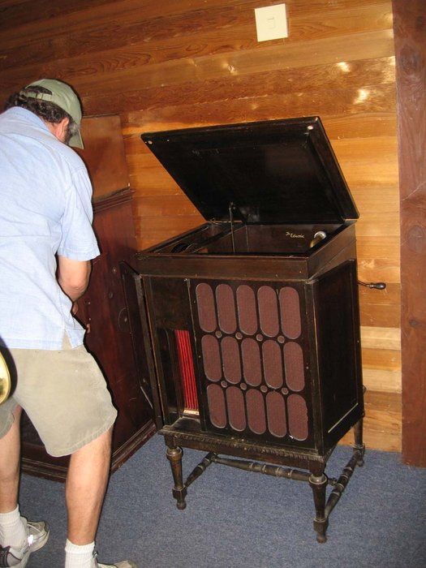
  IMG_1127.jpg [ 143.42 KiB | Viewed 1390 times ]
Top

jukejunkie
  Post subject: Re: Inventory of Beethoven and Schubert Edisonic phonographs
  Posted: Thu Apr 24, 2014 1:36 pm
Joined: Tue Jul 12, 2011 5:27 pm  Posts: 86
  Victor O
  Model: Schubert Edisonic
  Serial number: 1187
  When purchased: June 2013
  From whom purchased: From the original owner's daughter in Spokane WA
  Cabinet condition when purchased: A condition but the lid had veneer lifting.
  Upgrades made by present owner: Lid had to be redone to make it presentable and the rest of the case touched up (not striped). Still on all original mechanical configuration.
  Attachments:
  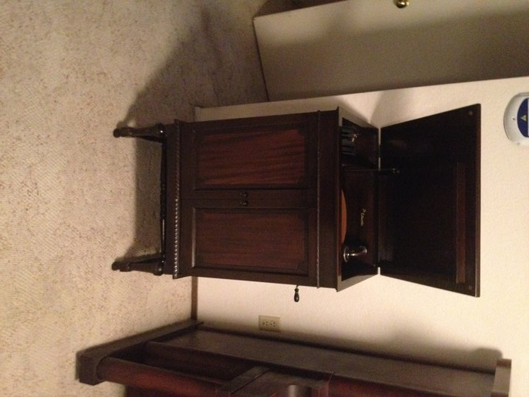
  Schubert doors.jpg [ 2.04 MiB | Viewed 1368 times ]
  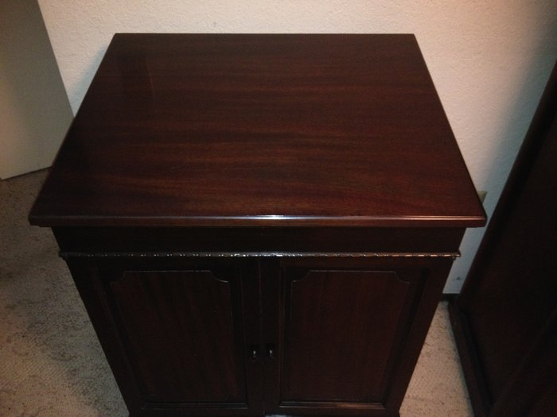
  Schubert top.jpg [ 1.63 MiB | Viewed 1371 times ]
  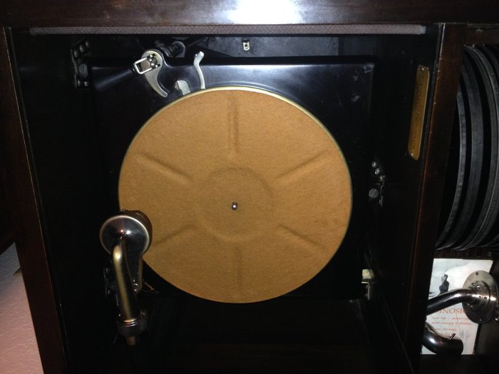
  Schubert inside.jpg [ 1.48 MiB | Viewed 1371 times ]
  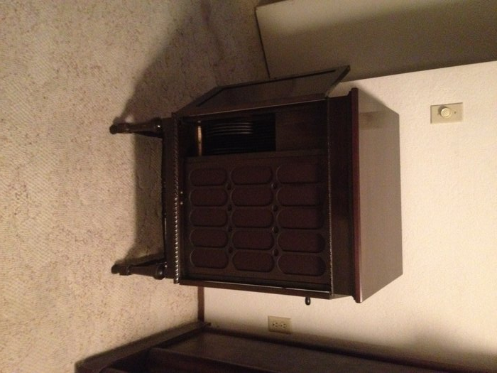
  Schubert front.jpg [ 2.17 MiB | Viewed 1371 times ]
  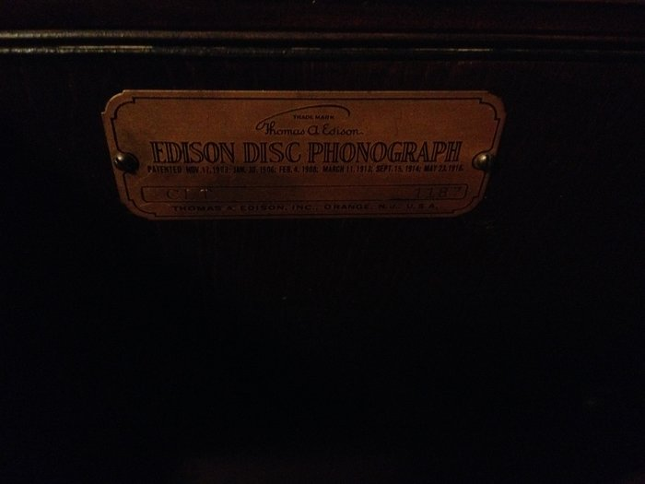
  Schubert tag.jpg [ 1.33 MiB | Viewed 1371 times ]
Top

pughphonos
  Post subject: Re: Inventory of Beethoven and Schubert Edisonic phonographs
  Posted: Thu Apr 24, 2014 3:34 pm
Joined: Tue Jul 17, 2012 11:35 am  Posts: 670  Location: Homewood, Illinois, USA
  Victor III
  "You must serve music"
  coyote wrote:
  Looking through my Union photos from 2010, there was a Schubert with its doors wide open. I didn't note the serial, however. Perhaps a forum member now owns it. If not purchased at Union, perhaps identifiable via its blemishes.
  Attachment:
  IMG_1127.jpg
  Hi Coyote,
  Thanks! I'm giving this machine the non-serial number designation USIL2010JUNE12 as June 12, 2010 was the first day of the Union show that year. Yes, I do think it's helpful posting these older photos of the Edisonics, even without serial numbers, as we might be able to eventually identify them via their blemishes, alterations, etc.
  "You must serve music, because music is so enormous and can envelop you into such a state of perpetual anxiety and torture--but it is our first and main duty"
  -- Maria Callas, 1968 interview.
Top

pughphonos
  Post subject: Re: Inventory of Beethoven and Schubert Edisonic phonographs
  Posted: Thu Apr 24, 2014 3:50 pm
Joined: Tue Jul 17, 2012 11:35 am  Posts: 670  Location: Homewood, Illinois, USA
  Victor III
  "You must serve music"
  jukejunkie wrote:
  Model: Schubert Edisonic
  Serial number: 1187
  When purchased: June 2013
  From whom purchased: From the original owner's daughter in Spokane WA
  Cabinet condition when purchased: A condition but the lid had veneer lifting.
  Upgrades made by present owner: Lid had to be redone to make it presentable and the rest of the case touched up (not striped). Still on all original mechanical configuration.
  Thanks Jukejunkie. Comment I'll make here is you have the earliest machine posted here yet.
  "You must serve music, because music is so enormous and can envelop you into such a state of perpetual anxiety and torture--but it is our first and main duty"
  -- Maria Callas, 1968 interview.
Top

pughphonos
  Post subject: Re: Inventory of Beethoven and Schubert Edisonic phonographs
  Posted: Thu Apr 24, 2014 9:42 pm
Joined: Tue Jul 17, 2012 11:35 am  Posts: 670  Location: Homewood, Illinois, USA
  Victor III
  "You must serve music"
  2006 POSTING ON "STEVE HOFFMAN MUSIC FORUMS"
  Model: Schubert Edisonic
  Non-serial number designation: USMD2006JULY7
  The following link
  http://forums.stevehoffman.tv/threads/l ... st-1891985
  contains the following description and photos posted of a Schubert by "drh" of Silver Spring, MD on July 7, 2006:
  "My most recent equipment purchase was this Edison Edisonic "Schubert" model diamond disc player, which I bought in April and which pretty much swallowed my equipment budget for the rest of the year."
  Attachments:
  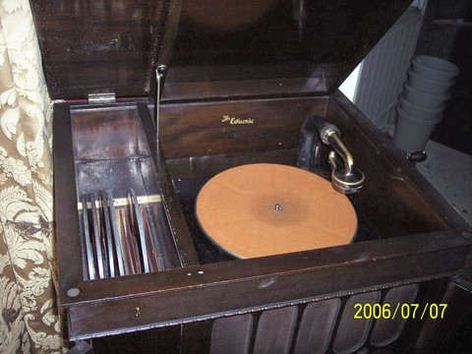
  reduced Edisonic playing chamber.jpg [ 63.51 KiB | Viewed 1328 times ]
  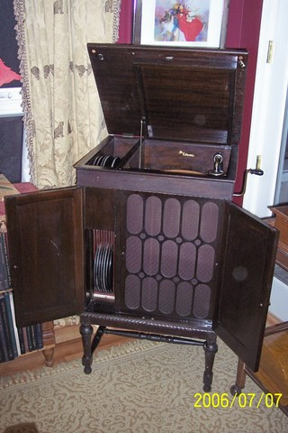
  reduced Edisonic doors open.jpg [ 58.01 KiB | Viewed 1328 times ]
  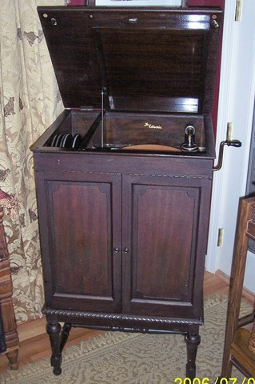
  reduced Edisonic doors closed.jpg [ 56.38 KiB | Viewed 1328 times ]
  "You must serve music, because music is so enormous and can envelop you into such a state of perpetual anxiety and torture--but it is our first and main duty"
  -- Maria Callas, 1968 interview.
  Last edited by pughphonos on Mon Apr 28, 2014 9:24 pm, edited 2 times in total.
Top

pughphonos
  Post subject: Re: Inventory of Beethoven and Schubert Edisonic phonographs
  Posted: Fri Apr 25, 2014 10:40 am
Joined: Tue Jul 17, 2012 11:35 am  Posts: 670  Location: Homewood, Illinois, USA
  Victor III
  "You must serve music"
  2006 POSTING ON "MISTER OPERA" WEBSITE
  Model: Schubert Edisonic
  Non-serial number designation: GERMANY2006
  The following link
  http://www.misteropera.com/html/schuber ... ic_us.html
  contains the following photos posted of a Schubert under the date 2006.
  NOTE: There is no indication on this link of its geographic place of origin. I am assuming Germany as the German lanugage features prominently in the overall website.
  Attachments:
  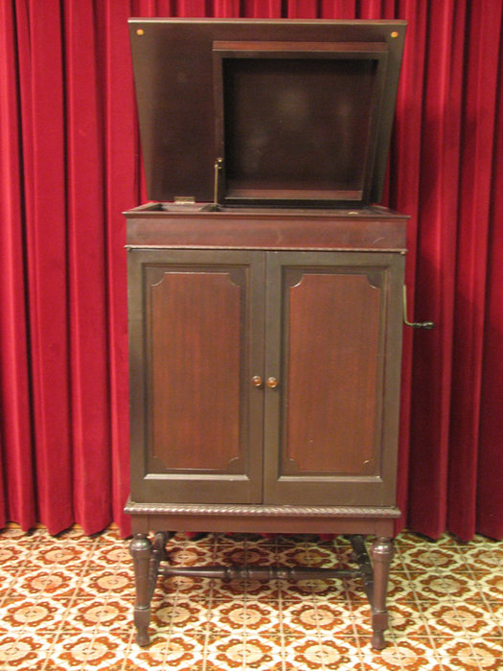
  Edison_DD_Shubert_Edisonic_A609th.jpg [ 533.79 KiB | Viewed 1249 times ]
  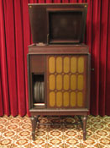
  Edison_DD_Shubert_Edisonic_Cth.jpg [ 28.45 KiB | Viewed 1296 times ]
  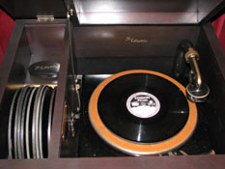
  Edison_DD_Shubert_Edisonic_Bth.jpg [ 30.99 KiB | Viewed 1296 times ]
  "You must serve music, because music is so enormous and can envelop you into such a state of perpetual anxiety and torture--but it is our first and main duty"
  -- Maria Callas, 1968 interview.
  Last edited by pughphonos on Thu May 01, 2014 9:39 am, edited 2 times in total.
Top

pughphonos
  Post subject: Re: Inventory of Beethoven and Schubert Edisonic phonographs
  Posted: Fri Apr 25, 2014 11:09 am
Joined: Tue Jul 17, 2012 11:35 am  Posts: 670  Location: Homewood, Illinois, USA
  Victor III
  "You must serve music"
  POSTING ON "TRADE ME: WHERE KIWIS BUY AND SELL" FROM 2012
  Model: Schubert Edisonic
  Non-serial number designation: NEW ZEALAND2012MAY3
  Very minimal information on a Schubert that obviously is no longer whole. Still worthy of note; might be the only Schubert (partial or whole) in New Zealand (or at least formerly in New Zealand). The ad was closed on May 3, 2012 and read:
  "Mahogany cabinet with double doors and flip lid. Used to house stereo."
  http://www.trademe.co.nz/antiques-colle ... 147198.htm
  "You must serve music, because music is so enormous and can envelop you into such a state of perpetual anxiety and torture--but it is our first and main duty"
  -- Maria Callas, 1968 interview.
Top

pughphonos
  Post subject: Re: Inventory of Beethoven and Schubert Edisonic phonographs
  Posted: Fri Apr 25, 2014 4:22 pm
Joined: Tue Jul 17, 2012 11:35 am  Posts: 670  Location: Homewood, Illinois, USA
  Victor III
  "You must serve music"
  1987 DATA FROM THE NEW AMBEROLA GRAPHIC
  The New Amberola Graphic (a publication dedicated to the Edison phonographic hobby and running from around 1973 until 2002) conducted and published a survey among its subscribers who owned Edisonic phonographs.
  The following information was written/posted by Jim Tennyson ("Lenoirstreetguy") of this forum: "The editor of the New Amberola Graphic, Martin Bryan, did a quick survey in July 1987 of the machines owned by the readers. The serial numbers for the Schubert ranged from 1150 to 4484." (NOTE: Jim is talking about only the phonographs reported in that 1987 survey; in our survey we already know that the numbers went at least as high as 5678--ed.). "Those for the Beethoven ranged from 1220 to 2036." (NOTE: Our survey includes 1121 for the low end and 2488 for the high end--ed.). "Assuming that the serial numbers began at 1000, it suggests that there were at least 3500 Schuberts and over 1000 Beethovens. Martin points out that we can't be sure all numbers were used. He was surprised, from the vantage point of the 1980s that the production seemed so high: one saw them rarely then, but from the number that turn up on ebay, 3500 doesn't seem impossible by any means."
  Jim Tennyson has very kindly scanned the results of this survey, which was published in no. 61 of the Graphic in July 1987 (see below). You can see from the scan that the following Beethovens and Schuberts were extant in 1987; hopefully all are still with us. For ease of analysis, I will repeat the serial numbers directly below and link them to comments on those machines that were made in the survey.
  BEETHOVENS:
  1220
  1262 (equipped with Long Play mechanism)
  1316
  1757
  2036 (equipped with Long Play equipment)
  SCHUBERTS:
  1150 (in 1987 owned by Dick Seitler, who reported that it had the Long Play equipment and two springs)
  1216
  1441 (equipped with mute ball)
  1656
  1913
  2002
  2058
  2982
  3023
  4246
  4484
  Interestingly, the only number from this 1987 list that duplicates one that has been currently submitted here (2014) is #1216, which now belongs to Michael (see below)--who did not own it in 1987. One can only hope that the rest of the 1987 owners are either still healthy and happy; or that their machines have been passed along in their families; or (failing that) that the machines subsequently found their way to new, proud, and protective owners.
  Attachments:
  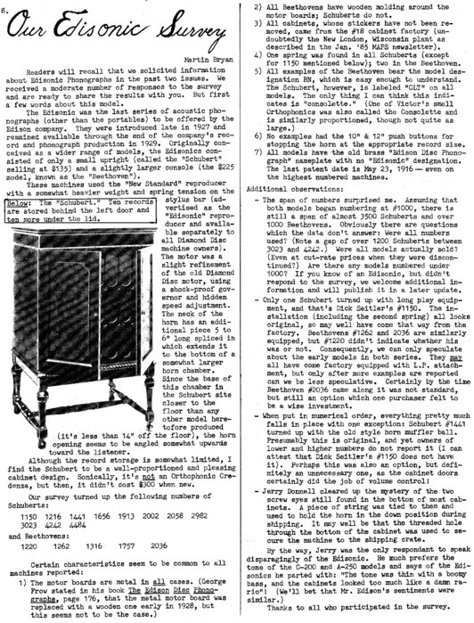
  IMG.jpg [ 160.13 KiB | Viewed 1243 times ]
  "You must serve music, because music is so enormous and can envelop you into such a state of perpetual anxiety and torture--but it is our first and main duty"
  -- Maria Callas, 1968 interview.
  Last edited by pughphonos on Sat May 03, 2014 7:48 am, edited 6 times in total.
Top

pughphonos
  Post subject: Re: Inventory of Beethoven and Schubert Edisonic phonographs
  Posted: Fri Apr 25, 2014 5:18 pm
Joined: Tue Jul 17, 2012 11:35 am  Posts: 670  Location: Homewood, Illinois, USA
  Victor III
  "You must serve music"
  CRAIGSLIST OFFERING FROM FORT WORTH/ARLINGTON AREA, TEXAS, SPRING 2014
  Model: Schubert Edisonic
  Serial number: 1394
  A gentleman in Texas has been offering a Schubert for sale (with records, for $700) via the Dallas Craigslist for several weeks by this point. The link is posted immediately below:
  http://dallas.craigslist.org/mdf/atq/4382799656.html
  The gentleman's first name is Wes. I contacted him for the serial number and he very kindly responded today; the serial number was not originally on his ad.
  Wes' machine is distinctive in that it has clearly been refinished and no longer has the original Edisonic decal. Some collectors like the refinished look; others do not. At any rate, I wish him the best in finding a good home for this intact machine.
  Below I will cut and paste much of his ad, plus the photographs provided, so that when his posting disappears the information and images will not be lost to us.
  Wes starts out with a general history of the Schuberts, gained from secondary sources, and then writes "I will also include the original Edisonic reproducer {it does play, but somewhat poorly} and a standard Edison reproducer {which plays perfectly} and 20 Edison diamond disk records. This is an absolute steal for 700$ on a very rare piece. Please text or leave message @ 8one7-689-757two."
  Attachments:
  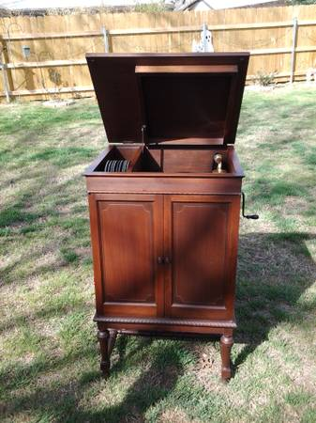
  00P0P_9HEiFaMFVch_600x450.jpg [ 32.48 KiB | Viewed 1260 times ]
  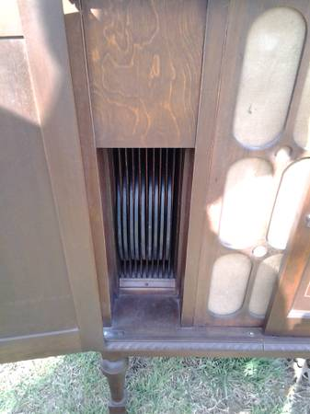
  01313_3n3OTl5CAfJ_600x450.jpg [ 20 KiB | Viewed 1260 times ]
  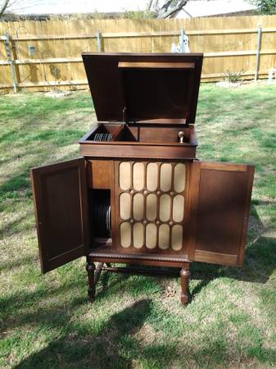
  00808_c1BZ2b4uL1i_600x450.jpg [ 32.43 KiB | Viewed 1261 times ]
  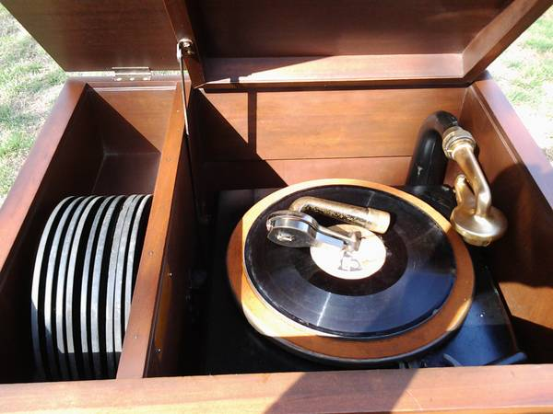
  00w0w_eDa22jyL86D_600x450.jpg [ 39.72 KiB | Viewed 1261 times ]
  "You must serve music, because music is so enormous and can envelop you into such a state of perpetual anxiety and torture--but it is our first and main duty"
  -- Maria Callas, 1968 interview.
Top

Previous topic | Next topic

Display posts from previous:  Sort by   

 | Page 3 of 25 | [ 247 posts ] | Go to page Previous 1, 2, 3, 4, 5, 6 ... 25 Next

