gemering
  Post subject: Re: Inventory of Beethoven and Schubert Edisonic phonographs
  Posted: Tue Apr 22, 2014 7:46 am
Joined: Sun Jul 29, 2012 9:35 pm  Posts: 1119  Location: Northwest New Jersey
  Victor IV
  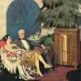
  Edisonic Schubert:
  Serial#: 1556
  When Purchased: August 2013
  From Whom: Craigslist Atlanta
  Cabinet Condition: C- with some large chips to the veneer on top and a badly warped left side. Grill cloth is original and not torn.
  Upgrades: I had to re-attach the reproducer collar which had fallen off.
  The machine sounds great and I would love to bring it back to its former glory.
  Sadly, I do not have any experience or skill in cabinet repair, or I would do the job myself.
  Gene
  Attachments:
  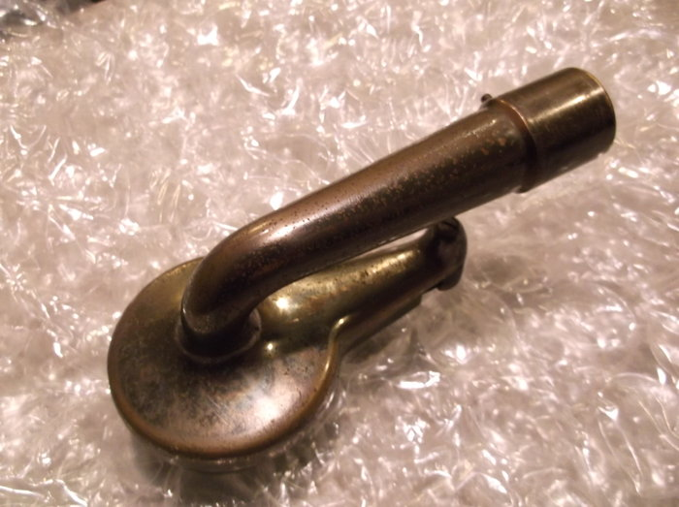
  DSCF9967.JPG [ 2.74 MiB | Viewed 1171 times ]
  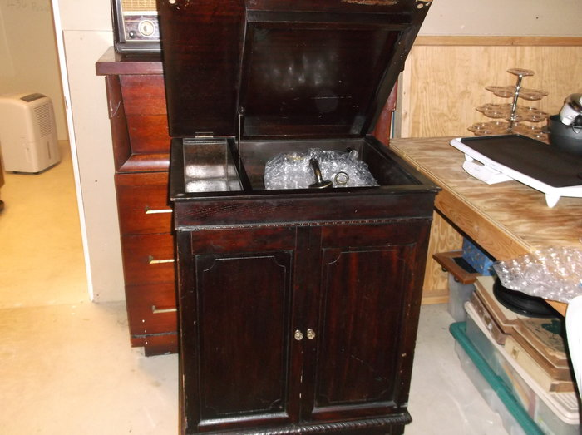
  DSCF9959.JPG [ 3.57 MiB | Viewed 1172 times ]
  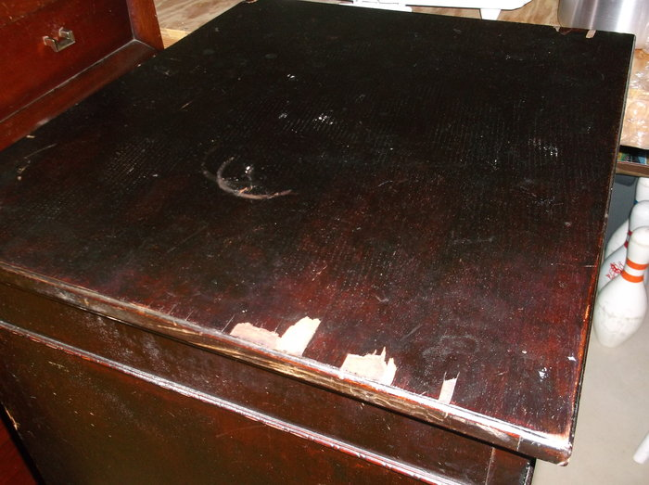
  DSCF9961.JPG [ 3.74 MiB | Viewed 1172 times ]
  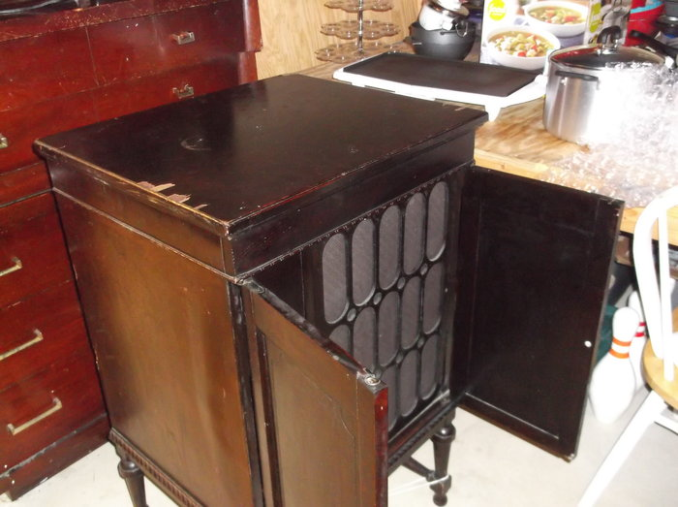
  DSCF9965.JPG [ 3.94 MiB | Viewed 1172 times ]
  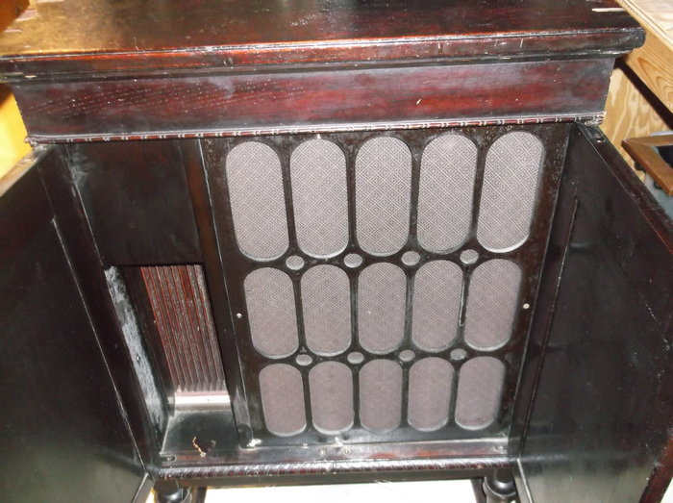
  DSCF9964.JPG [ 4.2 MiB | Viewed 1172 times ]
Top

Valecnik
  Post subject: Re: Inventory of Beethoven and Schubert Edisonic phonographs
  Posted: Tue Apr 22, 2014 10:57 am
Joined: Sat Jan 10, 2009 3:28 pm  Posts: 3725  Location: Česká Republika
  Victor VI
  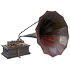
  Edison Records - Close your eyes and see if the artist does not actually seem to be before you.
  Great initiative here. I hope everyone with one of these provides the information. I'd also like to see some good, detailed pictures of the Beethoven if one of you is able.
  Thanks!
  Visit The Phonograph Company, an archive of gramophone, graphophone, phonograph and talking machine images and information. Also, visit The Phonograph Company on Facebook and on YouTube.
Top

phonogfp
  Post subject: Re: Inventory of Beethoven and Schubert Edisonic phonographs
  Posted: Tue Apr 22, 2014 12:48 pm
Joined: Wed Jan 07, 2009 5:08 pm  Posts: 6210  Location: New York's Finger Lakes
  Victor Monarch Special
  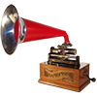
  Who is John Galt?
  Sorry - - just another one of these...
  Model: Schubert Edisonic
  Serial number: 3020
  When purchased: January 26, 2009
  From whom purchased: Rochester (NY) Craigslist
  Cabinet condition when purchased: Poor. The non-crank side of the cabinet had been exposed to weather; perhaps on a porch. All four legs required complete dismantling and re-gluing. The non-crank side of cabinet required stabilization and a complete re-veneer (all the original veneer was missing on this side). The top of the lid required re-veneering. The original finish was salvaged on the rest of the machine. Replacement knobs.
  If it hadn't been for the Edisonic reproducer, the machine's excellent playing condition, and the records, I probably wouldn't have brought this one home. The machine came with 24 discs, 21 of which were 52000 series dance bands and a few Vaughn De Leath. The machine bears a decal (and small stickers on some of the discs) for a well-known Rochester retailer, the Levis Music Store. The original discs are still kept in the machine.
  George P.
  Attachments:
  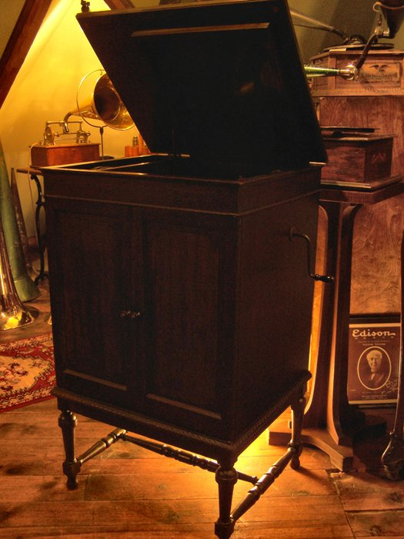
  schubert3.jpg [ 621.06 KiB | Viewed 1141 times ]
  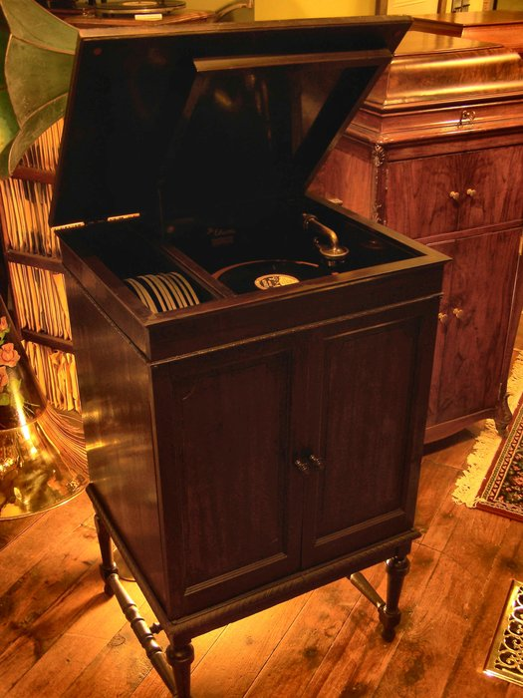
  schubert1.jpg [ 655.39 KiB | Viewed 1141 times ]
  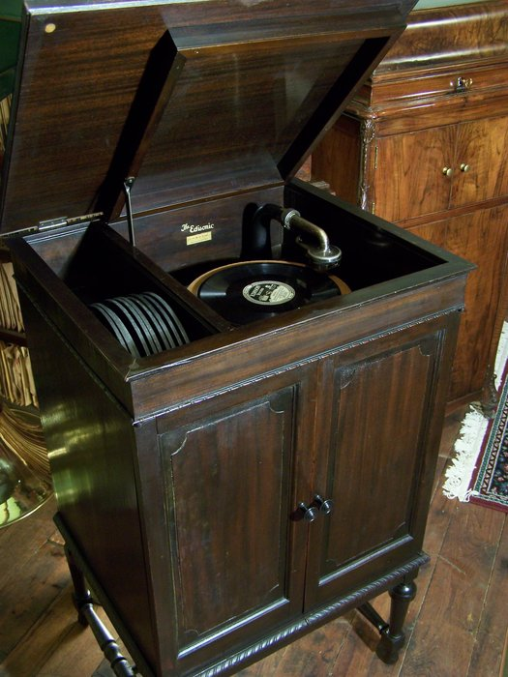
  schubert2.jpg [ 1.47 MiB | Viewed 1141 times ]
Top

coyote
  Post subject: Re: Inventory of Beethoven and Schubert Edisonic phonographs
  Posted: Tue Apr 22, 2014 1:08 pm
Joined: Thu Jan 08, 2009 12:41 am  Posts: 374  Location: Pittsburgh, PA
  Victor II
  
  Model: Schubert Edisonic
  Serial number: 2288
  When purchased: February 2009
  From whom purchased: eBay seller from Strongsville, OH, who probably purchased it from Estes Auction (see third May 1, 2014 post in this thread), assumed from matching damage on right door and location proximity.
  Cabinet condition when purchased: veneer intact, but alligatored/weathered/scratched, original door knobs but one cracked and glued prior to owning (looks to be a common occurrence with these knobs). Grille cloth original and great condition.
  Upgrades made by present owner: None, other than replacing standard reproducer with correct Edisonic.
  Hm, thought I had more photos, but this approximates the finish condition.
  Attachment:
  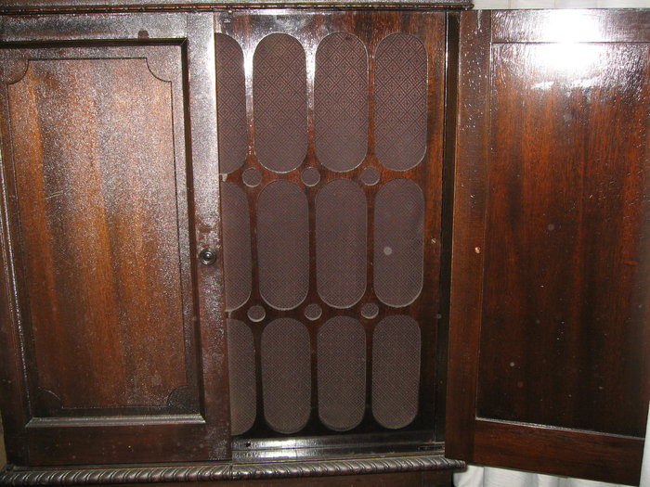
  IMG_0871.JPG [ 4.62 MiB | Viewed 1139 times ]
  Attachment:
  File comment: showing dents to lower right corner of right door
  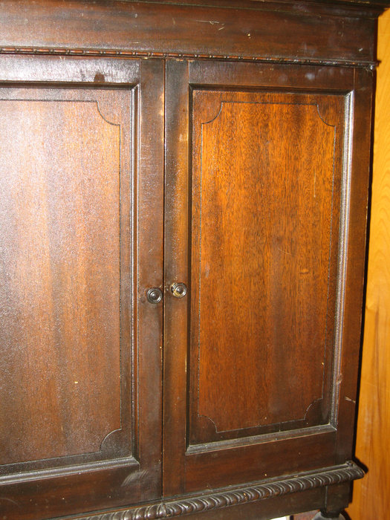
  2.jpg [ 5.87 MiB | Viewed 1034 times ]
  Last edited by coyote on Thu May 08, 2014 12:19 am, edited 5 times in total.
Top

FellowCollector
  Post subject: Re: Inventory of Beethoven and Schubert Edisonic phonographs
  Posted: Tue Apr 22, 2014 2:28 pm
Joined: Tue Jul 07, 2009 6:22 pm  Posts: 1260
  Victor IV
  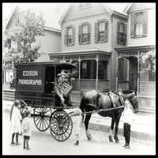
  Mine is a Schubert model.
  Model: Schubert Edisonic
  Serial number: 4005 (pretty late!)
  When purchased (by me): May 1999
  From whom purchased: Original owner's family.
  Cabinet condition when purchased: Very good original. Light alligatoring to finish. Couple of light bumps on one cabinet corner.
  Upgrades made by present owner (me): Nothing. I like it just as it is.
  Other interesting aspects: Cabinet was full with (mostly) later 52,000 series Edison Diamond Discs and a separate wooden crate that contained another 20 or so.
  Doug
  Doug
  http://www.youtube.com/user/MusicBoxBoy
Top

schweg
  Post subject: Re: Inventory of Beethoven and Schubert Edisonic phonographs
  Posted: Tue Apr 22, 2014 2:44 pm
Joined: Sun Jan 11, 2009 8:41 pm  Posts: 722  Location: okc ok
  Victor III
  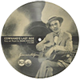
  Here are the two I mentioned earlier in this post. I will add more pics of the Beethoven later.
  Attachment:
  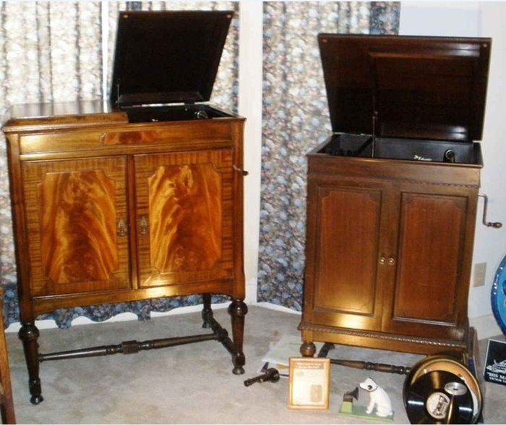
  bee.JPG [ 142.53 KiB | Viewed 1124 times ]
  Steve
Top

pughphonos
  Post subject: Re: Inventory of Beethoven and Schubert Edisonic phonographs
  Posted: Tue Apr 22, 2014 2:53 pm
Joined: Tue Jul 17, 2012 11:35 am  Posts: 670  Location: Homewood, Illinois, USA
  Victor III
  
  "You must serve music"
  Wowsers, Steve! All our Edisonics are special, but I think we can all take our hats off to you for two pretty spectacular machines.
  "You must serve music, because music is so enormous and can envelop you into such a state of perpetual anxiety and torture--but it is our first and main duty"
  -- Maria Callas, 1968 interview.
Top

schweg
  Post subject: Re: Inventory of Beethoven and Schubert Edisonic phonographs
  Posted: Tue Apr 22, 2014 6:33 pm
Joined: Sun Jan 11, 2009 8:41 pm  Posts: 722  Location: okc ok
  Victor III
  a couple more
  Attachment:
  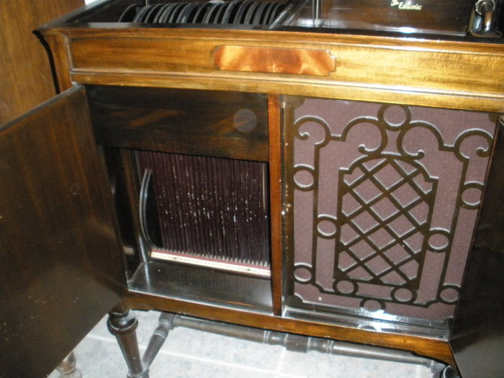
  P4220008.JPG [ 1.88 MiB | Viewed 1105 times ]
  Attachment:
  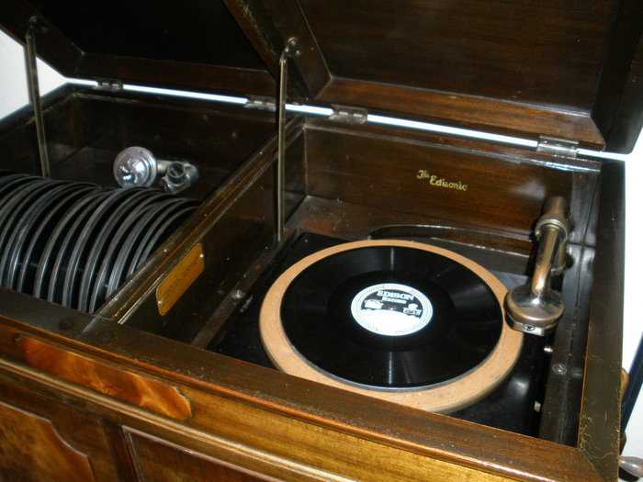
  P4220007.JPG [ 1.82 MiB | Viewed 1105 times ]
Top

pughphonos
  Post subject: Re: Inventory of Beethoven and Schubert Edisonic phonographs
  Posted: Tue Apr 22, 2014 9:49 pm
Joined: Tue Jul 17, 2012 11:35 am  Posts: 670  Location: Homewood, Illinois, USA
  Victor III
  "You must serve music"
  SCHUBERT EDISONIC IN THE UK AS OF 9/8/2012
  Model: Schubert Edisonic
  Serial number: 1902
  Our very own Epigramophone reported the following on our forum on September 8, 2012:
  There cannot be many Schuberts in the UK, but one of the few is the subject of an article in the CLPGS magazine "For the Record" No.23 Autumn 2007.
  The article states that early in 1928 a wooden motor board was fitted together with a different horn, possibly in response to Edison's belated introduction of electrical recording.
  The UK machine bears the Serial Number CLT:1902 and has a black painted metal motor plate.
  "You must serve music, because music is so enormous and can envelop you into such a state of perpetual anxiety and torture--but it is our first and main duty"
  -- Maria Callas, 1968 interview.
Top

Dustie89
  Post subject: Re: Inventory of Beethoven and Schubert Edisonic phonographs
  Posted: Tue Apr 22, 2014 11:31 pm
Joined: Mon Apr 01, 2013 1:22 pm  Posts: 572
  Victor III
  I have a nice Schubert s/n 2723, and a Beethoven s/n 1853 in my collection. The Beethoven is in need of complete restoration, and missing the reproducer.
  Dustin Ellis
  Mount Pleasant Edison Phonograph Museum
  Mount Pleasant Texas
Top

Previous topic | First unread post | Next topic

Display posts from previous:  Sort by   

 | Page 2 of 25 | [ 247 posts ] | Go to page Previous 1, 2, 3, 4, 5 ... 25 Next

