Reproducer/Sound box Type | Needle/Stylus | Record Type
Any sound box with a mica diaphragm: Victor Exhibition; No. 2, No. 3, No. 4; Columbia No.5, No. 6, etc.  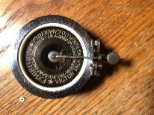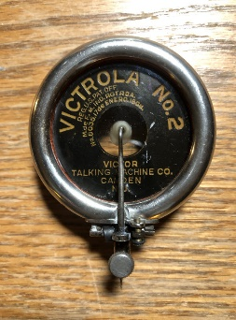  Exhibition and No.2 photos by Peter Poggi  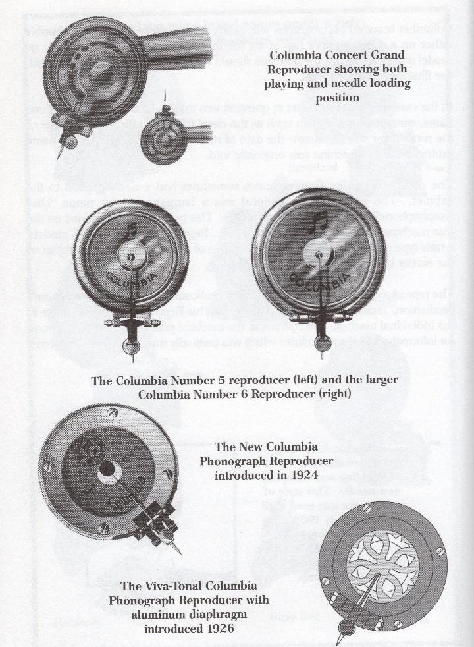  From The Columbia Phonograph Companion, Vol. II, by Robert Baumbach. | Steel  Low tone  Medium tone  Loud tone  Spearpoint  Bamboo  Fiber  Tungs-tone | Earlier than 1925  Acoustically recorded shellac, mostly laterally cut. Records manufactured before the introduction of electrical recording in 1925 are intended for mica diaphragm reproducers. Stick to acoustically recorded records from before 1925. The mica diaphragm is built to handle the low volume and frequency range of the acoustic discs. Playing post-1925 electrically recorded discs may delaminate the diaphragm and cause excessive movement of the needle in the groove, damaging the groove walls.

Reproducer/Sound box Type | Needle/Stylus | Record Type
Victor Orthophonic, Columbia Viva-Tonal (see above), any sound box with an aluminum diaphragm, etc.  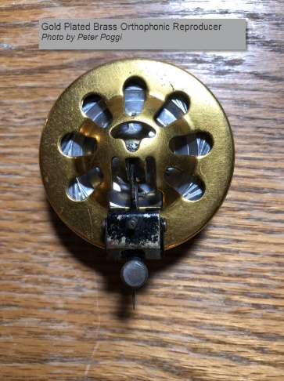 | Steel,  Spearpoint,  Bamboo,  Tungs-tone | Any laterally cut, electrically recorded 78 made before 1937. You can play an acoustical recording with an orthophonic, but there is no real sound advantage.
 | Steel,  Spearpoint,  Bamboo,  Tungs-tone | Electric recordings made between 1925-1937 using the Western Electric Westrex recording system (Victor Orthophonic & Columbia Viva-Tonal specifically) are part of a balanced system.
 | Steel Soft Tone,  Bamboo | Records made after 1937 were designed with a different recording curve made to generate a tiny piezo-electric spark in a Rochelle salt-crystal pickup. There is too much sound energy in that groove for an Orthophonic-style reproducer to handle efficiently. Records after 1937 can be played using a soft tone -tone needle but it’s not compatible with the Westrex system.

Reproducer/Sound box Type | Needle/Stylus | Record Type
Pathé | Sapphire Ball | Pathé uses a vertical cut groove that is U-shaped in cross-section and is tracked with a sapphire ball stylus.
Edison Diamond Stylus | Diamond | Edison DD Vertical Cut. Edison ¼” discs use a groove that is V-shaped in cross-section and is tracked with a conical diamond stylus.

Differentiating between Acoustically and Electrically recorded records.
Assume you are looking at a disc and you do not recognize the artist nor know the production year. You can tell its shellac and not vinyl from the weight and thickness. BUT is there any physical or visual characteristic that can indicate whether it's acoustic or electrically recorded?
You may be able to date the disc by examining the labels. This is a great reference for this purpose. http://majesticrecord.com/labelsvictor.htm
Often there is some reference to ‘Electrically Recorded’ or lightning bolts, etc. incorporated in the design. Some Victor records have “VE” (“Victor Electric”) printed on the label or engraved in the “run-out” area. Some of the last Victor “Batwing” labels have the word “Orthophonic” to the left of the spindle hole as they switched over to electric recording in 1925. The Victor “Scroll” label appeared on electrically recorded records from 1926 through 1937.
A good rule of thumb regarding acoustic machines with mica diaphragms:
Avoid playing 78s with a lead in groove on the perimeter, which date from approx. 1934 and later. 78s with a lead in groove have a wider dynamic range and increased volume that a mica diaphragm just wasn’t designed to handle, even with soft tone needles.

If you must play later 78s on a mica diaphragm type of sound box, go easy on the later records and use the thorn or fiber needles.

